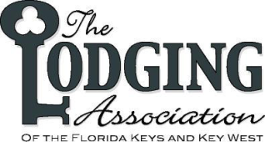
2018
Annual Awards Banquet
Nomination Form

Individual Person: ______________________________________ Title: ______________________
Business Name: __________________________________________________________________
Award Nomination:
Key West Lodging Property of the Year Upper Keys Lodging Property of the Year Inn Property of the Year
Key West General Manager of the Year Upper Keys General Manager of the Year Innkeeper of the Year
Key West Employee of the Year Upper Keys Employee of the Year Innkeeper Employee of the Year
Wright Langley Award Margo Golan Community Service Award
Frank Romano Associate Award for Excellence

Nominated By: _________________________________________ Contact #: ________________
Please complete the following to the best of your ability:
Previous Awards / Recognitions Received: ______________________________________________
________________________________________________________________________________
Professional Achievements: (special recognitions, awards, board appointments, or other designations)
________________________________________________________________________________
________________________________________________________________________________
Community Service: (local, county, state level participation in civic and service organizations, charitable activities)
_________________________________________________________________________________________________
_________________________________________________________________________________________________
Involvement with the Lodging Association: ___________________________________________________
________________________________________________________________________________________
Other Information: (why do you believe they should receive this award?)_____________________________________
_________________________________________________________________________________________________
Please return nomination forms by Friday January 12th, 2018
Fax 305-296-1408 or email: executiveoffice@keyslodging.org

