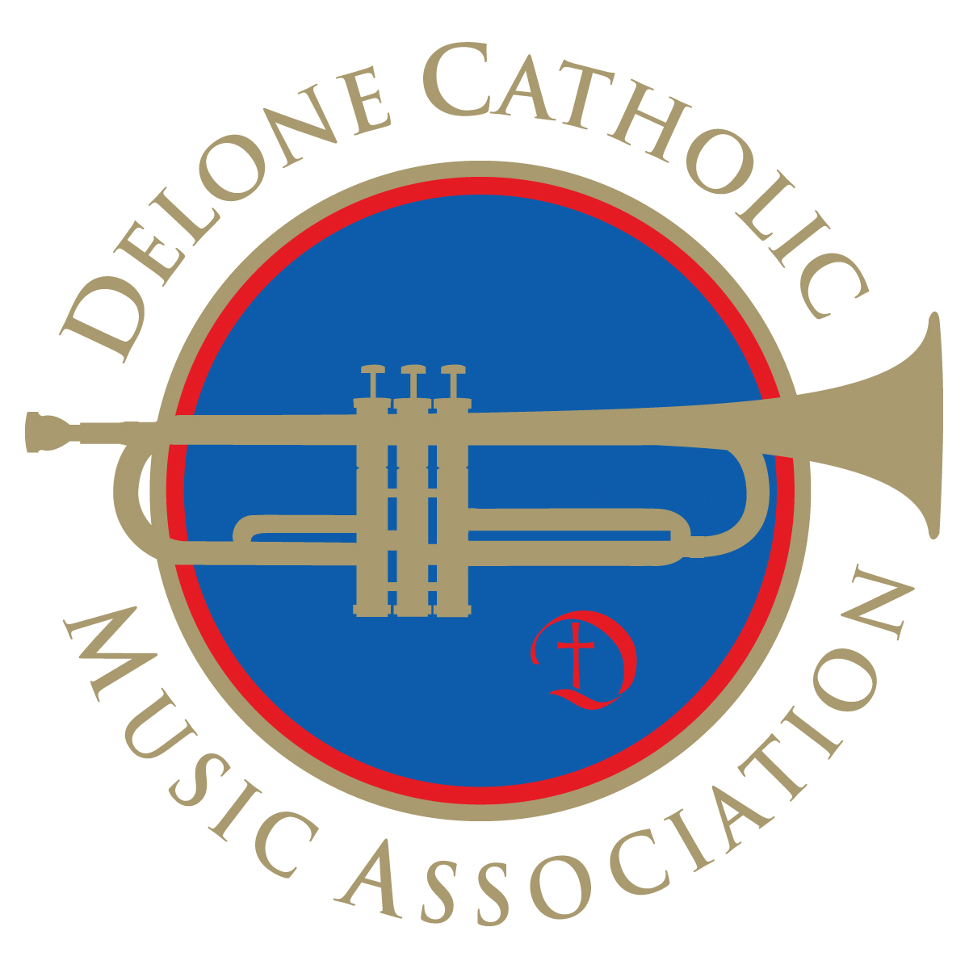
Delone Catholic Music Association
Carnival 2017
June 12 – June 17, 2017
ADVANCE TICKET SALES

The Delone Catholic Music Association Carnival is scheduled for June 12 – 17, 2017. Once again this year, we offer both a “ride all night” bracelet for Monday, Tuesday and Wednesday nights, and the reduced price tickets for any night of the carnival.
REMINDER! CARNIVAL GROUNDS ENTRY FEE!
We want your experience at the Delone Catholic Carnival to continue as a safe and enjoyable one! To enhance carnival ground security, and to comply with the guidelines established by the Borough of McSherrystown, we will be collecting a $1.00 entrance fee for all patrons 13 years and older. In addition, no outside food or drink is permitted on the carnival grounds.

The Ride-All-Night bracelets purchased in advance from the Music Association cost $12 each and allow unlimited rides for one night (valid Monday, Tuesday, or Wednesday only). Purchasing bracelets at the carnival will cost $25.

Advance purchase tickets may be used on any rides during the entire run of the carnival and can be purchased at 25 tickets for $10. Purchasing 25 tickets at the carnival will cost $20 in bulk or $1 each.

Orders may be placed online until June 9 at www.DeloneCatholic.org or by mail using the order form below and returning the completed order form by Friday, June 9 either to the Main Office at Delone Catholic (please do not leave orders for Mrs. Yealy) or mail to:
Mary Martz
Advance Ticket Sales
1100 Hoff Road
Hanover, PA 17331
Please enclose a check or money order payable to Delone Catholic Music Association – do not mail cash. All mail-in orders MUST be received by June 9 to receive the advance purchase discounts.
Tickets or bracelets will be distributed in the lobby of Delone Catholic High School during the hours of 6 p.m. and 9:30 p.m. the week of the carnival. No tickets will be mailed or distributed from the school office.
---------------------------------------------------------------------------------------------------------------------------------------------------------------
Please print all information.
PARENT’S NAME: _________________________________________________________________________________________________________________________
STUDENT’S NAME: _______________________________________________________________________PHONE NUMBER: __________________________
ADDRESS: __________________________________________________________________________________________________________________________________
CITY: _____________________________________________________________________ STATE________________ ZIP CODE: __________________________
Number of Ride-All-Night Bracelets ________ at $12 each Subtotal __________
(valid Monday, Tuesday, or Wednesday of carnival)
Number of Strips of 25 Ride Tickets ________ at $10 each Subtotal ___________
(valid any night of carnival)
Grand Total ________

Delone Catholic Music Association is not responsible for lost orders. Returned/Cancelled checks will be charged a $25 Fee.

