Northern Exposure

Newsletter of the
New England Garden Clubs, Inc.

Connecticut – Mane – Massachusetts
New Hampshire – Rhode Island - Vermont

August 2026

DIRECTOR’S REPORT

Here I am, this utterly perfect late July morning- some sun, few clouds, ideal temperature and no humidity, sitting at my laptop, writing this to you, hoping you’ll join me.
Join me Friday, October 9th, I’ll be sitting at this laptop again. It’ll be in the morning also. I will have chaired a meeting of the NEGC Board. That finished, I’ll stretch, refill a largish water glass, then sit down to greet you as you’re admitted to the Zoom NEGC Business Meeting, which I’ll call to order at 10:00 a.m..
There’s a wonderful 10th Annual NEGC Meeting, have you registered for that yet? You should. Join me at Killington, Tuesday, October 13th and 14th. All sorts of details about that are in stories you’ll find as you scroll down in this newsletter). Donna Donnelly, President of National Garden Clubs, and Susan Miner, formerly from New Hampshire, 3rd Vice President, National Garden Clubs, will come to Killington. I know how wonderful the program is. The Federated Garden Clubs of Vermont deserve awe and praise for their work. Doris Van Mullen’s Committee has been fantastic. The two meetings used to be held together. I’ll take the blame for splitting them up. In an ideal world, more of our roughly 20,000 members could hear the six Federations’ Presidents give their reports (three minutes each, and someone holds a timer!), hear about our finances from the Treasurer, learn about new developments (such as the Pilot Photography Group, the only, repeat ONLY one) and other initiatives. Still, you may not have realized you could attend part of the meeting for free, while at home.
You do need to register though. It’s easy. Go to The Federated Garden Clubs of
Vermont’s website https://www.vermontfgcv.com. Click on the link to Register for the
Fall Meeting. When you get there, you can Register for events at Killington (ohhh,
Please Come!) or continue to the bottom of the form and check on Registration for the Business Meeting. Do help us grow this part of our meeting. I look forward to seeing you at both the Oct. 9th and at Killington.
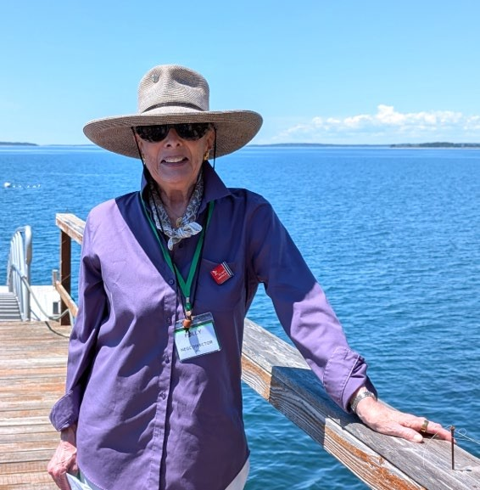
A total Non Sequitur - Have you submitted at least one photograph to the Photography Competition?! Deadline’s August 31st. Time’s awastin’! Check out the information about the Competition and the Photography Group on page 14.

Fondly,

Polly

NEGC Director Polly in Bar
Harbor on garden tour during GCFM June Convention, Photo supplied by Karen Rea, GCFM.
Polly Brooks

NEW ENGLAND GARDEN CLUBS | Member of National Garden Clubs, Inc

Register for New England Garden Clubs Annual Meeting
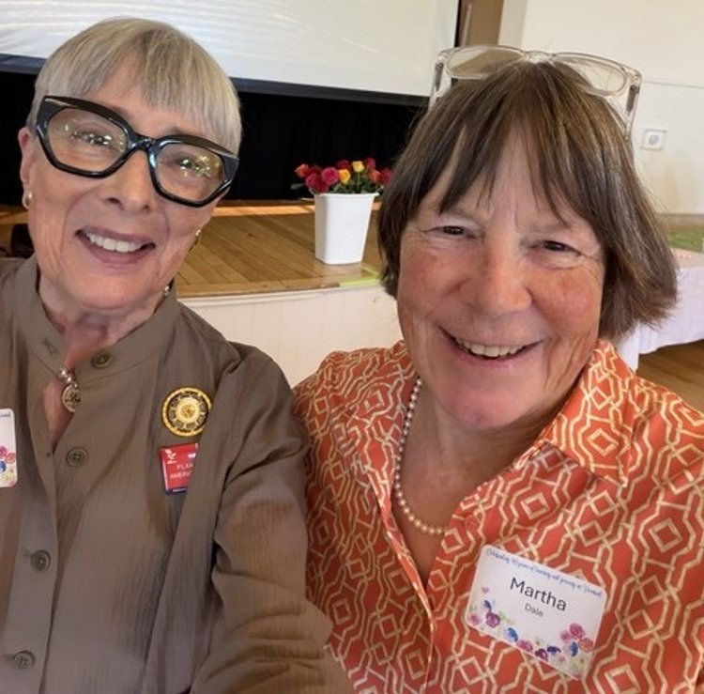
Save the dates and join us:
Review the brochure for all the program’s planned activities.

October 9 – Executive and Membership Meeting via zoom. All club members are invited to attend.
October 13-14 – 10th NEGC Annual Meeting
Killington Grand Hotel Resort, Killington,
Vermont
IMPORTANT – register for meetings, meals, and hotel room accommodations at the Federated Garden Clubs of Vermont website https://www.vermontfgcv.com
Left to right: NEGC Director Polly Brooks, FGCVT President Martha Dale
Vermont’s stunning fall foliage creates a vibrant tapestry of color and welcomes you to the 10th Annual Meeting of the NEGC. Take time to explore serene lakes such as Lake Champlain, charming towns like Stowe and Woodstock, picturesque small towns, covered bridges and majestic green mountains; picturesque small, enchanting towns; covered bridges, majestic green mountains and explore and engage in outdoor adventures.
For questions email djvanmullen@gmail.com
Doris Van Mullen
Meeting and Program Chairperson
Federated Garden Clubs of Vermont

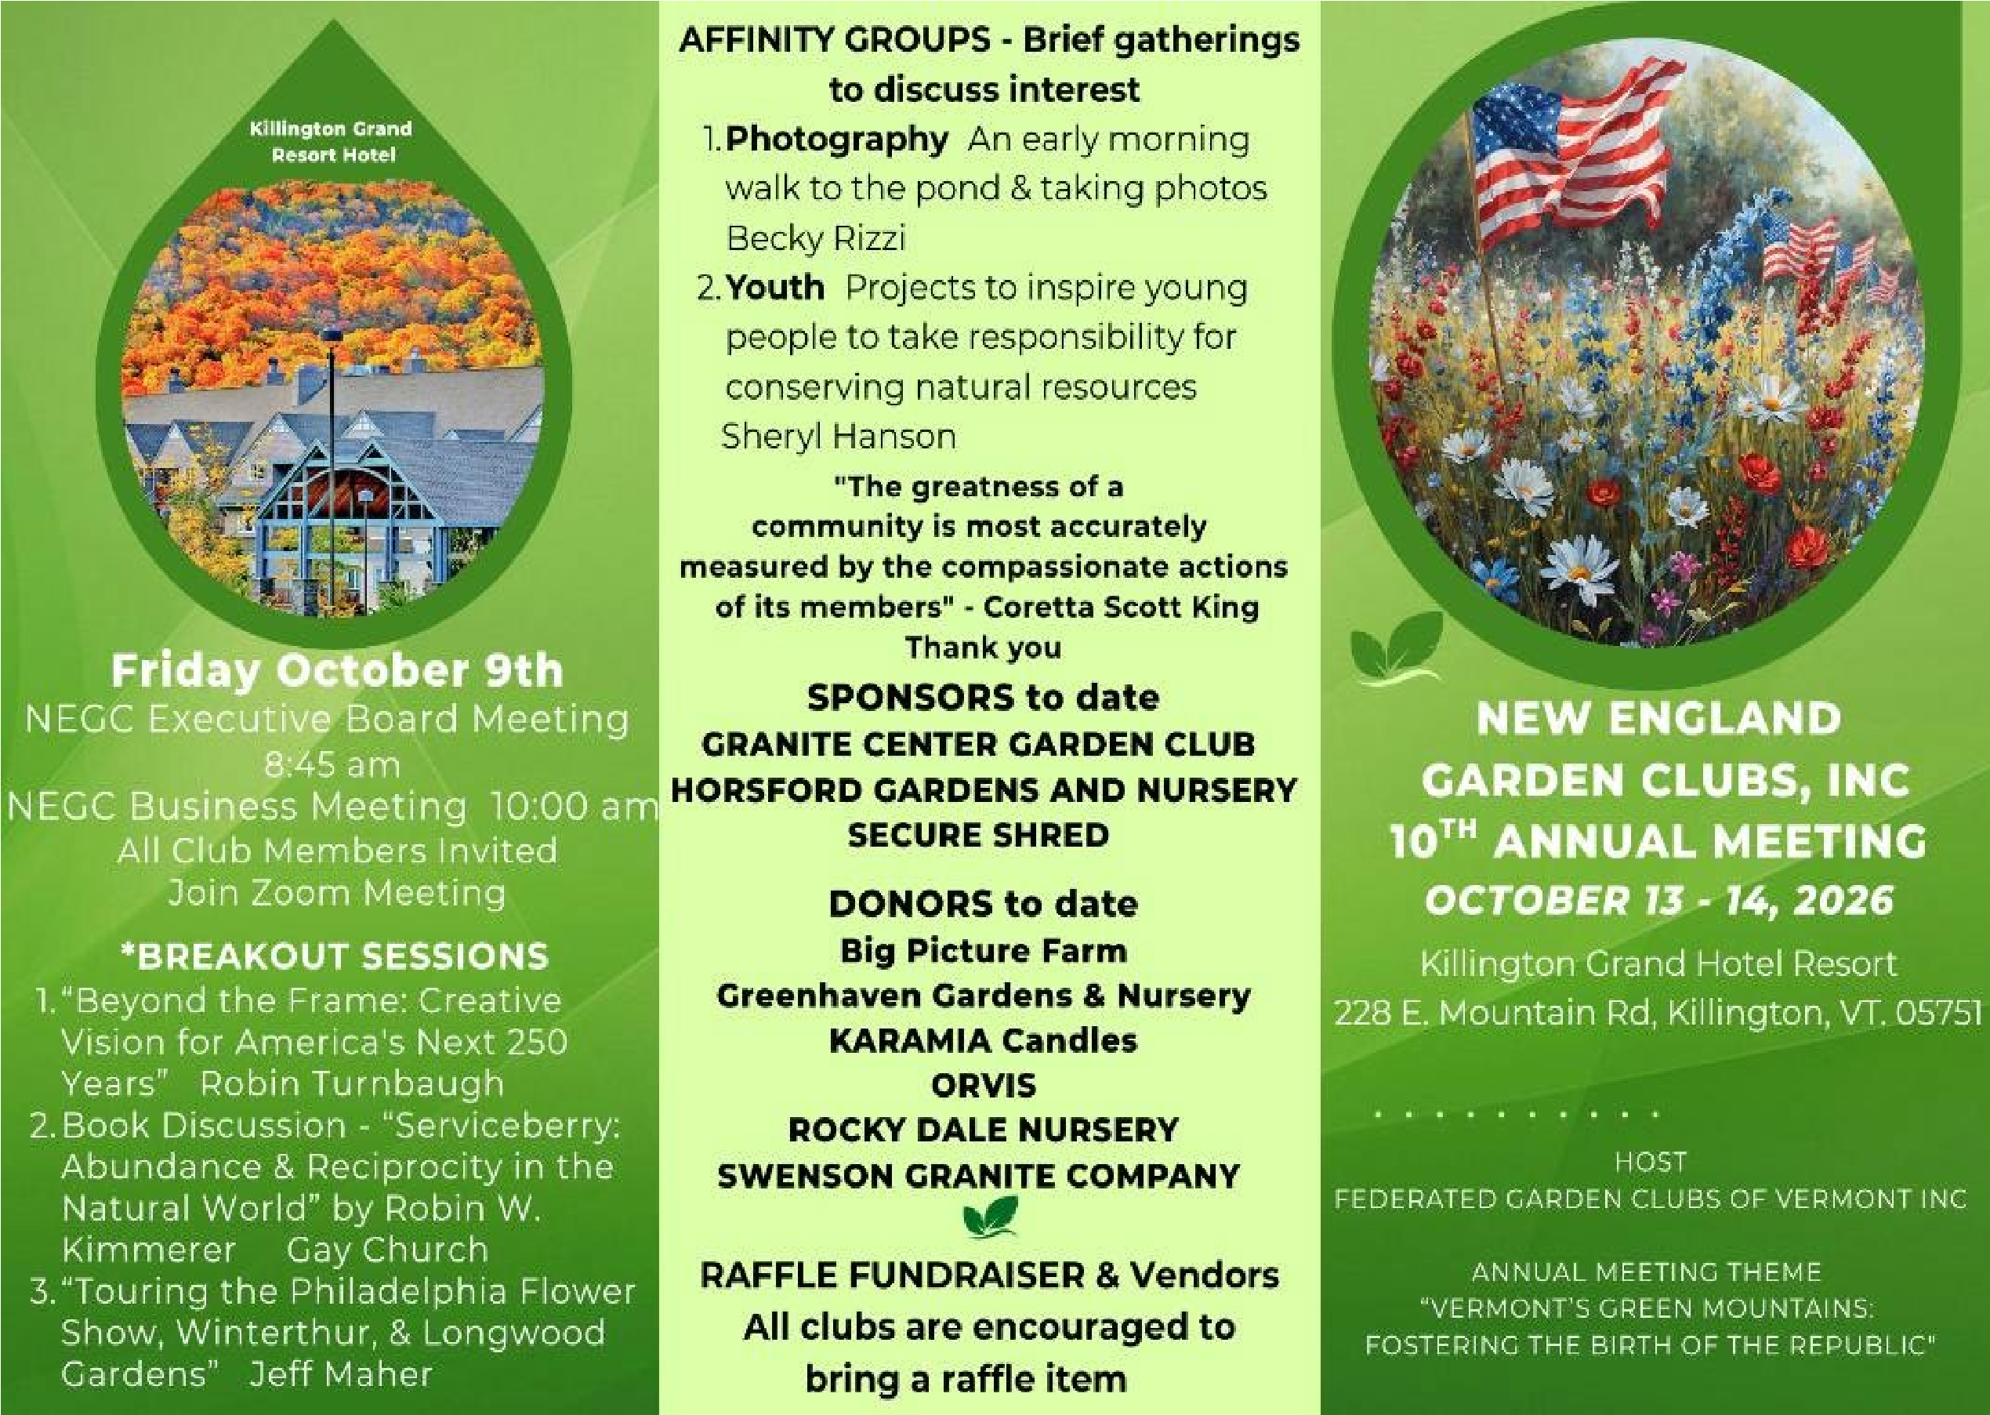
Come Join Us In Vermont For The NEGC 10th Annual Fall Meeting - October 13-14 - Killington, Vermont

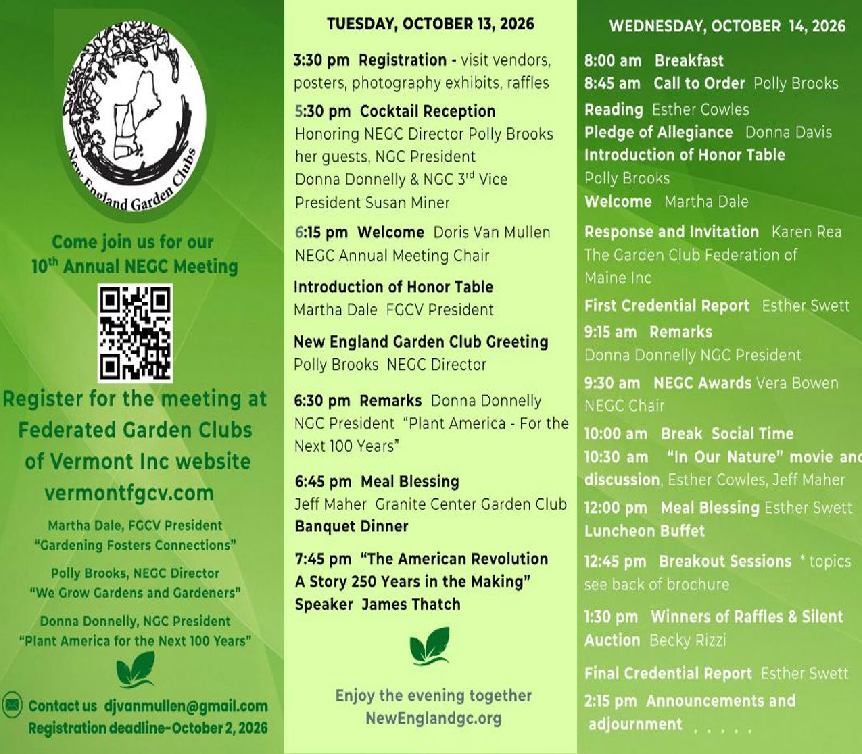

Table of Contents

Link to registration information for NEGC meeting in Vermont – page 2
Garden Club Federation of Maine – pages 5 - 7
Rhode Island Federation of Garden Clubs, Inc. – pages 7 - 9
New Hampshire Federation of Garden Clubs, Inc. – pages 10 - 12
Horticulture: Brilliant Bulbs – pages 12 and 13
NEGC Photography Judging Group Newsletter link – page 14
Photography Group 2026 Photography Show – page 14
How We Can Grow Gardens & Gardeners – pages 14 and 15
Saint-Gaudens National Historic Site – pages 15 – 17
Maine to Host Next Year’s NEGC Meeting – pages 17 and 18 Federated Garden Clubs of Connecticut – pages 18 - 20
Another Risk to Manage - Copyright Infringement – page 21
Garden Club Federation of Massachusetts – pages 21 and 22 NE Regional Hydrography Collaboration – pages 23 and 24

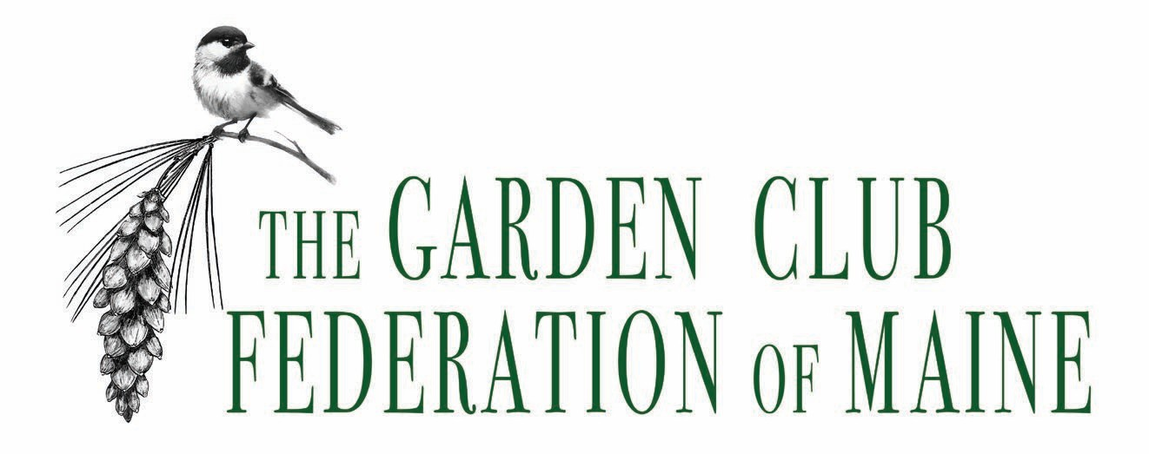

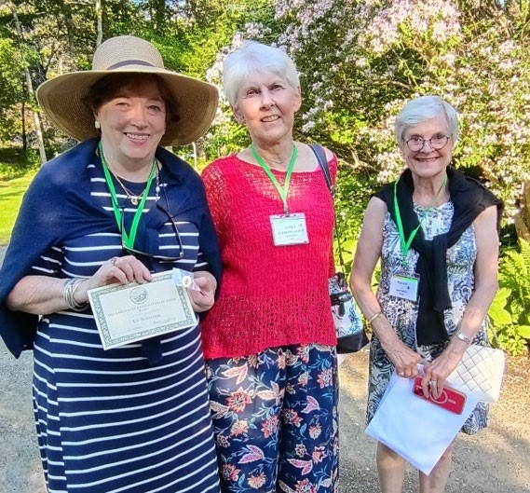
Greetings from Vacationland! Summer has passed by quickly. We kicked off the season with our Federation’s annual convention, held in Bar Harbor this year. We were pleased to welcome both our NEGC Director Polly Brooks and our National Garden Club 3rd Vice-President Sue Miner with her fiancé Chuck Neff. The weather was glorious for our garden tour on June 17. and while a bit cloudy with showers the next day, we were snug in the event center conducting the annual business meeting. With beautiful gardens, a gorgeous ocean-side venue and delicious food, everyone enjoyed themselves.
From left to

right:
Harpswell GC
President Cindy Mudford, GCFM
President Becky Gallery and Harpswell’s
immediate past president Tuckie Westfall
at State Life Member Recognition
reception

at Garland Farm

The pre-convention reception for our State Life Members was held at the Garland Farm. Listed on the National Register of Historic Places, Garland Farm is the last home of the noted landscape architect Beatrix Farrand and is now owned by the Beatrix Farrand Society. Food and drinks were provided by our hosts the St Croix District Garden Clubs. State Life members were able to visit the home and gardens while enjoying refreshments and conversation in the attached barn.
The highlight of the business meeting was awarding our GCFM Scholarship to Grace McGuire of Deer Isle. Grace, who is attending Wheaton College in Massachusetts as an environmental studies major, has been interested in gardening since elementary
school and hopes to go on to graduate studiesonce she completes her degree at Wheaton.
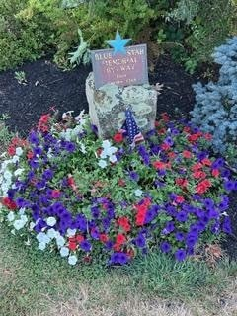
Maine joins the country in celebrating the 250th Anniversary of the Declaration of Independence. A variety of events are planned throughout the summer, but July was the focus in several towns. Harpswell Garden Club’s Historic Park Gardens were part of the town’s celebration on July 18. That was the date in 1776 on which the declaration was first read in Harpswell. The Harpswell Garden Club provided docents to guide visitors through the gardens, telling them about the people each section honors and offering information about the various shrubs and perennials in the gardens.
St Mary’s Garden Club: Blue Star Memorial, Falmouth, ME
Red, white and blue flowers abound in various containers and in the cutting gardens. Other clubs have added patriotic colors to the Blue Star Markers in their care, as well as using red, white and blue annuals in their plantings this summer. And while many of our clubs have incorporated red, white and blue in their plantings, one has extended the patriotic spirit to a town-wide contest. Poland Garden Club is holding a Summer Grow Contest: the red, white, and blue edition! There are four categories to be judged: Business, Youth, Container and
Garden View, as well as a People’s Choice category to hopefully attract more followers to the club’s Facebook page. Our Board of Directors meets in early August. One
item we want to address is how to attract more applicants to our federation’s scholarships. GCFM offers a scholarship, and as with other federations, the winner
enters the NGC scholarship pool. A handful of clubs in Maine also award scholarships to local students who are majoring in horticulture or related subjects. Each year, some scholarships are not awarded, with no applicants at all. This year’s recipient of the GCFM scholarship recommended using social media to spread the word. Our board will discuss this and, possibly, add other suggestions to be more successful in reaching out to our state’s college students.


Harpswell Garden Club’s Gold Star Memorial in P-3 Park, Brunswick Landing, on July 4th

We look forward to visiting Vermont in October for the NEGC annual meeting.

Becky Gallery
President, Garden Club Federation of Maine

Hello from Little Rhody

Here in Rhode Island, we are busy preparing for the start of a new club year. It is hard to believe how quickly the past year has flown by! Under our updated bylaws, each monthly meeting now includes an educational program, so my board and I have been working diligently to plan a year filled with engaging, informative and enjoyable presentations. We are looking forward to another wonderful season of learning, fellowship, and gardening together.
Our little state hosted eight plant sales in May and I was fortunate to attend six of them. It was a wonderful opportunity to visit with members from clubs across Rhode Island, enjoy their hospitality and see the enthusiasm and hard work that went into making each sale a success.
June brought the spectacular
Newport Flower Show, themed
"Pearls of Newport," to Rhode
Island. It was exciting to see so many members from our garden clubs showcasing their creativity through beautiful floral designs and horticulture entries. I was also delighted to see so many of our clubs participate in the group design exhibits. Their creativity and teamwork were on full display, making Rhode Island well represented throughout the show.

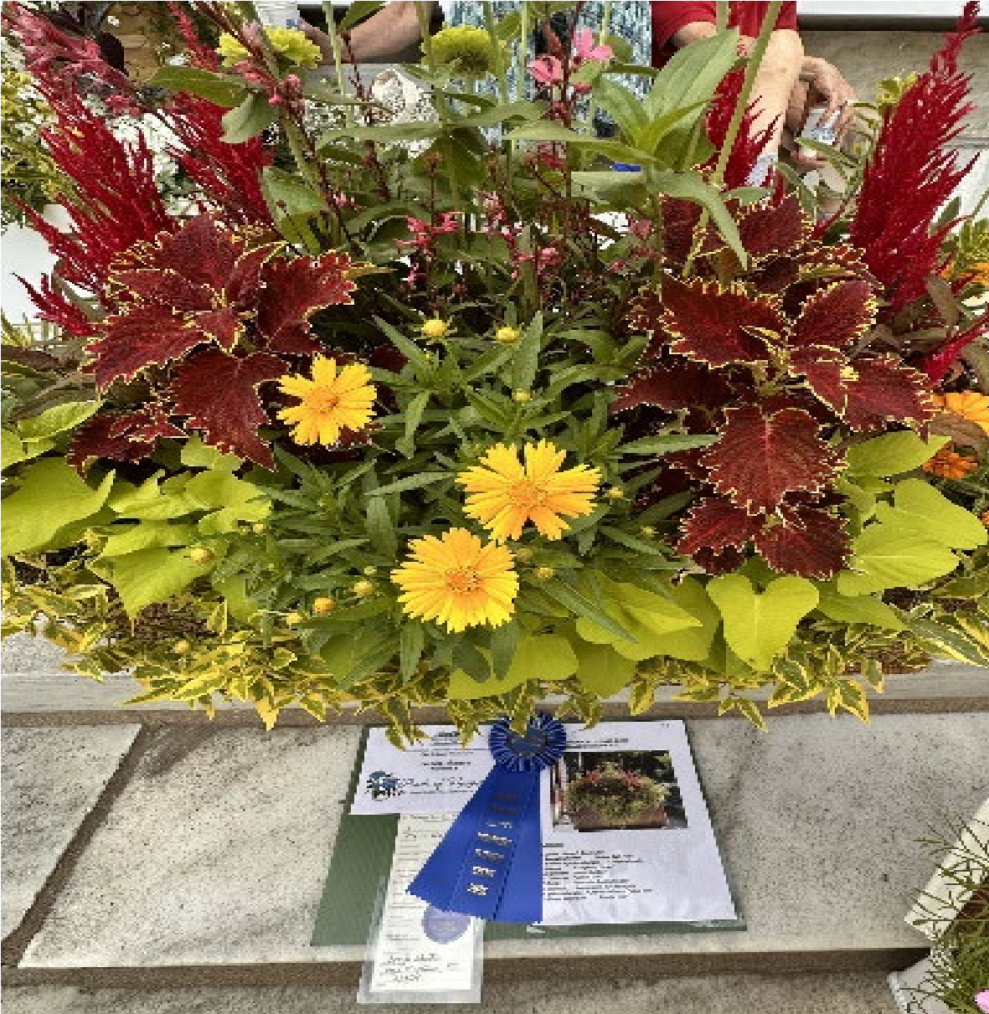
We were fortunate to enjoy two wonderful garden tours this season, hosted by the Edgewood and Barrington Garden Clubs. The Edgewood Garden Tour was blessed with beautiful sunshine, allowing each garden to shine at its very best. Although the Barrington Garden Tour was met with cloudy skies and a bit of drizzle, the breathtaking gardens more than compensated for the weather. Each garden was a reflection of the homeowners' hard work, creativity and dedication. Their willingness to open their gardens for everyone to enjoy,

Class Title: "Cliff Walk," 2nd Place
Vicki Iannuccillo Bristol and Bayberry GC of RI

Horticulture Division I – Creative Containers
Class 2: Classic Window Box, 1st Place: Brenda
Johnston. Plum Beach GC of Rhode Island
made both tours a truly memorable experience.
This spring, we were fortunate to have two wonderful Art in Bloom events! It is exciting to see these beautiful exhibits continue to grow and I look forward to presenting the Art in Bloom Award once again at our Annual Convention. Thank you to the clubs whose creativity and dedication helped make these events such a success. We are delighted to celebrate two outstanding scholarship recipients from Rhode Island this year! Taylor Sirois was awarded the Rhode Island Life Member Scholarship and also received a prestigious National Garden Clubs Scholarship — an exceptional achievement that reflects her dedication and accomplishments. Liam Cotter was also selected to receive a Life Member Scholarship award, recognizing his hard work and commitment.
It is especially exciting to have had two deserving applicants receive scholarship awards this year. Congratulations to both Taylor and Liam, and we wish them continued success in their educational pursuits.
Hope everyone enjoyed the 250th anniversary of this beautiful country!

Kathleen Damiani
President. Rhode Island Federation of Garden Clubs

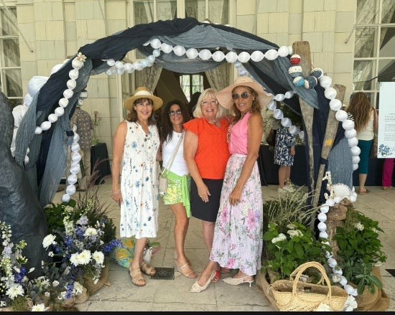

From left to right With my garden club new members: Sandy Decistofano, Western Cranston Garden Club; Loreen, a friend; Kathleen Damiani, RIFGC President; and Rashelle Zira, Western Cranston Garden Club.

New Hampshire Federation Garden Clubs

New Hampshire Federation and the Currier Museum of Art in Manchester, NH presented the inaugural Art in Bloom, in March. NHFGC thanks to all the neighboring states who came to support this event. Save the date of March 19 - 21, 2027. for the second Bloom at the Currier.
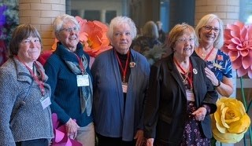

NEGC Supporting NHFGC Bloom at the Currier. Left to right: Martha
Dale, Vermont; Becky Galley, Maine; Suzanne Bushnell, Maine; Winnie Schmidt, NH; Sue Miner, NH/NGC.


Pictured (left to right) are the winners of awards at the Currier
Museum of Art Bloom event: Fiona McKenna, Pauline “Peeps” Bogeart, Winnie Schmidt, Carrie Dugan and Joanne Dickie.

The highlight of every year is our Annual Meeting, and this year's gathering was truly a celebration of both the New Hampshire Federation of Garden Clubs (NHFGC) and our nation's Semi quincentennial. The venue was beautifully decorated in patriotic colors and members embraced the spirit of the day by wearing patriotic attire. The program, "Growing a Nation – The Evolution of Gardens in America," was created and presented by John Forti, a nationally recognized lecturer, garden historian, ethnobotanist and garden writer. His inspiring presentation perfectly complemented the theme of the celebration.
We were thrilled to welcome our largest Annual Meeting attendance ever, with 170 members enjoying the day. NHFGC was also honored to host state presidents and officers from our neighboring states, as well as Susan Miner, National Garden Clubs (NGC) Third Vice President, who brought greetings on behalf of the national organization.
Another milestone this spring was the tremendous success of Bloom, the inaugural collaboration between NHFGC and the Currier Museum of Art. More than 2,100 guests attended the event during a beautiful weekend in mid-March. The Currier's goals were to increase community awareness of the museum and grow its membership — both of which were exceeded. NHFGC's goal was to bring together art, floral design and the community in a meaningful way. Together, we created a truly memorable celebration. The success of Bloom has generated exciting opportunities for NHFGC. Several nonfederated garden clubs have contacted us to learn more about federation membership. Our Membership Chair and committee will be busy visiting clubs, sharing information about the many educational, networking, and leadership opportunities available through NHFGC.
While insurance coverage was once the primary reason clubs joined the federation, today's interest is centered on learning, collaboration and participation. We are especially highlighting the four educational schools offered through NGC. We are also delighted to welcome the Garden Club of Deerfield as our newest member club. We look forward to their participation in the federation and are already making plans for the next Bloom, scheduled for March 18 – 21, 2027.
Across New Hampshire, our clubs continue to make a positive impact in their communities. Many clubs are celebrating the Semi quincentennial through patriotic projects and displays while also creating pollinator gardens throughout the state. Scholarships have been awarded and members are opening their gardens for informal gatherings, tours and club outings that celebrate the beauty of the season and encourage fellowship.
Our clubs also continue to invest in future generations by sharing a love of gardening through youth programs and summer projects. One club has even helped a group of senior citizens establish their own garden club. These efforts reflect our continuing mission to "Plant Seeds of Friendship."
As we look ahead to the coming year, our goals include reviewing our financial decisions; clarifying recent changes to our rules, policies, and procedures; and improving communication throughout the federation. We also look forward to welcoming additional clubs into NHFGC and continuing to grow together through education, service and friendship.


NHFGC Annual Meeting pictured (left to right): Polly Brooks, NEGC
Director; Susan MacPherson, President GCFMa; Susan Miner, NGC Third Vice President from NH; Kathleen Damiani, President RIFGC; Winnie Schmidt, President NHFGC.

Winnie Schmidt
President, New Hampshire Federation of Garden Clubs

Brilliant Bulbs

Bulbs are an easy way to inject color and excitement into a border or patio. Not only planted in autumn for blooms in spring, but they can also be planted earlier in the year, when frosts have passed, to give splashes of color in summer, autumn and winter. Buy fresh, firm bulbs.
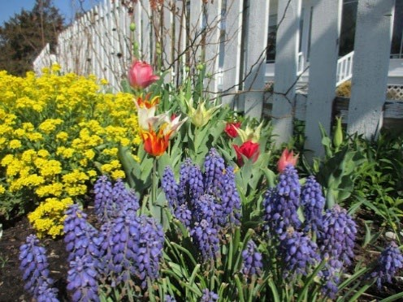
When to plant

Bulbs are relatively cheap to buy, easy to put in and just about look after themselves.
As a rule of thumb, you should plant them six months before flowering, so summer and autumn-flowering bulbs are usually planted from late spring onwards. Winter and spring-flowering bulbs should be planted in late summer to early autumn, so they have time to produce roots before winter. Tulips are an exception as they need to be planted in late autumn/early winter when the temperature has dropped, as planting them early increases the chance of them getting a fungus disease called tulip fire.
Where to Plant
There are three main places to plant bulbs in the garden: in the grass, in pots, in borders.
In the grass: It’s not just crocuses that will grow in short grass, many spring flowering dwarf irises, as will dwarf narcissi, grape hyacinth, and snowdrops.
In pots: Containers are the ideal way to display the riotous colors of bulbs in bloom and are perfect for the large showy flowers of tulips, lilies and alliums. Almost anything with drainage holes works well, add broken crocks over the drainage holes before halffilling with a multi-purpose compost. Add the bulbs, cover with more compost. In the border: Once the bulbs are planted you can leave them to do their thing. If you plant a lot, keep track of where they are, take a photo when they are in full bloom.
How to Plant
Create a trench or hole in the soil, push the bulbs into the soil pointed end up, at a depth of about three times the height of the bulb. Replace the soil and gently firm in. Avoid treading on the earth as this can damage the bulbs.
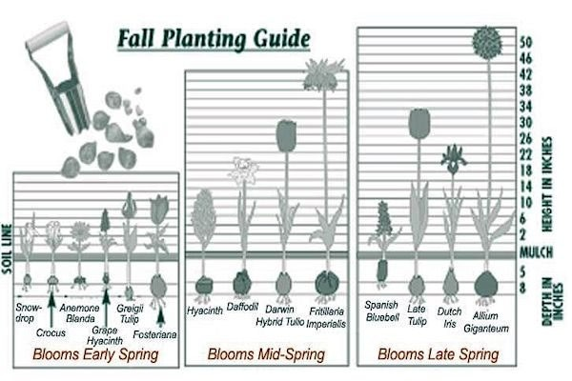
Planting guide courtesy of landscapedesignbylee.blogspot.com
What to do afterwards
Whether it is a bulb, a tuber, rhizome or corm, each one has its own store of fuel that it uses to push up leaves and make flowers. The most important thing with perennial bulbs is not to cut off the foliage, even after the flowers have gone, as it uses them to replenish its store of food for next year. After about six weeks or when the leaves turn yellow you can cut them off.

Sue Redden
NEGC Horticulture Chairperson


NEW ENGLAND GARDEN CLUBS

PHOTOGRAPHY GROUP NEWSLETTER

use this link to read the newsletter
HTTPS://CONTA.CC/45MS0O
V

Photography Group 2026 Photography Show

Don’t forget to enter The NE Garden Clubs, Inc. Photography Group
2026 Photography Show: "Our New England!" ENTRIES CLOSE AUGUST 31, 2026 This is a juried photo competition open to all our NE Garden Club members. Here is the link to download the 2026 show schedule:
Our New England! Photo Show schedule
Here is the link to the entry form where you can upload your images.
The finalists’ images will be displayed at the NEGC Annual Meeting: October 13 -14, "Vermont’s Green Mountains: Fostering the Birth of the Republic " at Killington Lodge & Resort, Killington , VT

How We Can Grow Gardens & Gardeners

If a Federation does not offer NGC Environmental, Gardening, Landscape Design or Flower Show Schools, its Board has no Schools Chairs to describe each schools’ courses to club members in its newsletters, to outline/explain the content, to explain the benefits to the student, their club and their community. Four of our six Federations currently offer no schools.
If you are a club member in any Federation in the country, but lets stick with New England for the moment, you have easy access to three of the established schools and to classes in the only pilot Photography Program in the country.
They are held virtually. And classes are offered year ‘round. Where do you find them? I suggest two sites- National Garden Clubs www.gardenclub.org. and The Federated Garden Clubs of Connecticut www.ctgardenclubs.org.
When a Federation School Chair has all the necessary ducks in a row, they put them on the calendars at the websites.
Connecticut offers two this September: Environmental School will be held 9/17- 9/18. Gardening School will be held 9/21- 9/22.
Both the Massachusetts and Connecticut Federations offer Landscape Design and
Flower Show Schools. Flower Show School is an in-person school, best begun with Course 1. Luckily, both Federations just finished Course 4, so many of you have time to prepare for Course 1 in 2027. More exciting information about FSS coming soon.
NEGC Photography Group, in partnership with Hunt’s (a family business with branches in 4 of our 6 states), offers 2 online classes in August with discounts for our members. To enroll, go to www.edu.huntsphoto.com
Online Lightroom Classic File Management, 8/12, 7 p.m., $15. Discount.
The discount code is NEGCCLRFM
Online Lightroom Classic Editing, 8/11, 8/18, or 8/25, 6:30 p.m., $20. Discount. The discount code is NEGCLR.

NEGC Director Polly Brooks

Saint-Gaudens National Historic Site

Route 12A, 20 miles south of Lebanon, New Hampshire. www.nps.gov/saga/index.htm, saint-gaudens.org/visit/
Saint-Gaudens National Historic Site
Box 73
Cornish, NH 03745
(603) 675-2175

When American sculptor Augustus Saint-Gaudens (1848-1907) was in need of a tall male on which to model his highly regarded statue of Abraham Lincoln, a friend suggested that he travel to New Hampshire, where he could likely find many tall, hearty Yankees on which to model the seated Lincoln, now a permanent fixture in Washington DC. It isn’t known if he was successful in his search, and if he was, who that man was, but the result of his travel was a growing fondness of the fog-laden hills and the lovely Connecticut River at Cornish. In 1891 he purchased a house which he called Aspet, eventually moving in permanently in 1900 when he was diagnosed with cancer. Saint-Gaudens did most of his important work here, and replicas of his most important works, including the famous Shaw Memorial, depicting the Boston brigade of Black soldiers that fought in the Civil War. The original is on display in front of the Massachusetts State House. A replica of the memorial entitled “Grief” and commissioned by the essayist Henry Adams in memory of his wife, Clover, is set in a copse of hedge.
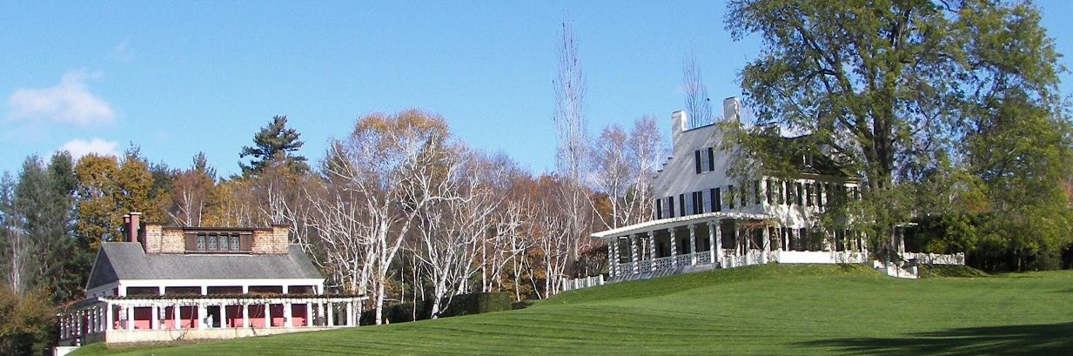
-

Saint-Gaudens National Historical Park (photos courtesy www.nps.gov)
Saint-Gaudens was the central figure of the Cornish Colony which attracted over 100 other artists, including Maxfield Parrish. When he wasn’t influencing American sculpture, he dabbled in landscape architecture at Aspet. Local pines were planted as hedges to create a series of rooms around the house. A bowling green, a formal ellipse, a cutting garden, and a rectangular perennial garden all surround the house. Old photographs show that Saint-Gaudens completely planted this area with numerous flowering plants. In the 1940s, garden designer Ellen Biddell Shipman was hired to recreate a sorely neglected garden here and developed perennial borders separated by a well-proportioned lawn and decorated with a few of the artist’s burnished putti. One area contains a water lily garden, fed by bronze turtles that spit out a steady stream of water. An engaging birch walk runs along the edge of the bowling green and several nature trails.
Once covered by glaciers and glacial meltwaters, the landscape of this property is home to upland forests, wetlands, open fields, brooks and ponds. This has become an important resource to study, manage and protect over 200 species of birds, mammals, reptiles, amphibians and fish. In addition, there are over 400 vascular plant species with seventeen known invasive plants. The most important component of a healthy, stable forest is regeneration. Such research involves monitoring each invasive for spread and controlling, based on its invasiveness, removal techniques and damage
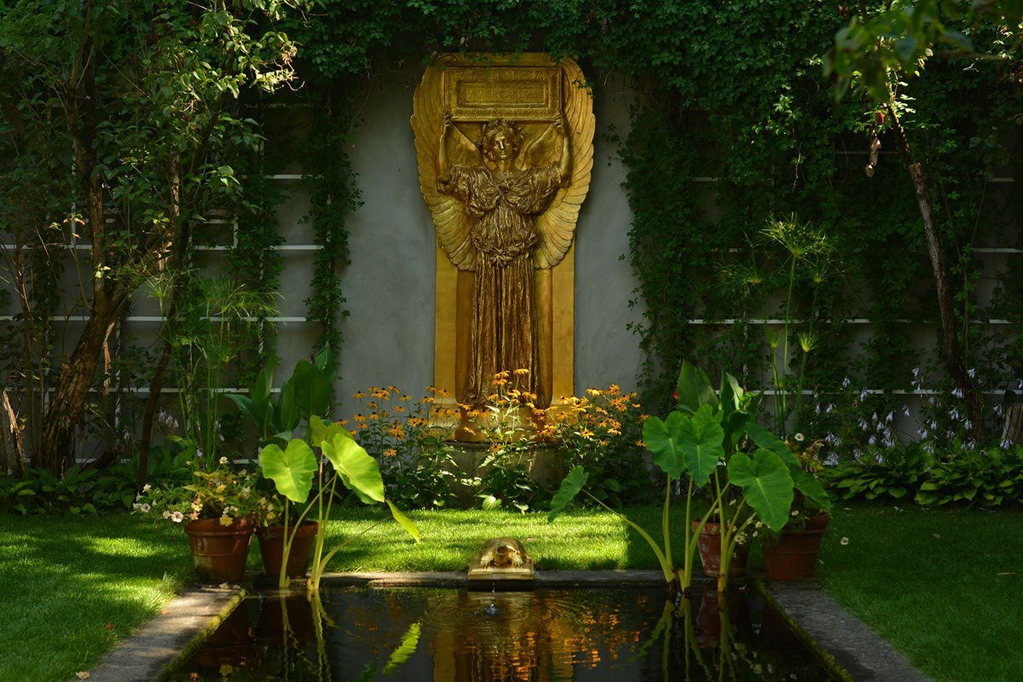
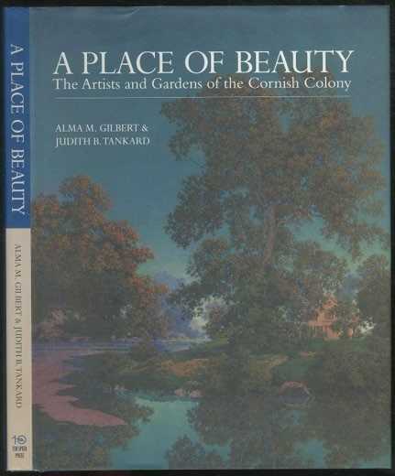
caused by these species. The Northeast Temperate Network has been monitoring the landscape here for many years and research indicates that the forests are relatively healthy and largely composed of native species. The dominance of hemlock is concerning, since the recent detection of hemlock woolly adelgid. Another finding is that deer impacts are unsustainable throughout the park, and a management program through culling and strategic fencing will be required to permit the forest to sustain itself.
Attractive at any time of the year, leaf-peepers would do well to include this on an autumn foray, when fall foliage of the surrounding mountains is spectacular.

Further reading: A Place of Beauty: The Artists and
Gardens of the Cornish Art Colony, Alma G. Gilbert &
Judith B. Tankard, Ten Speed Press, published June 1,
2000

Sandi Tinyk,
NEGC Historic & Public Gardens Chairperson

Maine to Host Next Year’s NEGC Annual Meeting

While several Garden Club Federation of Maine (GCFM) members will be making the trip to Killington, VT, to attend this year’s NEGC Annual Meeting, we’re also in the preliminary stages of planning next year’s event in Maine. Suzanne Bushnell, former NEGC Region Director (2019-2021) and GCFM President (2015-2017) and Karen Rea, also a former GCFM President (2023-2025) will co-chair the event.
We have lined up a beautiful seaside retreat -- the Sebasco Harbor Resort & Golf
Club (www.sebasco.com) which sits along the northernmost tip of Casco Bay in Phippsburg, Maine. The venue is “quintessential Maine” as it’s known as a full-service resort which has catered to families for decades. Amenities include their scenic golf course, tennis and pickleball courts, a heated outdoor saltwater pool, a lake where you can kayak and canoe, bicycles they loan out for you to explore the campus and a bowling alley. They also have an on-site waterside restaurant and pub.
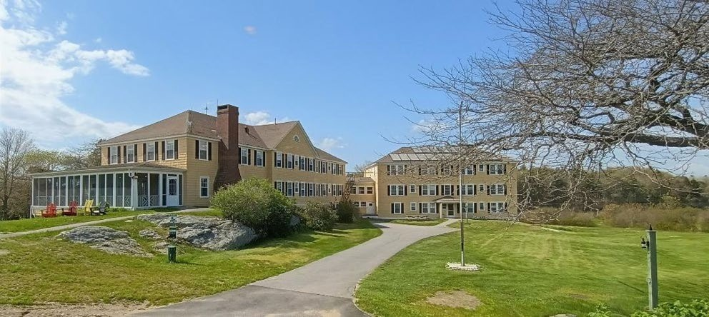
Photo by Suzanne Bushnell
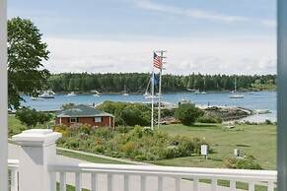
The resort is close to the quaint city of Bath which hosts one of the leading maritime history museums in the US, the Maine Maritime Museum and numerous shops and restaurants. The resort is also less than an hour from Coastal Maine Botanical Gardens which was recently voted one of the top 10 botanical gardens in the country. Another city that’s only 30 minutes away, and on the route to Phippsburg, is Brunswick which Travel & Leisure Magazine recently named #4 in its list of towns with the most walkable “Main Streets” (behind Nantucket, Carmel-by-the-Sea, and Charleston, SC). As you can tell, there’s LOTS to see and do if you come to next year’s NEGC meeting in Maine! More details will appear in future Northern Exposure issues about the 2027 meeting. But be sure to put October 4th and 5th on your 2027 calendar! To take advantage of everything you might want to see and do along the coast of Maine, the Resort will be offering attendees the opportunity to stay an extra day at the same conference room rate which will start at $169 for a standard king room in the Main Lodge (pre-tax rate).
Photo courtesy Sebasco Harbor Resort & Golf Club

Suzanne Bushnell
NEGC 2027 Annual Meeting Co-Chairman



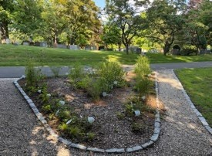
I hope you are all enjoying a wonderful summer with family and friends, and that your gardens are flourishing – filled with vibrant blooms and alive with butterflies, hummingbirds, and bees!
My President’s theme, BEE RESILIENT ~ Garden for Nature! encourages clubs to enhance the beauty of their community and preserve nature in a changing climate by creating small native gardens in a public location with advance funding from The Federation. I am thrilled to say that twenty-nine clubs are having a great time planning, installing and caring for their BEE RESILIENT gardens. Details and how to apply for project grants is available HERE: https://ctgardenclubs.org/projects/presidents/.

We recently hosted an informative and engaging Federation Fridays
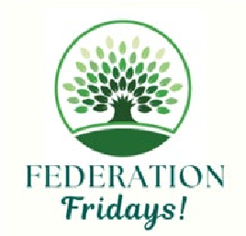
(our monthly 90-minute Zoom workshops presented by FGCCT Board Members, offering attendees a “deep dive” into timely and meaningful topics) on “Parliamentary Procedure – How it Works & Why it Matters.”
Our Parliamentarian provided valuable guidance to help clubs conduct
meetings more effectively and efficiently. A PDF of the PowerPoint that she used is available here: https://ctgardenclubs.org/club-corner/federation-fridays/.
Club Officers Day! – a Zoom workshop, will take place on Wednesday, September 9th. Board Members will present information on a variety of topics: finances, insurance, applying for awards, social media, promotion, fundraising, youth and senior gardening, schools, resources from The Federation and NGC, and more. This is a good opportunity for our new and existing club officers to receive valuable information and to ask questions. You are most welcome to attend. Registration here: https://ctgardenclubs.org/events/presidents-day/.
We have two NGC Schools planned for the Fall which are open to you all. Details and Registration is available here: https://ctgardenclubs.org/education/schools/.
Environmental School (Course 1) – September 17-18, 2026: via Zoom
Gardening School (Course 3) – September 21-22, 2026: via Zoom
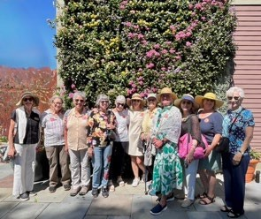
Our popular Regional Roundtables have continued in 2026. The next event will be hosted by the Wallingford Garden Club on October 7th. Moderated by FGCCT Board Members, these in-person gatherings bring together Club Officers and Committee Chairs from neighboring towns to exchange ideas, share experiences and explore topics of mutual interest. Our Tri-Council (Gardening, Landscape and Environmental) plans very interesting trips to local gardens and sites. This summer they toured the spectacular residential gardens at Stonington Garden Club’s “Gardens by the Sea.” Next was a bus trip to
Massachusetts to see “Garden in the Woods” (Native
Plant Trust) in Framingham and “New England Botanical
Garden” in Boylston. Their next event will be the Roaring Brook Nature Center in Canton, CT, combined with another location nearby. More trips are planned for the fall.
The 116th Plant Science Day on August 5th at beautiful Lockwood Farm in
Hamden is a very popular destination for gardeners. Sponsored by the Connecticut
Agricultural Experiment Station (CAES), the day features presentations by experts on CAES research, technical demonstrations, plant disease diagnosis, plant and insect identification, barn displays, questions answered, and more. The Federation has an information/membership table. More details here: https://portal.ct.gov/caes/plantscience-day/2026/plant-science-day-2026.
The FGCCT Board Meeting. held in July at the amazing Hill-Stead Museum, a National Historic Landmark, in Farmington. Set within 152 acres of breathtaking gardens and landscape, the museum has an extraordinary collection of Impressionist and decorative art, meticulously displayed within its original (circa 1946) interiors. Twenty-nine Committee Chairs discussed their current and future plans and then enjoyed guided tours of this 1901 Colonial Revival mansion.
We will gather at the lovely Aqua Turf Club in Plantsville on October 21st for The Federation’s 97th Annual Awards Meeting and Luncheon. This is always an inspirational and pleasurable event, where over eighty Connecticut, New England Garden Clubs and National Garden Clubs top awards, and over one hundred Certificates of Achievement, are presented to CT Clubs and individual members for the exceptional work accomplished over the past year.
Planning is well underway for the 46th Annual Connecticut Flower and Garden Show, which will take place at the CT Convention Center in Hartford, February 18 – 21, 2027. This event features 150,000 square feet of expansive live gardens, nonstop seminars and hundreds of vendors. The Federation will present a 12,500 square-foot NGC Standard Flower Show, themed: “ART BLOOMS IN CONNECTICUT” ~ Where Creativity, Nature and Artistry Flourish,” It will feature stunning floral designs inspired by fine art, unique Horticultural specimens, remarkable Botanical Arts & Crafts, extraordinary Photography and interesting Educational Exhibits. A draft Flower Show Schedule will be available soon, here: https://ctgardenclubs.org/.
The Federation sponsors remarkable custom crafted tours. The remaining tours in
2026 include: Boothbay and Portland, Maine; Morocco; and Boston in December for the
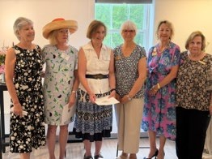
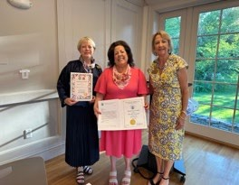
Boston Pops. In 2027 tours are planned to South India’s Karnataka, Morocco, Portugal, The Chelsea Flower Show, Scandinavia, Italy, Smoky Mountains/Blue Ridge and the Rose Bowl in Pasadena, California. Details on these tours and Registration information, here: https://ctgardenclubs.org/events-overview/tours/. Our 111 Clubs range in size from 8 members to 154 members and each does marvelous things for their communities. This year we presented fifteen
NGC Certificates of Merit and FGCCT Presidential
Citations, honoring clubs celebrating anniversaries. There were nine clubs celebrating 100 or more years, and six clubs – 50 to 95 years!
Lastly, we all use clip art, photos and drawings that we find with Google and other search engines, to “dress-up” our social media, websites and presentations. Please be careful! I urge you to read the following article in this newsletter about the risk of possible Copyright Infringement with the casual use of online images.

Very best regards
Nan Merolla
President, The Federated Garden Clubs of CT, Inc.
nan.merolla@ctgardenclubs.org
FGCCT Website: https://ctgardenclubs.org/
Photos by Wayne Gura, Wilton Garden Club; Susan Laursen, Wallingford Garden
Club; Nan Merolla, FGCCT President

Another Risk to Manage - Copyright Infringement

Read this if you use clip art, pictures or drawings from the internet in your social media or club website postings!
A web search for an image of a garden or for pictures of garden equipment is likely to yield a list of websites with lots of images to choose from and easily copy to your social media page or website. Do you check to make sure that they’re really free and not subject to copyright? You should!
There are law firms who now make a business of using automated searches of the web looking for copyrighted images where the user doesn’t have a license and then sending the organization who posted the picture a demand letter, asking for money and threatening legal action.
To avoid getting one of those letters, follow simple steps:
Use images and drawings you or a club member prepared from scratch or pictures a club member took.
Read the fine print! Sometimes, the website says it grants a license to you, the user, if you provide attribution, perhaps a link to the website for the picture(s) you use. So, do that either on each page where there is an image, or on an acknowledgement page.
Here are some resources if you’d like to learn more; the second one, a law firm, is more technical:
https://www.copyright.gov/help/faq/faq-fairuse.html
https://allendyer.com/tips-for-avoiding-copyright-infringement/

John Davis, FGCCT Treasurer
Nan Merolla, FGCCT President

Summer Greetings From Garden Club Federation of Massachusetts

Our Federation clubs are enjoying a hiatus from the frantic pace of the springtime. Over half of our clubs had plant sales scheduled, garden tours and celebratory events during the past few months. While for the most part not actively meeting, the clubs’ leadership is immersed in preparations for the new “season” of garden club activity. GCFM will be celebrating its Centennial year in 2027. A dedicated committee is actively researching a host of celebratory events for all GCFM members to enjoy over the course of the year. Our initial celebration will commence on June 10, 2027, with an

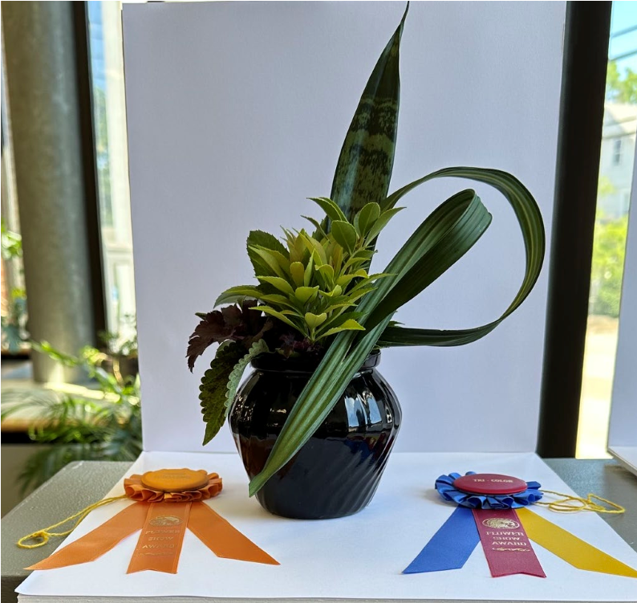
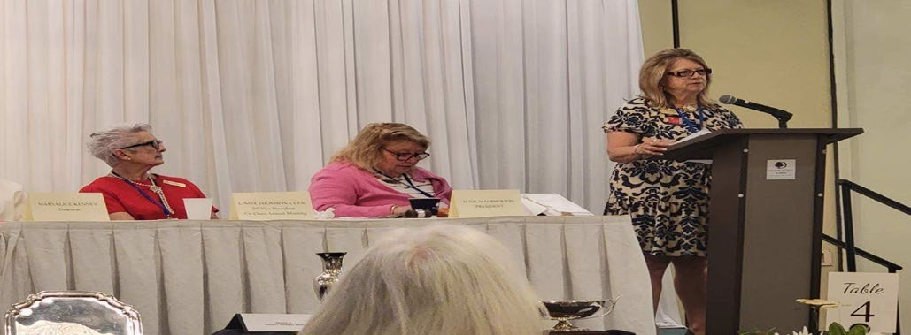
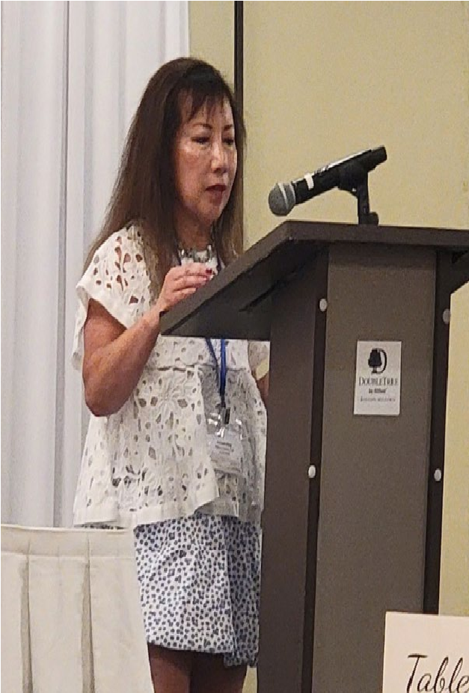
afternoon of workshops followed by a cocktail party and dinner at the newly opened Renaissance Hotel in Framingham. Our Annual Meeting will follow the day after at the same location.
Beate Bolen, Springfield Garden
Club
Blue Ribbon, Tri-Color Award
Design of Excellence, “Shady
Woods” Category
A Tiny Nation Blooms

Linda Thomson
-
Clem, Susie MacPherson

and NGC President Donna Donnelly

Juju Lem
-
Pang gives a
presentation for Sudbury
Garden Club at GCFM’s
99
^{th}
Annual Meeting
In June, GCFM held our Annual Meeting in Milford. We were honored to host Donna Donnelly as our special guest. Donna initiated our day-long event with a warm and inspiring presentation that focused on the historical perspective of NGC and noted that GCFM’s first president, Mrs. Margaret Motley, was nominated as NGC’s first president at its inception. Special highlights of the meeting were morning presentations by thirteen garden clubs each briefly detailing a community-focused club project for which they had received state and national awards. It was a wonderful opportunity to share creative and inspiring endeavors with the audience. In June, GCFM began its Flower Show season with an
impressive schedule. The Judges’ Council sponsored a petite show, “A
Tiny Nation Blooms.” In July, the Southeastern District presented the outstanding NGC Standard Flower Show, “Oceans Around Us,” at the Heritage Museum in Sandwich.
Upcoming shows include the
Marshfield Fair in August, the
Framingham Garden Club in
September and the Topsfield Fair and Tower
Hill shows, which will be open to the public in October. We are delighted by the growing interest in and commitment to these exhibitions.
The fall will be a busy one as all nine of our Districts have already scheduled District meetings for the club presidents, treasurers and interested club members around the state. Board members are enjoying a bit of respite prior to reconnecting with our statewide clubs. It is going to be an exciting and fast paced season ahead of us!

Regards to all,
Susie MacPherson
President, Garden Federation of Massachuset

New England Regional Hydrography Collaboration
offered by MassGIS (Bureau of Geographic Information)

A regional effort among the New England states to update surface water data across the region.

Overview MassGIS has been working with all the other New England states to update our surface water data across the region. There are a number of New England regional hydrologic units (HUCs) that cross state boundaries, as well as many more watersheds that exist wholly within each state. This initiative will advance the development of elevation-derived hydrography across all watersheds in Connecticut, Massachusetts, Maine, New Hampshire, New York, Rhode Island, and Vermont.
This collaborative work reflects a sustained regional effort. In June 2024, Connecticut, Rhode Island, Massachusetts, Vermont and Maine worked together to submit a joint Data Collaboration Announcement (DCA) application under the USGS 3DHP program, aiming to map cross-border hydrologic units. While that initial proposal generated enthusiasm, it was not funded due to budget and timing constraints. In 2025, the collaboration expanded to include watersheds that cross our state boundary with New York and New Hampshire. Together, this group submitted a new grant application, which was approved for the FFY26 budget cycle. Paperwork to make that award and initiate the cross-border work is now underway. Recognizing that watersheds often cross political boundaries, this project emphasizes the importance of interstate collaboration and the value of high-quality hydrographic data, with a focus on developing data in watersheds that span multiple states. The group’s motto is: political boundaries are immaterial to the flow of water. This regional work enhances and extends the work MassGIS and the
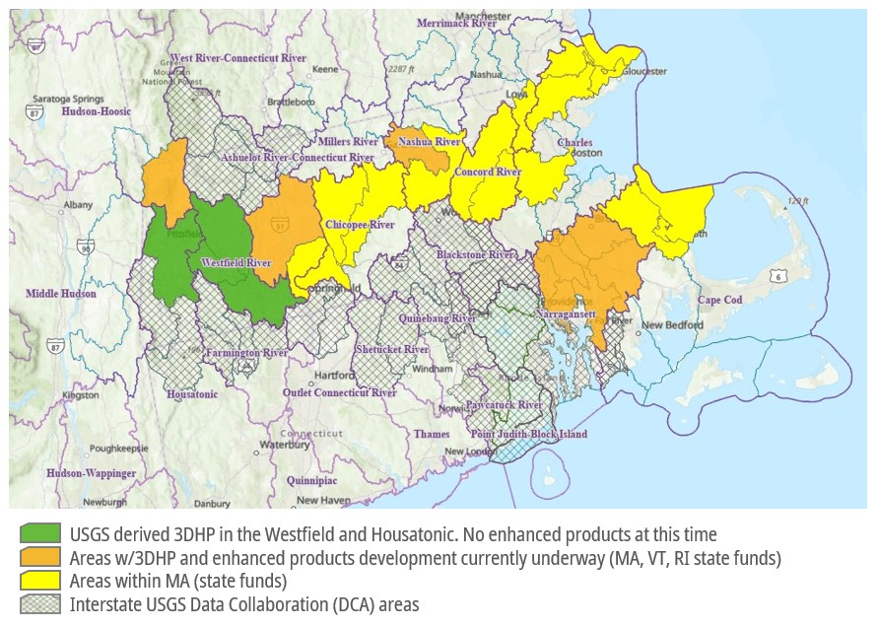
Massachusetts Hydrography Framework Implementation Committee are doing to improve hydrography data across the Commonwealth.
The 3DHP is a national initiative to modernize surface water mapping by creating high-resolution, elevation-derived hydrography that integrates seamlessly with lidarderived elevation data as part of the 3DNational Topography Model. The grant approval enables us to move into coordinated planning and stakeholder engagement to support the development of improved hydrography data. Work on the New England regional effort will begin soon, and we look forward to continuing this process with USGS, our partner states, and the selected vendors.
As a significant part of this collaborative work, all the states are working to develop additional enhancements, with the 3DHP data as the foundation. Those enhancements include local stormwater infrastructure data, wetlands data, and delineation of the top of the bank for all streams and rivers. This additional data will enable us to model the full hydrographic lifecycle. Among the many uses of that modeling, it:
- enables use of the data to predict and mitigate flooding and other economic risks;
- improve water flow modeling as part of planning for and designing stormwater infrastructure by contractors working for cities and towns across the Commonwealth; and,

- protects public water supplies Date published:
March 24, 2026 Mass.gov

NEGC Calendar
Deadline for the November issue of Northern Exposure is October 25
– that issue will cover the months ofNovember, December and
January - please e-mail articles. photos or questions to editor Nancy
Atwell at atwelln@aol.com

National Garden Club
September 17 – Fall Board Meeting, St. Louis, MO.

New England Garden Clubs

October 13 and 14 - New England Garden Clubs’ Annual Meeting FGCV is hosting the NEGC Fall Meeting at Killington Ski Resort, 228 East Mountain Rd, Killington, VT 05751. Phone: 802-404-4622.

October 4 and 5, 2027 - New England Garden Clubs’ Annual Meeting, Garden Club Federation of Maine hosting at Sebasco Harbor Resort & Golf Club, Phippsburg, Maine.

Environmental Schools
September 17 – 18 – Course 1, Derby, CT via Zoom.

Gardening Schools

September 21 – 22 – Course 3, New Haven, CT via Zoom.

Landscape Design School

October 28 – 30 – Course 1, Waltham, MA (Virtual).

State Conventions and Meetings

October 21 – FGCCT Annual Awards Meeting and Luncheon

October 23 - NHFGC Fall Gathering at Gardens at Uncanoonac
Mountain, Goffstown, NH

October 21 – Garden Club Federation of Maine Fall Conference
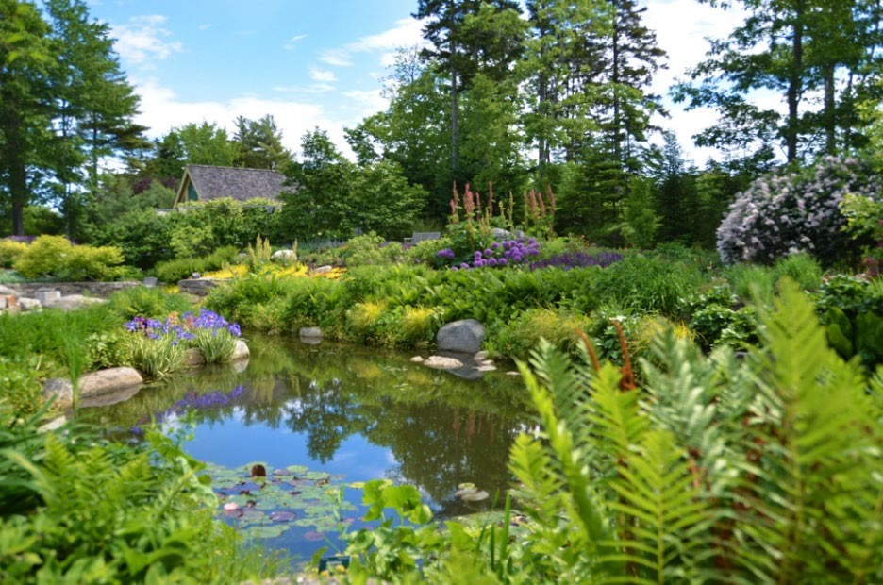
Photo courtesy Coastal Maine Botanical Gardens

