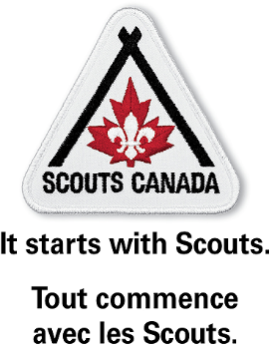

Message to Council Scouters to be distributed by CK3

As many of you may be aware, Scouts Canada has been working to make it easier to access consistent top quality first aid training. In order to do this, we have entered into a partnership with St. John Ambulance (SJA) for first aid training across the country. In short, Scouts Canada now has the ability to deliver SJA First Aid training internally using our own pool of instructors. The agreement also means that we will integrate the online portion of the current SJA Standard First Aid course developed for the pandemic into the David Huestis Learning Centre for use in regions in Scouting Stages 2-4.

We are also able to access existing Standard First Aid courses through St John Ambulance at a reduced fee. When registering for a public course, Scouting members may call to register and ask for the Scouts Canada rate.

This partnership is simply a new option – Scouters who are already delivering courses for another organization are welcome to continue working with that organization. Scouters and youth are still welcome to take courses through other organizations. The SJA training will exist to ensure that a quality, affordable option is available to our members.

We are looking for Scouters for are certified first aid instructors to join our team. The certifications can be for any type of first aid training and from any provider recognized in your province. Instructors from other organizations can take a short “crossover” course from St John Ambulance in order to become a qualified SJA instructor.

In order to capture information to facilitate our building a First Aid Training Team in your Council we ask that you fill out the form at https://app.smartsheet.com/b/form/9ffe8cc764b444d39d09cb3a7d8ec176 by May 19, 2021.

We are also interested in hearing from any Scouters who would be willing to become a first aid instructor, keeping in mind that training would likely not happen for several months.

We will be in touch with Group Commissioners, Group Support Scouters and Scouting Relationship Mangers shortly to determine needs at the Group level so please let them know of any specific needs in your Sections.

Feel free to contact me at alex.gazaleh@scouts.ca if you have any questions.

Stay safe and stay well.

Yours in Scouting,
Alex Gazaleh (he/him)
Project Lead, St. John Ambulance Partnership
Scouts Canada | National Service Centre
alex.gazaleh@scouts.ca
C 613.290.3493

