Step-by-step guide for recreation online accounts

Learn how to create or log into an online account to view and register for recreational activities with the City of Claremont. Also learn how to reset your password or username if you have an account but have forgotten that information.

Method 1: From the City of Claremont Website
- Open your internet browser and search for “Claremont Recreation Center” in the search bar.
- Click on the link that lists: Recreation Classes | City of Claremont, CA
  - Not all search engines retrieve the same information, however you want to make sure that the link you are clinking on has “Recreation Classes” in the title and you can see Claremont, CA within the title, description, or link.
- Scroll down to the section titled "Activity Registration", should be on the right side of the page.
- Click on the link that says "Create an Account". This will take you to the registration portal.
- Continue by entering an email address.
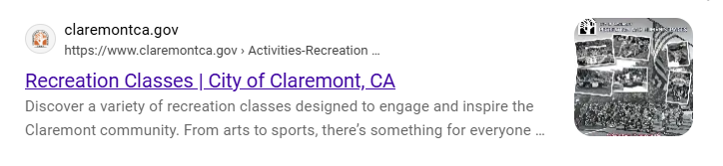

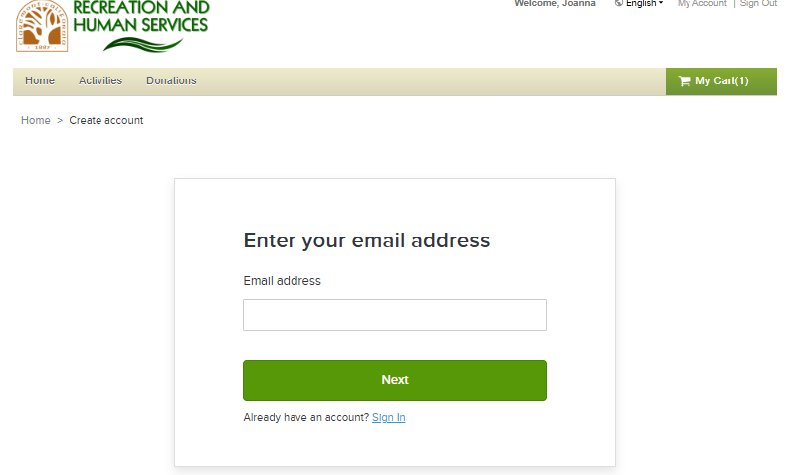
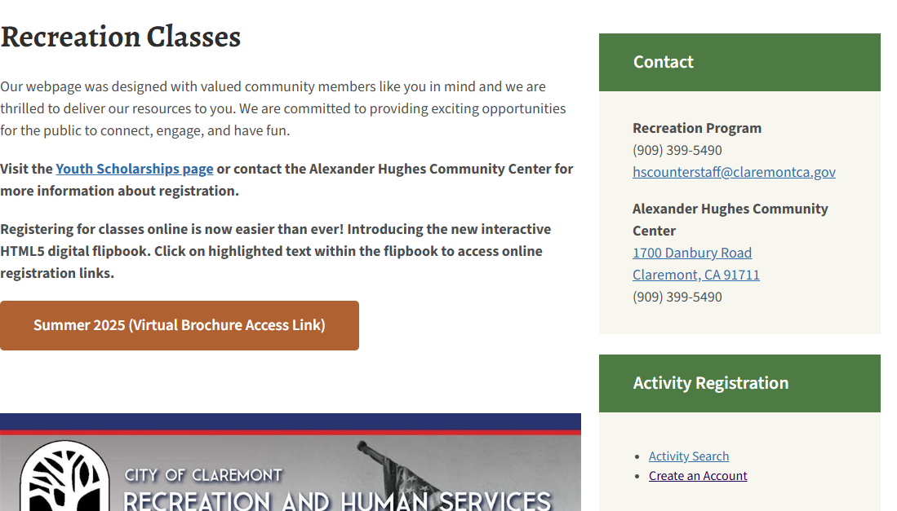

Method 2: Directly via ActiveNet
- Open your browser and go to this link:
https://anc.apm.activecommunities.com/claremontrecreation
- Once on the page, click the yellow button that says "Sign In/Up".
- On the login page, click the blue button that says "Join".
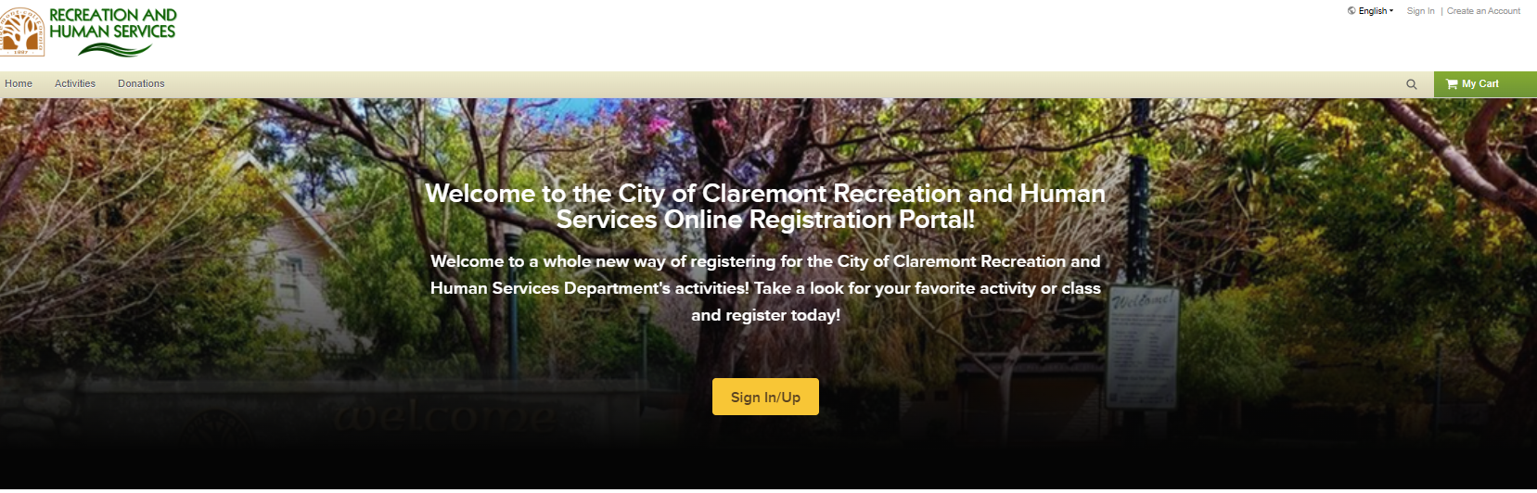
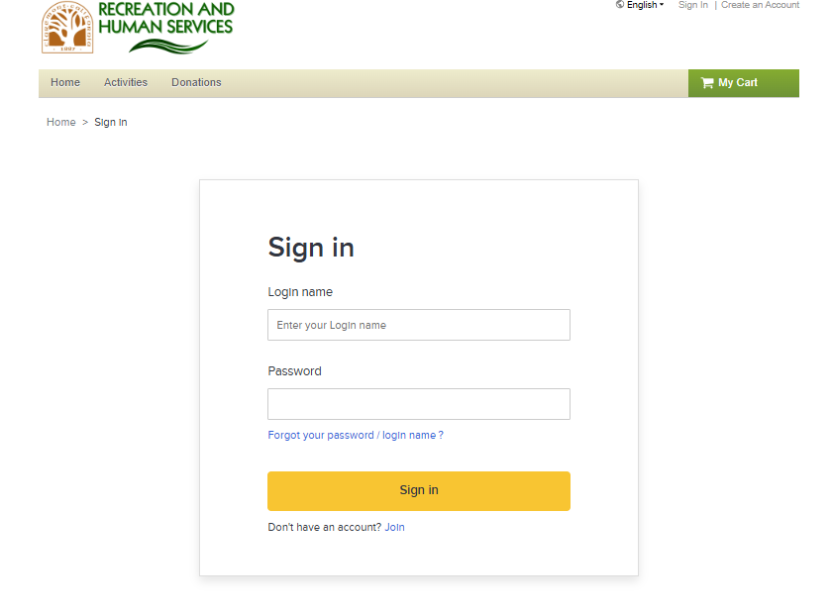
Creating an online account:
- Enter your email address and continue to fill in the required information to create your account.
  - Read and agree to the waivers by checking the boxes next to each waiver.
  - After reviewing everything, click the green "Next" button to continue.
- Complete the remaining information (personal details, contact info, etc.).
- Emergency Contact
  - Proof of Residency: If you're a Claremont resident, be prepared to show proof of residency, ID and Utility bill are most common.
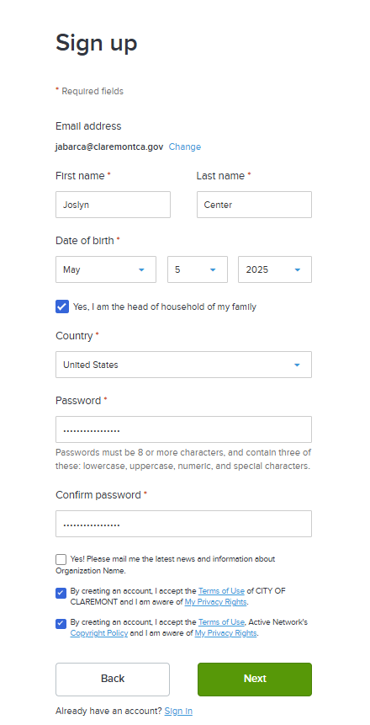
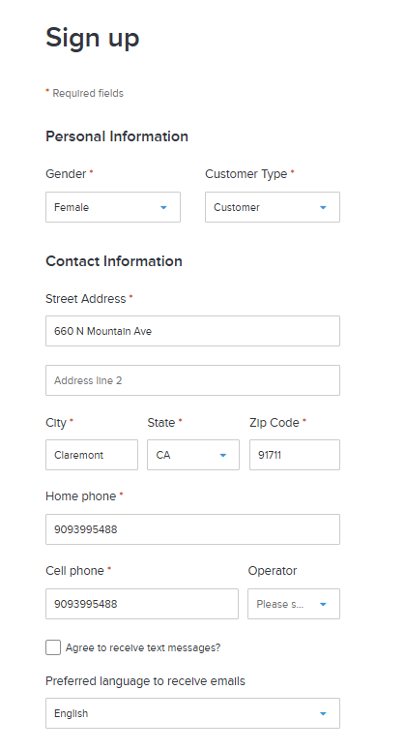
- Click the green button that says "Create Account" when all required fields are filled out.
2
1

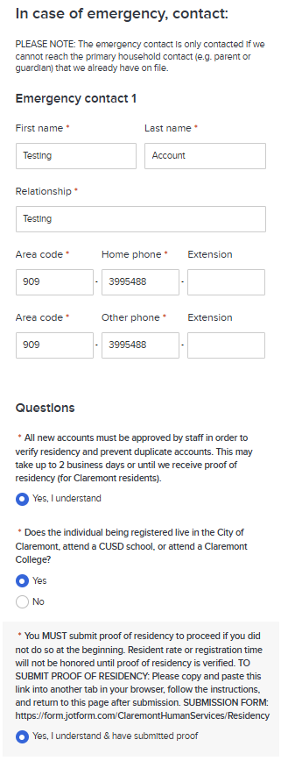
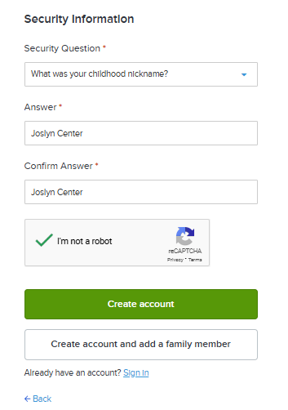
3
4

- After creating your account, it will need to be verified by city staff before you can register for classes. City staff will reach out to you to verify residency either in-person or you have the option to upload residency verification documents such as a driver’s license or utility bill.
- Verification may take a few days, but you will receive an email notification once your account is verified.

Forgot Password and Username?
If you ever forget your username and password, follow these steps below.
- On the login page, under the password box, click on the blue text
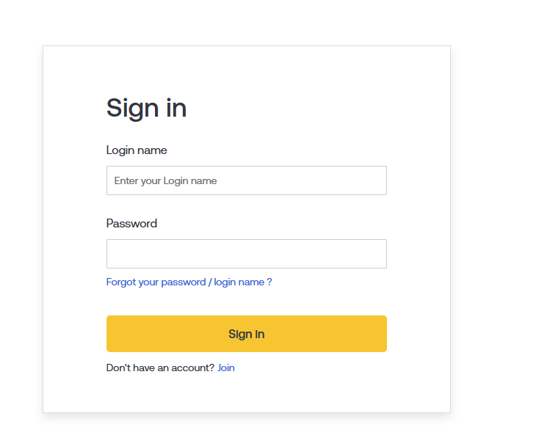
  - There are two different links that are separated by the /. Click on the word “password” to reset you password and “login name” to retrieve your login name information.
- The next page will prompt you to enter you email address that you used when you registered for your account.
  - If you forgot your password, an email will be sent with a website link to be able to reset your password.
  - If you forgot your login name, an email will be sent with your login name information.

