“Scavenger Hunt”
By Bob Newbert
USCG Master Captain, AP-IN

Step aside Sherlock Holmes.
Move over Inspector Clouseau.
Time’s up Hercule Poirot.
You’re toast Nancy Drew.
You’ve been out-bumbled Columbo.
There’s a new star in seaside sleuthing Jessica (Fletcher).

Yup! Capt. Dave Medvedeff, and crew, are the hottest detectives in Harbour Town. They are winners of the ABCHH Scavenger Hunt, an on-the-water challenge that’s part “Amazing Race,” part ABC boating test, part Trivia, part brain teaser, part “Jeopardy,” and 100% fun!

Scavenger Hunt tests your navigation skills, chart reading, problem solving, time management, familiarity with our waterways, and general knowledge of everything from literature to pop music.
Think it’s easy? Where would you go to locate these challenges of ABCHH’s Scavenger Hunt?

- I start life as a male, but eventually wise up and perfect myself as a female.
- Half of my SC relatives live in Beaufort County.
- You find my uppity, high-class cousin at the spa.
- I live at 32 North Street. Every noontime at 44 minutes past the hour I hear cathedral bells chime. It’s always 44 minutes after 12. This is strange because the cathedral is far away on 80 West Street. The 51-year old carillon is showing its age because it’s “off” by 41 minutes. Where am I?
- Object .7 mi. from N (16+16) (8+4).(620-4) and W (100-20) (60-8).641 on a heading of 57º
- Old salts know me as the place where Miss Liberty once stood.
- I’m pretty boring. Don’t do much but hang around the marina for days on end while my namesakes played in rock bands, and were favorites of Eric Clapton, Jimi Hendrix, Buddy Holly and George Harrison.
- Object 1.3 mi. from 32º 8.993’N • 80º 49.824’Won a heading of 270º
- You will find at least one of my relatives at every hoedown.
- I am an object 32º from the equator and 80º from Greenwich. To pin me down you’d need a little 8.993’ and 49.824’ for Good Luck. What am I?

Dave and his crew (Art LaPoint, Cathy LaPoint, Paula Hanni and Ben Hanni) met the challenge to outscore all rivals solving riddles and crossing the finish line with their required objects before time expired and disqualified them. They are champions. They won ABCHH’s “Super Sleuth” Award!
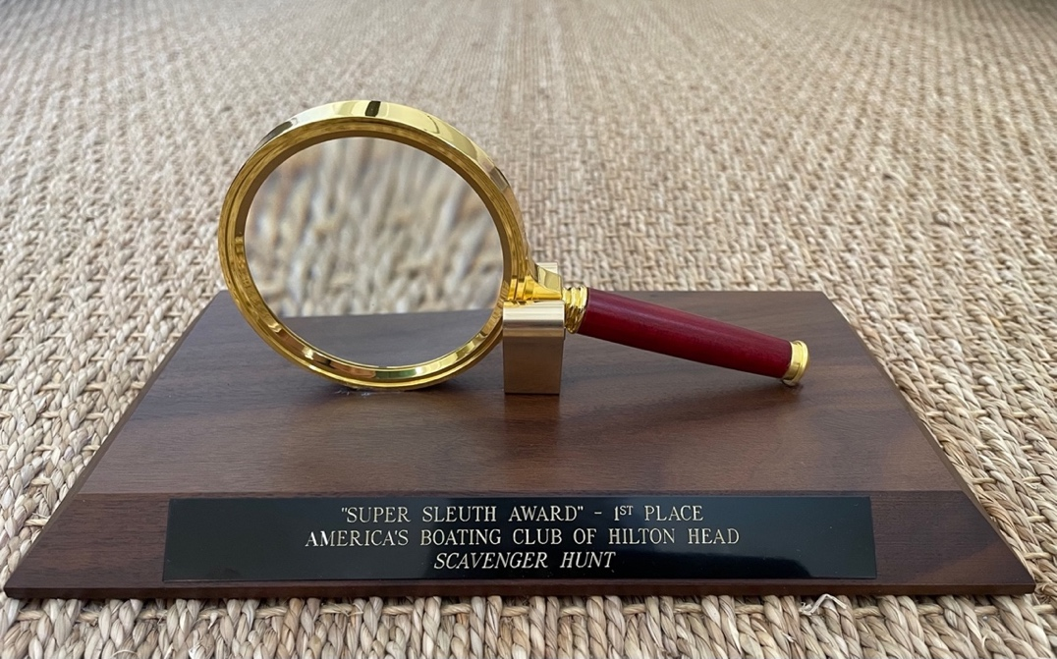
Others on the Medal Stand were:

2nd Place
Capt. Phil Burke with Brad Loescher, Frank Modrowsky and Glenn Crews

3rd Place
Capt. Kevin Prettner with Judy Prettner, Annie Lago, Frank Lago, Brian Crooke, Patti Crooke, Rick Campbell and Susan Campbell.

We had two teams that tied, and came within a whisker of the medal stand. There were 135 items to locate and these two teams tied on points so On-the-Water Scavenger Hunt League officials (OTWSHL) met to recognize their achievement with an “Honorable Mention.” Special honorees were:
- Capt. Craig Loomis with Deb Loomis and Dave McBride
- Capt. Jim Iannachino with Joe Tucker, Susan Tucker, David Winnett and Kim Winnett.

League officials also named Capt. John Westervelt winner of the previously unannounced “Displacement Division.” This is a special category for displacement hulls. John and his team (Vicki Westervelt, Mike Gilroy, Leslie Gilroy, Beth Ann Dickie, James Dickie and Linda Bange) scored in the middle of the pack aboard “Scottish Queen,” a 34 ft yacht with a displacement hull which limited their cruising speed to 7-8 knots against the tide. They could not possibly cover as much ground as boats with planing hulls, and still be present in the Harbour Town Clubhouse with their “gets” by the 12:30 deadline. They ran the race on one leg, in other words, yet still scored very high. They deserve special recognition… maybe even a book or movie. Think “Boys in The Boat.”

Lastly, the league honored Capt. John Fitzgerald with its “Visiting Team Award.” Much of Scavenger Hunt required extensive local knowledge of our waterways and landmarks. Fifty percent (50%) of John’s team were out-of-state visitors who, while strong in spirit, could not possibly distinguish Alljoy Landing from Buckingham Landing. Their strong effort merits our applause.

It’s axiomatic that competition requires score keeping. There’s first place and there’s last place.
But the reality of Scavenger Hunt is that all who participated enjoyed lively team meetings to decode the “Get” List; sensational on-the-water sleuthing; and convivial Awards Ceremony partying.

They are all winners.

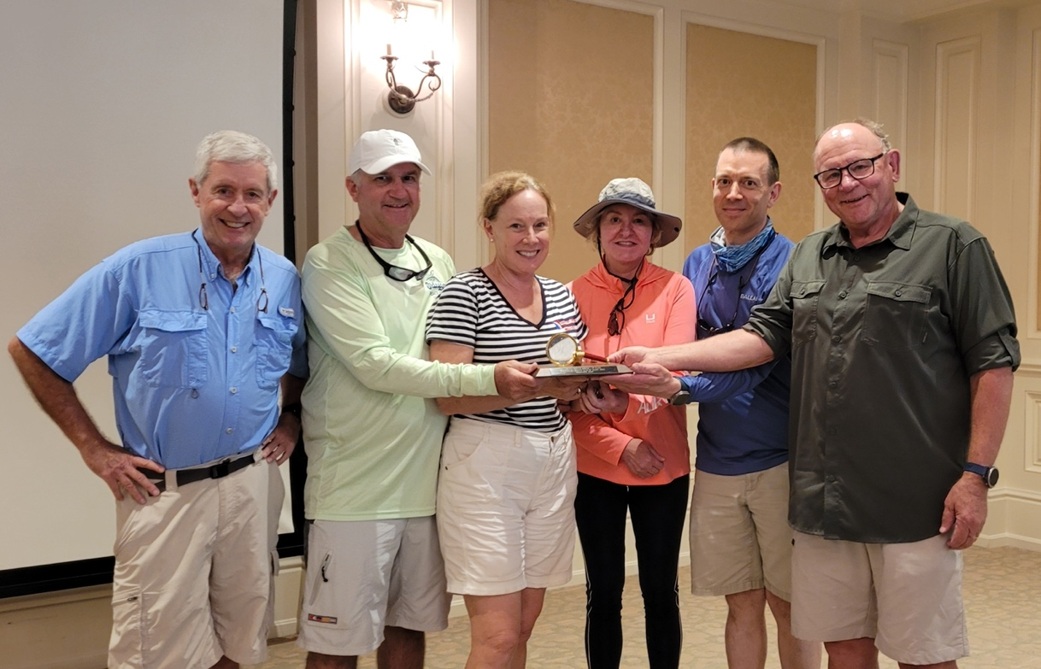
1st PLACE “SUPER SLEUTH” WINNERS join hands with their trophy as Bob Newbert (OTHSHL Commissioner) looks on (L to R): Dave Medvedeff. Cathy LaPoint, Paula Hanni, Ben Hanni and Art LaPoint.

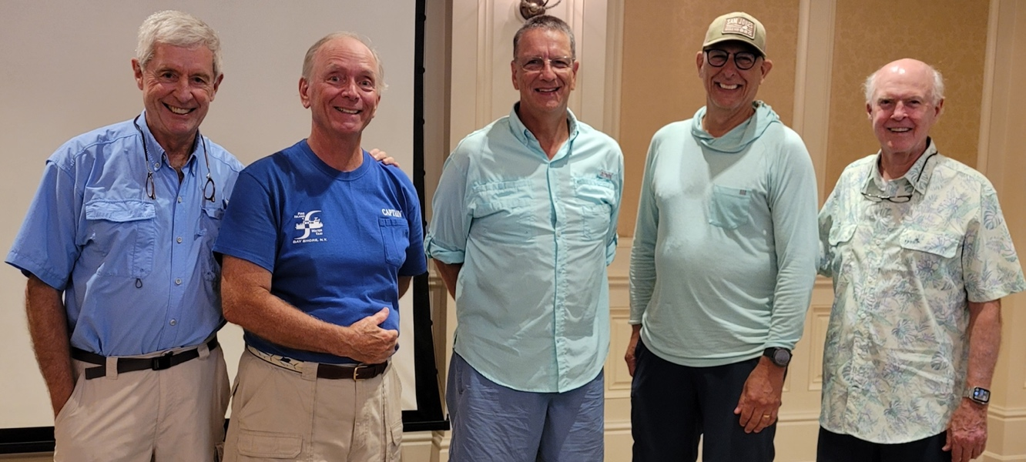
SILVER MEDALISTS with a 2ND PLACE FINISH are (L to R from Commissioner Newbert): Phil Burke, Frank Modrowsky Brad Loescher and Glenn Crews.
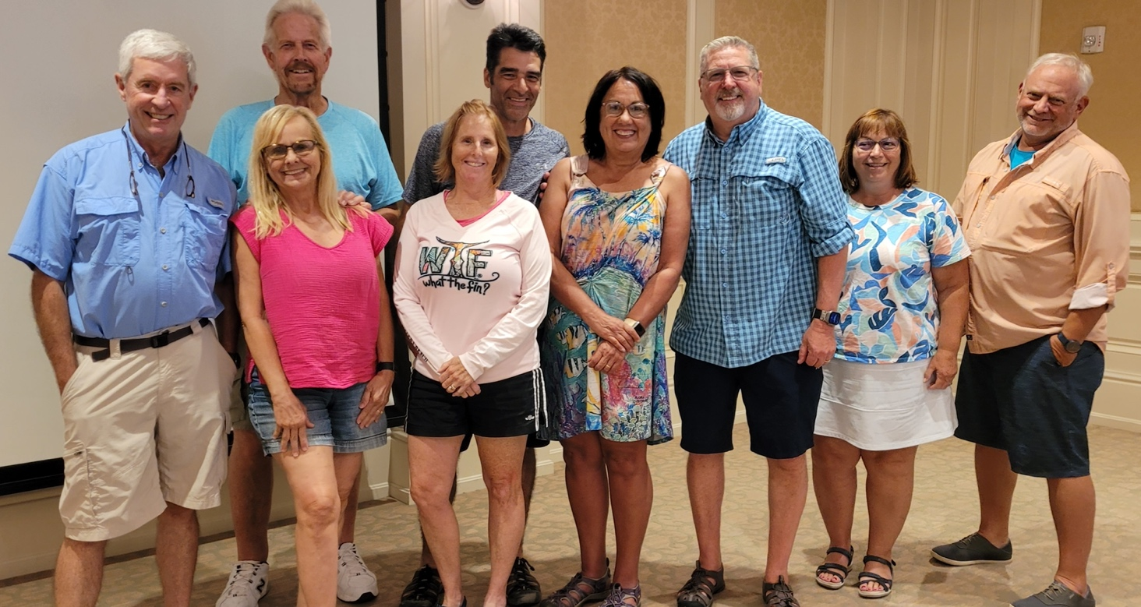
BRONZE MEDALISTS (enough of the old guy on left in the blue shirt already) are (L to R): Susan & Frank Campbell, Annie & Frank Lago, Judy & Kevin Prettner, and Patti & Brian Crooke.

The OTWSHL (On-the-Water Scavenger Hunt League) wishes to thank our competition judges for their time & talent: Paul Hoyte, Nancy Stermer, Mark Stone, Jeanne Kangas, Rebecca Jeffries, Terre Newbert and Mark Newbert.

SCENES FROM THE AFTER PARTY
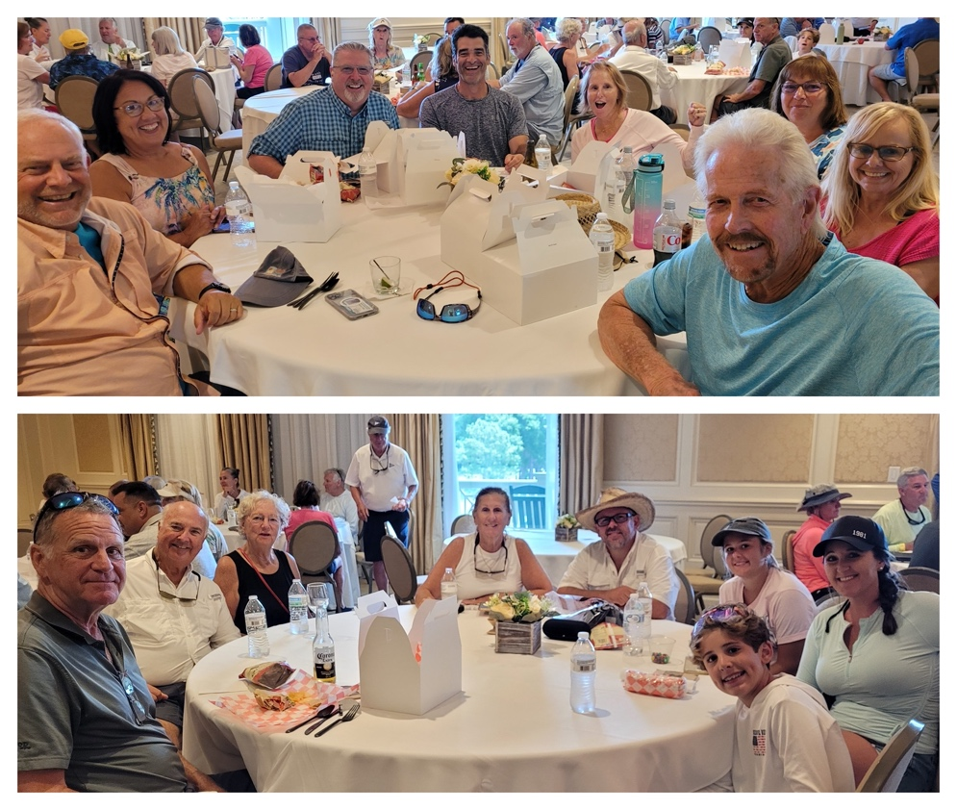
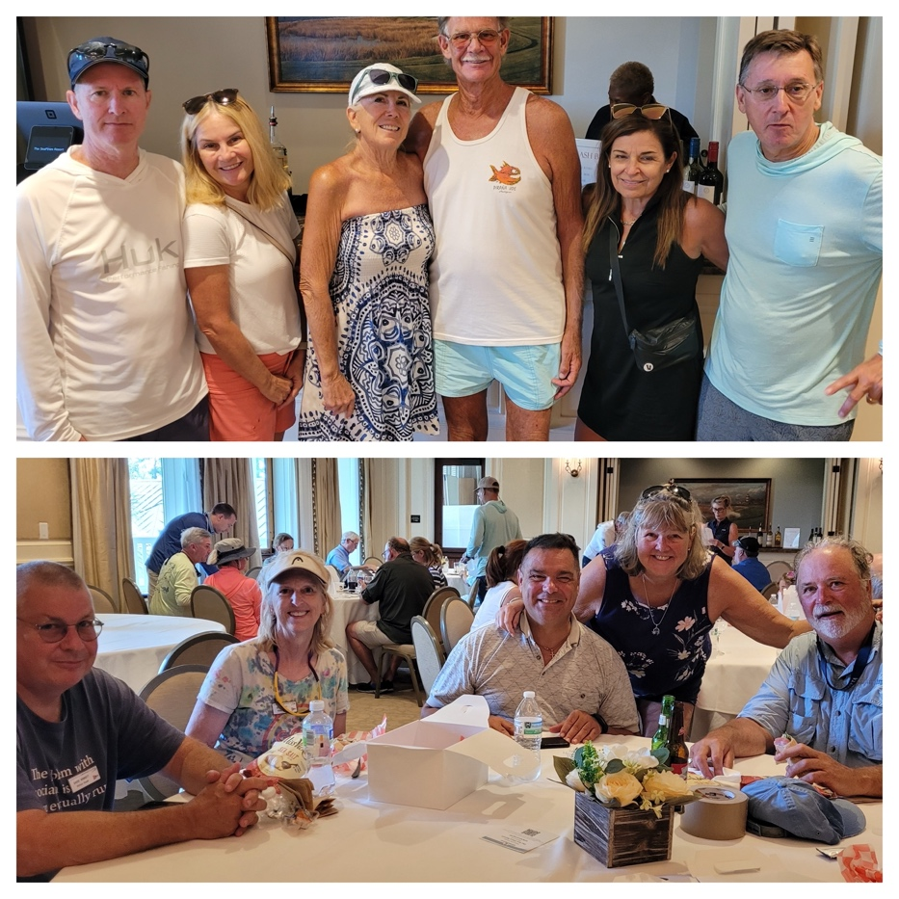

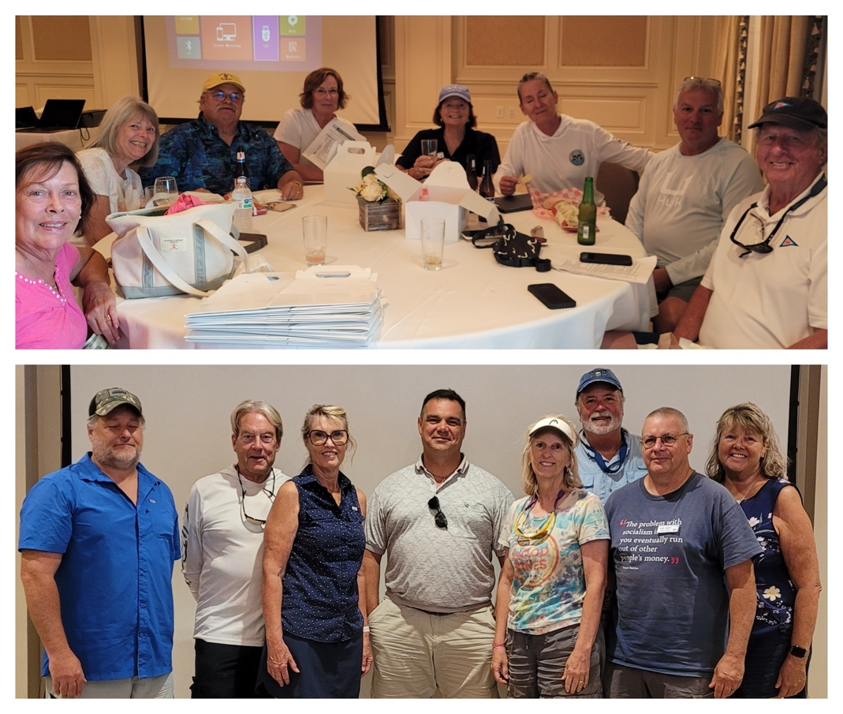

Photo credits: Nancy Stermer

