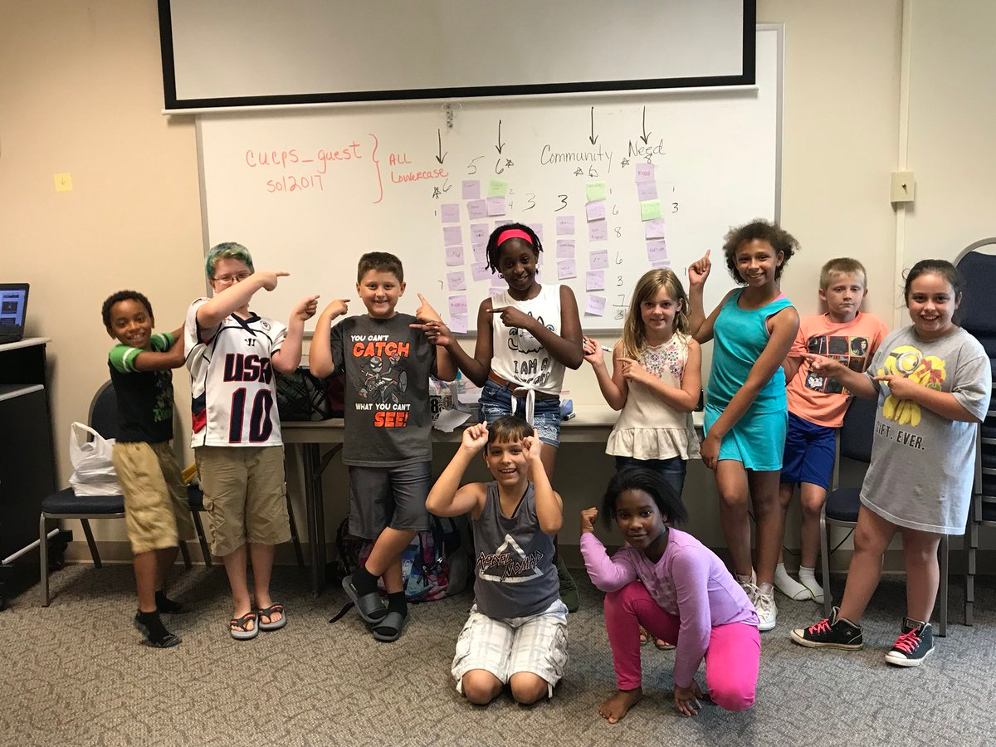
CCES kidpreneurs learned two main concepts: “Sharing ideas, that’s what WagiLabs is about” and “You get to explore things you never had before.”

In WagiLabs, curiosity and passion led students to becoming the problem solvers and entrepreneurs of their community.

Anyone interested can download the WAGiLabs Playbook to start a journey or visit https://www.wagikids.org for more information on how to bring kidpreneurs to any community.

Everyone is invited to follow Cumberland County Public School’s journey by clicking on the following links:

Cumberland County Public Schools WagiLab Camp

CuCPS WagiLabs Camp: Day 1

CuCPS WagiLabs Camp: Day 2

CuCPS WagiLabs Camp: Day 3

CuCPS WagiLabs Camp: Day 4

CuCPS WagiLabs Camp: Day 5

