The Positive Impact of Professional Learning Communities (continued)

In their book Leaders of Learning, DuFour and Marzano state, “The best strategy for improving schools and districts is developing the collective capacity of educators to function as members of a professional learning community (PLC) - a concept based on the premise that if students are to learn at high levels, processes must be in place to ensure the ongoing, job-embedded learning of the adults who serve them” (2011, p. 21). Learning opportunities in PLCs can take many forms based on the needs of the students and the school community. Leadership within these powerful groups builds a collective teacher efficacy that supports authentic student learning.

In his article, Collective Teacher Efficacy (CTE) according to John Hattie (2018), Hattie recognizes this collective belief that faculty and staff positively affect student achievement as the “new number one” influence affecting student achievement. To effectively support teachers and build collective efficacy within a school community, the Center for Comprehensive School Reform and Improvement Issue Brief details research strategies to support school leaders. In the October 2007 Brief, Building Collective Teacher Efficacy: How Leaders Inspire Teachers to Achieve, Brinson and Steiner highlighted the importance of (1) building instructional knowledge and skills, (2) creating opportunities for teachers to collaborate while sharing skills and experiences, (3) interpreting results and analyzing feedback, and (4) engaging teachers in school decision-making opportunities. Building collective teacher efficacy through small group discussions in PLC meetings is key in both boosting student achievement and infusing professional learning into the school community.

Recognizing the importance of empowering teachers, Peter DeWitt highlighted collective teacher efficacy as a driving factor for school success. Featured in Education Week’s December 2, 2018 edition, Peter DeWitt revisited critical issues faced by school leaders. He recognized the importance of teacher voice in addition to empowerment. Professional learning communities provide a framework for a conducive sharing environment where teachers have a voice and are empowered as leaders of learning.

How can school leaders provide these opportunities for their teams? One example is the collaborative efforts of the Comprehensive Instructional Program which was formed in the heart of Southwest Virginia. Organized in July 2014, this consortium of 30 school divisions across the Commonwealth provides a network of dedicated educators who spend quality time sharing, learning, creating, and working together to better serve students.

Led by Dr. Matt Hurt, the Comprehensive Instructional Program organizes teachers and school leaders into both grade level and content area teams that meet several times a year. During these professional learning community meetings, members share evidence-based strategies, lesson plans, assessments, resources, and most importantly, build relationships that span across Virginia.
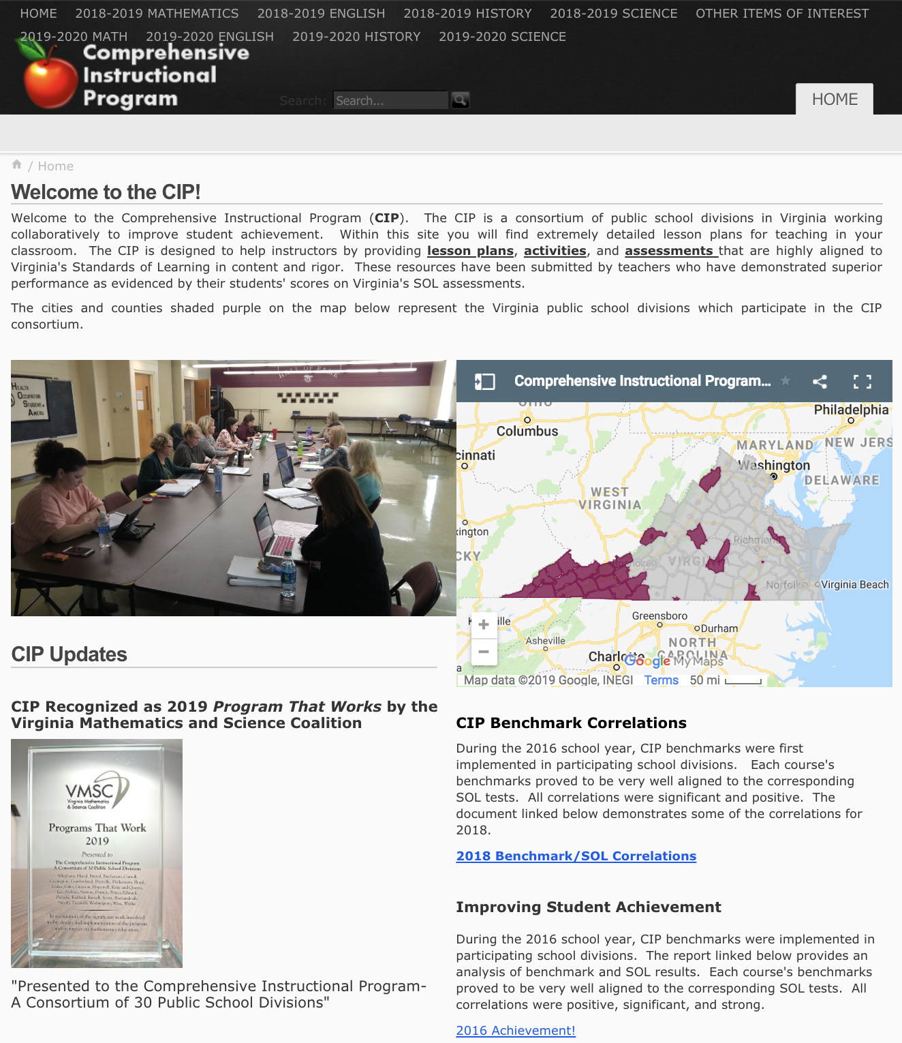
http://www.cip.education

The collective teacher efficacy created through this consortium resulted in the top academic performance of students in these classrooms. Despite factors such as poverty, minority, and disability status, CIP school divisions outperform more affluent divisions on required state assessments. Based on the 2018 SOL performance data shared at the September 12, 2018, School Leaders’ Academy, Dr. Hurt noted that Virginia’s Superintendent’s Region VII, where the CIP consortium was initially formed, had the (1) lowest beginning teacher salary, (2) second lowest per-pupil expenditure, (3) second highest enrolment of students in poverty, and (4) highest enrollment of students with disabilities. Overcoming these challenges, this CIP region was the highest performing region in the Commonwealth in Reading, Math, and Science. Region VII ranked second highest in History and third highest in Writing. In addition, CIP was recently recognized as the 2019 Program That Works by the Virginia Mathematics and Science Coalition.

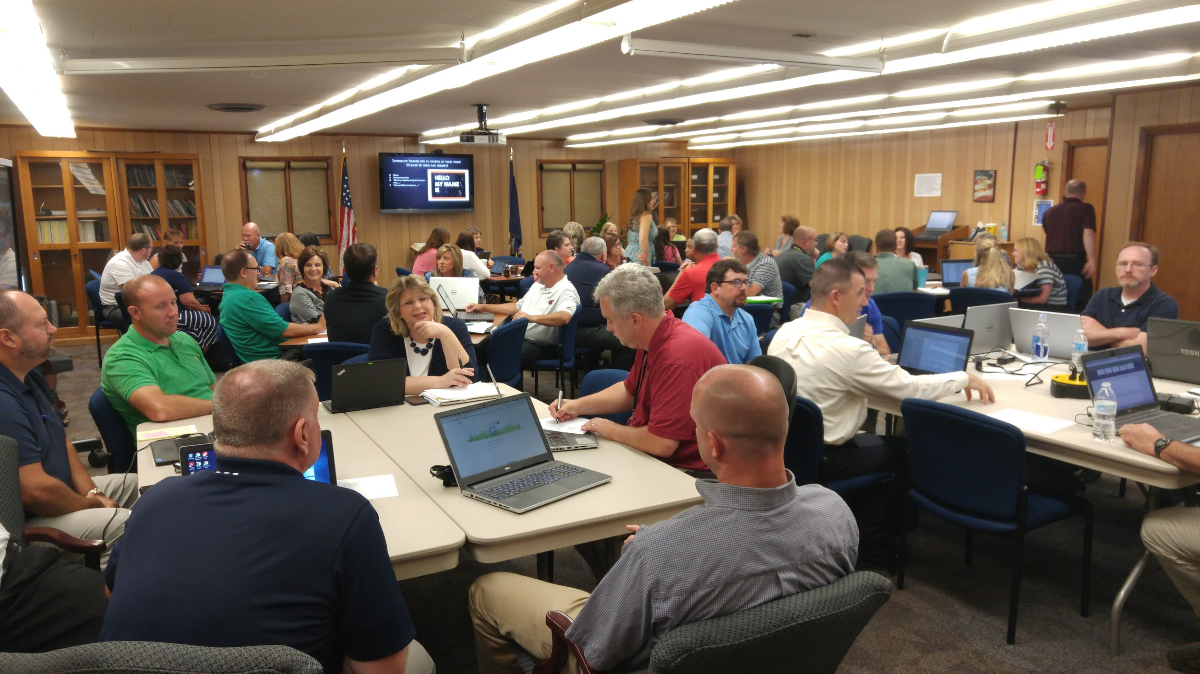

How was this possible? Relationships. Relationships. Relationships. Key factors in this success included intentionally blocking time in busy schedules for team meetings, preparing resources and data to share with their groups, collaborating on innovative teaching strategies, and engaging in ongoing conversations about how to move student learning experiences to the next level. In The Power of Collective Efficacy, Donohoo, Hattie, and Eells (2018) stated, “When teams of educators believe they have the ability to make a difference, exciting things can happen in a school [division].”

Dr. Cyndi Williams, Assistant Professor
Educational Leadership
Radford University

