Your St. Thomas 2024 Vestry Nominees

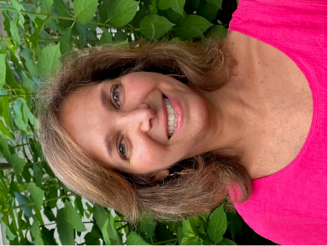
Tracy Ganem (Roberts) For 27 years St. Thomas has been my church home, and I appreciate and love this community. St. Thomas has always welcomed me, and my children, Ryann, Tess, and Jack. I enjoyed seeing my kids’ involvement in the church; they served as acolytes, were involved in youth groups, and my daughter, Tess, earned the moniker of “The Pie Girl” by selling pies to raise money for charities including Episcopal Relief and Development. Tess and Jack are involved with Special Sessions even now as adults.

I’ve had the pleasure of being co-chairman of VBS, a committee chair with Lobsterfest, a member of the World Mission team in Honduras, a manager for our Bailey Cove Farmers’ Market, a volunteer at First Stop, and part of many breakfast and dinner teams. These endeavors allowed me to represent St. Thomas and extend our hospitality, compassion, and goodwill to members of the church, our community, and in another country. From these events, I learned how much I love this church; how proud I am of this church; and how I can share this with others. I would be honored to serve on the Vestry.

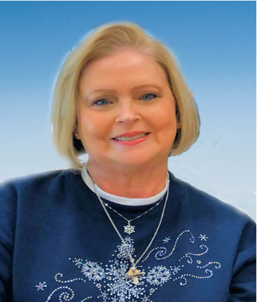
Cynthia Geis and her husband Gregg are active parishioners at St. Thomas, where Cynthia is Chairman of the Finance Committee. A 2019 Education for Ministry graduate, she is a member of the Daughters of the King and served as a delegate to the 2019 and 2022 Diocesan Conventions. She has participated in Invite, Welcome, Connect; Lobsterfest (2019-2022 Bake Sale-Co Chair); Fellowship Committee and facilitated a 2019 Lenten Program. She served as a weekly office volunteer from October 2018 through December 2022. From 2020-2022, Cynthia was a member of the St. Thomas Vestry that successfully guided the parish during the Covid-19 pandemic, the resignation of the rector, and the calling of a new rector. Cynthia retired as a senior program manager from a DoD agency in Fall 2018 and – when she’s not at St. Thomas – is an active community volunteer.

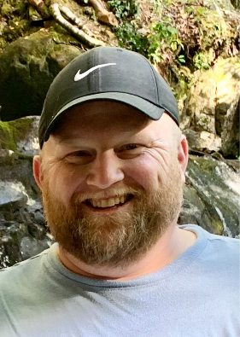
Mark R. Mohler I am honored to be nominated for Vestry here at St. Thomas Episcopal Church. My wife (Suzanne) and I have been married since 2011 and we have 3 children - Harper (9), Grant (7), and Brady (1). My family started attending St. Thomas when we moved back to Huntsville from Tuscaloosa in 2014. On that first Sunday; we were warmly welcomed by you all, the longtime members of St. Thomas, and that sentiment has remained constant since. We knew on that first Sunday that we had found our church home and family! St. Thomas has been such a great blessing and host to many special life events when myself and our oldest (Harper) were baptized together in 2015, Grant in 2017, and most recently Brady in 2023!

Here at St. Thomas I have volunteered with the Buildings and Grounds committee, Parish clean-up days, helped prepare and serve breakfast, and volunteered in many different areas of Lobsterfest (most recently as Lobster Roll Chairperson). I am a Program Integrator at the Missile Defense Agency where I assist in budget/financial execution, contract renewals/negotiations, and consistently collaborate with multiple groups and agencies to execute our ever-important mission. I feel these skills could also serve the church! If elected to serve on your Vestry, I hope to continue and mature the efforts of current and past Vestry members, as well as work together to progress and move our church forward!

Your St. Thomas 2024 Vestry Nominees

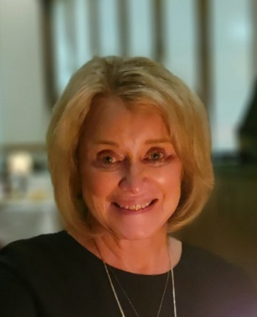
Elisa Stucker I became Episcopalian upon marriage to my husband, Mark, 48 years ago. A member of St. Thomas since 1997, I am active in several church activities. I represent our parish in the Bailey Cove Farmers Market hospitality booth, serve as an usher and greeter, teach Vacation Bible School, work in the kitchen for Lobsterfest, attend weekly Bible study, and I am a member of Daughters of the King. In the past I have enjoyed teaching Christian Formation to our St. Thomas children. I am a retired civilian U.S. Army Resources & Planning analyst. I am excited at the prospect of serving on our vestry.

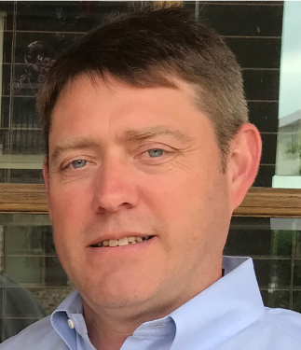
Brett Tomlin Amy and I were married at St. Thomas by Father Kee Sloan in October of 1993 and began attending church soon thereafter. We were both eventually confirmed by Bishop Sloan in 2018. We have one daughter, Sarah and one son, Foster. Both were baptized and confirmed at St. Thomas.

Amy and I co-chaired the Lobsterfest Parish Dinner for several years and the Tomlin family has served in a number of volunteer efforts at St. Thomas including: Lobsterfest, World Mission, Honduran Student Support, First Stop, Casa Temps, Stop Hunger Now and Sunday morning breakfast planning and preparation.

I have been an involved member of the Honduras Medical & Education Mission trip since 2016. I am a member of the BBQ Bandits cooking team, on the Building and Grounds Committee and currently serve as an usher. I previously served on the Vestry from late 2018 through 2021 and was elected Senior Warden for 2020 and 2021. During 2022, I was Chair of the Parish Profile and Discernment Committees. Most recently, I have been asked to serve on the newly formed Diocesan Vestry Consultant Committee.

I have worked as a real estate appraiser since 1999. I enjoy spending time with my family and our German shorthaired pointer Jayne, occasional travel and most anything outdoors.

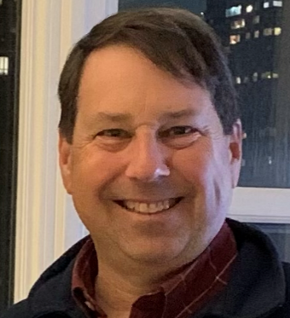
Peter Wilson My spiritual journey began in Jackson, Mississippi, where I attended St. Andrew’s Episcopal school, graduating in 1981. In 1990, I was baptized at Trinity Episcopal church in Mobile, and Martha and I were married at St. George’s Episcopal church in Nashville. After completing my surgery residency in 1998 at Vanderbilt, Martha and I moved with our daughters, Kristyn and Caroline, to Huntsville. We initially joined The Church of the Nativity, then St. Columba’s, before coming to St. Thomas in 2008. I am an Education for Ministry graduate, support the Esau group, and serve on various Lobsterfest committees. I was privileged to serve on the discernment search committee that brought Father Donavan to St. Thomas. I wish to join the Vestry to help our clergy accomplish their mission of caring and service to St. Thomas and our community. If elected, I would bring significant business and service experience. I served as Chief of Staff at Crestwood Hospital, President of the Madison Surgery Center, and am currently President of General Surgery Associates. I appreciate the opportunity to continue serving my St. Thomas community as a member of the Vestry.

