A new frontier in global health: how a historic public-private partnership in global health continues to break new ground

Panelists:
- Dr. Daniel Ngamije, Minister of Health, Rwanda
- Lynn Leonard, Global Program Leader, Soil Transmitted Helminths at Johnson & Johnson Global Public Health
- Dr. Johannes Waltz, Head, Merck Schistosomiasis Elimination Program and Global Schistosomiasis Alliance at Merck Group
- Sean Kerrigan, National Director, World Vision Rwanda
- Moderator: Joy Ruwodo, Director Public Affairs, END Fund

Panelist Bios:
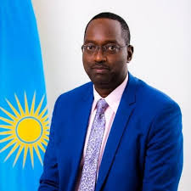
Dr. Daniel Ngamije, Minister of Health, Rwanda
Dr. NGAMIJE Daniel is the Rwanda Minister of Health since February 2020. In June 2018 he joined World Health Organization (WHO) Rwanda Country Office as National Programme Officer, and his duties among others were to provide technical assistance to the Ministry of Health on the development of Malaria and Neglected Tropical Diseases policies, strategies, guidelines, standards and norms -Support and assist to define programme implementation modalities, provide assistance to conduct periodical program review and resources mobilization.
From Feb 2007 to June 2017 he served as the Coordinator of the Project Implementation Unit (PMU) which later converted to the Single Project Implementation unit (SPIU), where he Coordinated and supported the process of funds mobilization, Grant negotiation with partners such the Global fund, World bank and bilateral MoH partners such as USA, UK , Belgium among others. He coordinated successful implementation of some project components and proceeded with periodical disbursement of funds to several implementing agencies and institutions country wide. Finally, he set and led a Monitoring and Evaluation System, reviewed and submitted consolidated financial and Programmatic reports for approval by MOH Partners prior subsequent disbursement of approved budget. During 10 years managing an annual portfolio of around 150 Million USD, he regularly obtained clean audit opinions from the Office of the Auditor General and other international private audit firms.
Prior to the above, Dr. Ngamije held various positions at the Ministry of health that include; Coordinator of the Malaria National Program (PNLP, Regional Director in Charge of Health and Social affairs in GITARAMA Province where he oversaw the Planning and Budgeting Process for all Health Facilities across the province and one of his Health District served to pilot Community Health Insurance(CBHI) from 1998-2002. Before being in management positions, he served first as Physician and later as Medical Doctor at Kabgayi Hospital from 1995-1997.
Dr. Ngamije completed Bachelor of Medicine and Surgery at Université de Kinshasa, DRC and Masters of Medicine in Public Health from Université Libre de Bruxelles, -Brussels, Belgium.

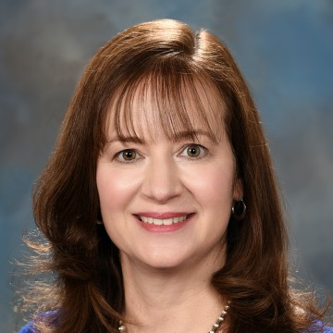
Lynn Leonard, Global Program Leader, Soil Transmitted Helminths at Johnson & Johnson Global Public Health

Lynn Leonard is the Soil Transmitted Helminth (STH) Global Program Leader within Johnson & Johnson Global Public Health. In this position she is responsible for the management of the VERMOX® (mebendazole) donation program to the WHO, which provides 200M doses of mebendazole annually to children in STH endemic countries. Lynn has been in J&J GPH since 2013 in a variety of roles, most recently managing the HIV portfolio. She has over 25 years of experience in the pharmaceutical industry from bench science to marketing and business development. Lynn has a BS in Biology, MBA in Marketing and a Post-Graduate Certificate in Health Economics.

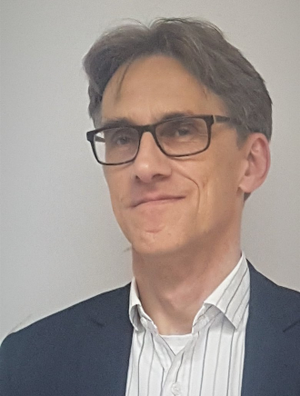
Dr. Johannes Waltz, Head, Merck Schistosomiasis Elimination Program and Global Schistosomiasis Alliance at Merck Group
Johannes is Head of the Merck Schistosomiasis Elimination Program (MSEP) at the German science and technology company Merck. In this position he is responsible for the placement of 250 million tablets of praziquantel (the gold standard for the treatment of schistosomiasis) throughout sub-Saharan Africa and beyond. Johannes is also Director of Strategy and Finance of the Global Schistosomiasis Alliance (GSA), an organisation which was initiated by Merck and now works as enabling and facilitating platform for its members and the wider schistosomiasis stakeholder community.
In addition, Johannes is chairman of the German Pharma Health Fund which aims to improve health care and medicines supply by supporting the fight against counterfeit and substandard quality medicines proliferation using GPHF-Minilab™ test kits.
Before joining Merck, Johannes was at Pfizer Worldwide Biopharmaceutical Operations where he held several positions, including Director, Emerging Markets and Multi-lateral Organisation Engagement (Europe). There he initiated, developed and managed strategic engagements with private and public organizations in the global health arena.
Johannes holds an MBA from Henley Management College, an MA from the School of Oriental and African Studies at the University of London, and a Doctorate of Law from the University of Vienna.

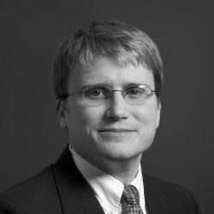
Sean Kerrigan, National Director, World Vision Rwanda
Sean Kerrigan leads the World Vision Rwanda team responsible for serving vulnerable children in Rwanda with an ambitious goal of improving the lives of 4 Million children by 2020. His portfolio includes oversight of technical programs including: Livelihoods; Health and Nutrition; Education and Water, as well as Sanitation and hygiene (WASH). The team’s focus includes cross-cutting themes of gender, child protection, children with disabilities and faith and development, in relief and development contexts.
Since joining World Vision in 2006, Sean has managed strategic cross-functional teams to: develop World Vision’s Web strategy, design World Vision International’s global fundraising strategy and investment, and lead Economic Development fundraising. Most recently, he led the global water, sanitation and hygiene (WASH) team responsible for oversight and technical support of WASH projects and programs in more than 60 countries. This portfolio included an unprecedented effort to bring clean water and sanitation to more than 15 Million people over seven years.
Prior to World Vision, Sean worked in the water and sanitation sector designing and installing turnkey water and wastewater treatment systems in Latin America, Africa, and the Middle East with Water Missions International.
He holds a bachelors degree in Chemical Engineering from Georgia Institute of Technology, an MA in Biblical Theology from Wheaton College, and an MBA in International Management from Thunderbird, School of Global Management,
He and his wife Rachel live in Kigali, Rwanda with their four children Caleb, Eli, Luke, and Keziah.

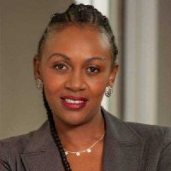
Moderator: Joy Ruwodo, Director Public Affairs, END Fund
Joy serves as a Director, Public Affairs for the END Fund Africa Region. An esteemed marketer and strong social and economic development advocate, Joy is driven by stimulating private sector actors and organizations to actively engage in addressing developmental challenges in their communities. Her role is focused on elevating the profile of neglected tropical diseases on the continent, as well as growing and engaging a community of African activist-philanthropists and business leaders who will join in the movement to end NTDs. Joy also serves on the South Africa Working Group for the Shared Value Africa Initiative, which convenes African organizations and business communities with the common purpose of building the continent’s economy.
Prior to joining the END Fund, Joy was the Marketing & Advocacy Executive for a leading independent research company, Ask Afrika. She was formerly the Marketing & Fundraising Manager at HospiceWits, a reputable non-profit organization that provides palliative care to thousands of people annually. Joy’s passion for business integration and growth saw her serve as President for the Johannesburg Masters Business Network International (BNI) Chapter, a business and professional networking organization whose sole purpose is to generate business for its members. She spent 8 years as a Retail Business Consultant and Brand Associate for Caltex, a global oil and gas company.
Joy completed her BCom degree in Management and Economics at Rhodes University. Pursuant to her interest in ongoing education and self-development, she embarked on an MBA through Wits Business School and completed her MBA Electives at McGill University in Montreal.
In her spare time, Joy enjoys traveling, having new experiences and exploring cuisine options with her husband and three children. She values time spent with friends and family greatly.

