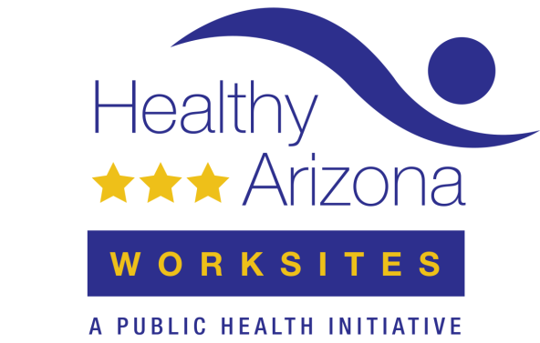
SAMPLE Worksite Health Improvement Plan

VISION: To create a worksite environment supportive of and help employees engage in healthy behaviors that contribute to the prevention and management chronic conditions (such as diabetes, obesity, and cardiovascular disease)
Your vision is ideally aligned with the strategic plan of the organization and represents the highest level of impact you aim to achieve. You may evaluate your efforts by assessing changes in health outcomes (such as decreases in chronic conditions or improved management of chronic conditions) as well as business goals (such as increased productivity, morale, and employee retention).

VISION:

GOAL 1: Support employees in achieving the recommended amount of physical activity (according to the 2018 Physical Activity Guidelines for Americans)

GOAL 2: Support employees in eating a healthy diet consistent with the 2015 dietary guidelines (developed by the U.S. Department of Agriculture and Department of Health and Human Services)

Your goals support the overall vision and progress can be measured through long-term and intermediate outcomes, which often can be achieved within 3 to 5 years.

OBJECTIVES support the overall goal, and progress can be measured through short-term and intermediate outcomes, as well as measuring achievements in the implementation process. Your worksite can take quantitative measures (employee data, surveys, observation) as well as qualitative measures (focus groups, surveys with open-ended questions, comment boxes). All objectives should be “SMART” (specific, measurable, achievable, relevant, and time-bound).

Goal 1:

Objective 1: | Evaluation measure:
Strategies | Implementation steps |  |  | Communication activities | Evaluation measures/measures of success (process, short-term and intermediate outcomes) | Budget (materials,  staff time, incentives, other costs)
 | How | Who | When
Objective 2: | Evaluation measure:
Total healthy worksite budget |  |  |  |  |  | $

