`

“Freshly Squeezed
or Name of Bra”

GFWC Georgia’s custom designed Bra-Ha-Ha
is an awareness project to remind women to
schedule a mammogram appointment today.
‘
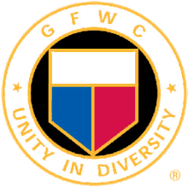
Bra-ha-ha designed ________________________ Woman’s Club.
To learn more about our club please contact: _____.

Use the hashtag #GFWCGeorgiaNWDistrict

________

`

“Freshly Squeezed
or Name of Bra”

GFWC Georgia’s custom designed Bra-Ha-Ha
is an awareness project to remind women to
schedule a mammogram appointment today.
‘

Bra-ha-ha designed ________________________ Woman’s Club.
To learn more about our club please contact: _____.

Use the hashtag #GFWCGeorgiaNWDistrict

