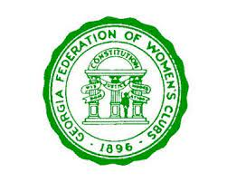
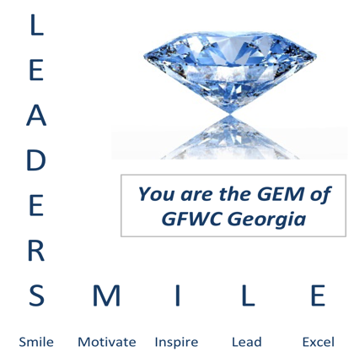
2021 GFWC Georgia LEADS Workshop
Friday, August 20, 2021 10 am to 4 pm
Registration begins at 9:45 am
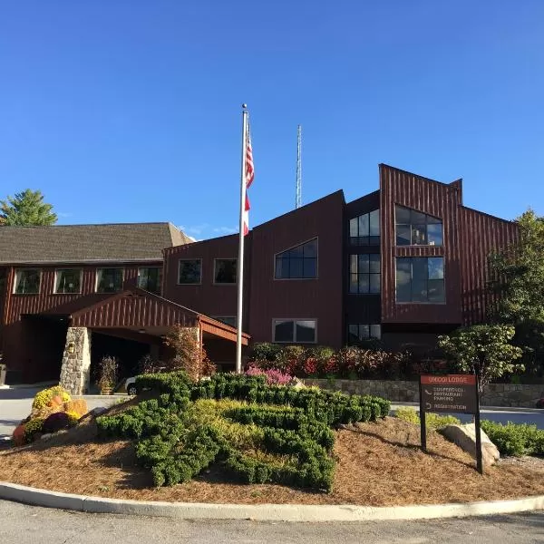

Unicoi Lodge 1788 GA-356, Helen, GA. 30545

This workshop will be fun, interactive & dynamic!
Fantastic Guest Speakers including Ida Dorvee & Tammy Garland.
GFWC Georgia leaders will show their “GEMS”.
Great opportunity to meet other leaders within our organization, and make new friends while having fun and learning.
Come learn about topics such as:
- Communication
- Conflict Resolution
- Team Building
- Meeting strategies
- Finances and budgeting
- Leading in a busy world . . and much much more

LEADS is open to ALL GFWC club women
Cost: $30 (includes lunch)
Remember: Leaders S M I L E
For questions contact Becky Bolden or Diane S. DeGaetano at Leads@gfwcgeorgia.org.

