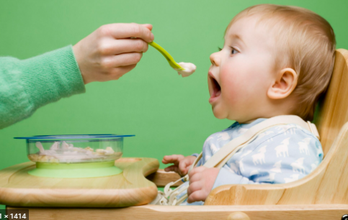
FARE Facts
1.Up to 80% of peanut allergies are preventable for high-risk infants. The Learning Early About Peanut Allergy (LEAP) and LEAP-On studies showed that feeding peanut foods early to babies at high risk for peanut allergy reduced their chances of developing a peanut allergy by 80 percent
2.Early introduction may help lower the risk of certain food allergies. For some children at higher risk for allergies to milk, peanut, egg, sesame, fish or wheat, the Enquiring About Tolerance (EAT) study indicates that introducing these foods early has the potential to lower the risk of developing these allergies, particularly egg allergies.
3. A varied diet may help reduce the risk of developing a food allergy. Studies suggest that feeding your baby a larger or more diverse number of foods or food groups might lower the risk of food allergy.
ALWAYS DISSCUSS INTRODUCING NEW FOODS WITH YOUR BABY’S DOCTOR FIRST

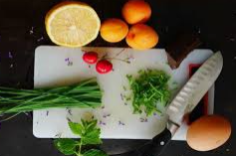
FARE Food
1.According to the American Academy of Pediatrics (AAP), you can start introducing single-ingredient foods like fruits (apples, pears, and bananas), vegetables (green vegetables, sweet potatoes, squash and carrots) and cereal grains (rice or oat cereal) between four to six months, when your infant is developmentally ready
2.Softer the better. Prepare foods that can be easily dissolved with saliva and do not require chewing. Some foods are potential choking hazards, so it is important to feed your baby foods that are age-appropriate and the right texture.
3.Age-appropriate peanut foods should be introduced only at home or in a doctor’s office, not at locations outside the home. When introducing peanut foods at home, pick a time when your infant is healthy and you are able to devote your full attention for at least two hours so that you can watch for an allergic reaction.
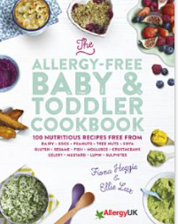
FARE Fun for kids
1.Wean your baby and nourish your toddler with 100 nutritious recipes free from all 14 major allergens. 'Introducing your baby to food is one of the many great joys of parenthood. When it comes to weaning children with food allergies, we are two moms who have been there, done that! www.amazon.com
2.The Allerbling™ Food Allergy Awareness Bracelet is a unique medical ID wristband that helps to keep your child safe at school, summer camp, or on play dates by alerting others to your child's food allergies. The customizable food allergy bracelet for kids displays each allergy on cute, charm-buttons. Children love the bright colors, which help to educate them and others to their sensitivities. The large, iconic food symbols used on the charms are easily recognized and transcend language barriers.
www.allerbling.com,wwwamericanmedical-id/kidsallergy/brecelets
3.A whimsical tale of eight friends with food allergies. Food allergies are never fun, but best friends always are! This light-hearted story explores the daily routines of eight best buggy friends such as Beetle, Cricket and Butterfly, as they face their respective food allergies with positivity and poise. At home and at school, at the park, or on the beach, Buga Bees find ways to stay safe,... www.bugabees.com
Karen Clydesdale, NW District GFWC GA Presidents Special Project, Chair

