

2022-2025

**Strategic planning**

**process**

**Cheshire Independent Living Services**

**Strategic Plan 2022-25**

Within the following document, you will find the passion and the excitement of our organization as it is captured in our vision, mission, and goals.

The Cheshire Board of Directors developed this Strategic Plan following a thoughtful process, as outlined below; and with extensive input from the Cheshire community, to whom we extend our most sincere thanks and appreciation.

The resulting Strategic Directions were created in partnership with our consumers, staff and partners, and will be our guide for the upcoming 3-years.

We look forward to the opportunities ahead as we travel this road together.

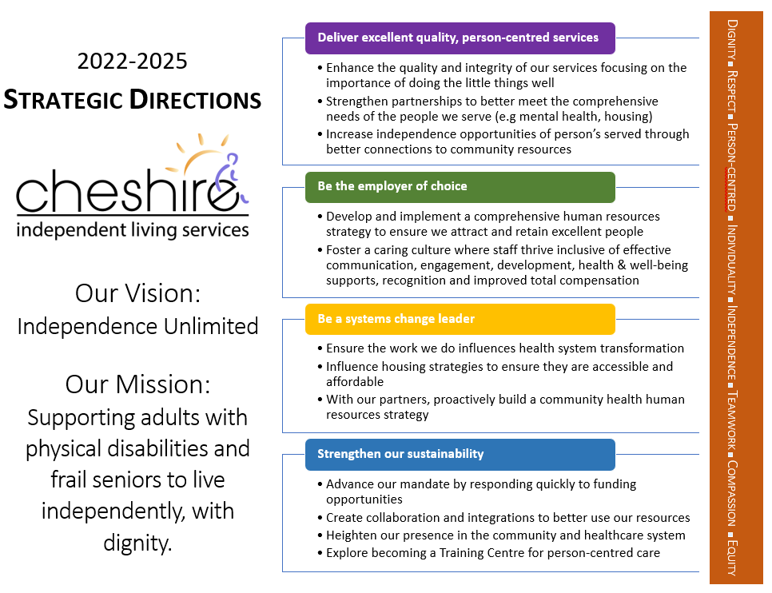

|  |  |  |
| --- | --- | --- |
| **Cheshire Independent Living Services – 2022-23 Strategic Actions** | | |
| ***Deliver excellent quality, person-centred services.*** | | |
| **Key Objectives** | | |
| **Enhance the quality and integrity of our services focusing on the importance of doing the little things well.** | **Strengthen partnerships to better meet the comprehensive needs of the people we serve.** | **Increase independence opportunities of person’s served through better connections to community resources.** |
| **Initiatives for 2022-23** | | |
| 1. Engage the people we serve, their families and their support networks to ensure our work aligns to their needs. 2. Demonstrate compliance to Best Practice Standards and a high standard of Service Delivery. 3. Develop a Back to Basics Training program, highlighting the delivery of person-centred, consumer-directed care with attention to "the little things" including a focus on cultural humility, diversity and inclusion. | 1. Lead the development of Collaborative Case Reviews in London Middlesex; Participate actively in all communities served. 2. Build better connections with hospitals, Home and Community Care and community partners to support Consumers through transition points in the health system. 3. Define the Care Planning scope of practice for Program Managers within the context of the Independent Living Model of Care. | 1. Develop strong internal connections to Community Support Services (CSS) Central Intake to better support consumers. 2. Explore the development and implementation of a Consumer Portal. |
| **Key Performance Indicators** | | |
| * Consumer advisory meetings held 6 times annually * Annual quality review; achieve 85% satisfaction * Town Hall meetings - twice annually to establish baseline for future measurement and engagement (led by Advisory, supported by ED) * Consumer engagement in quality initiatives * Back to Basics program developed and tested by March 31, 2023 * CARF Accreditation; prepare for Jan 2023 survey and achieve 3-year award * Missed Visits; below 0.1% * Maintain Continuity rate above 5 | * Collaborative Case Reviews implemented and held at least monthly in London Middlesex * Participation in Collaborative Case Reviews in Huron-Perth, Elgin and Oxford at least 6 times annually * Multi-sector Transition Planning, engagement and improvement initiative * CSS Service registrations of 400/month * CSS intakes completed of 200/month * Care Planning Scope of Practice defined and communicated | * Education to program management team completed by end of Q1 * Development of information packages for distribution * Central Intake packages incorporated into 100% of onboarding and annual service reviews starting in Q2 * Consumer Portal options analyzed and implemented by March 31, 2023 |

|  |  |
| --- | --- |
| **Cheshire Independent Living Services - 2022-23 Strategic Actions** | |
| ***Be the employer of choice.*** | |
| **Key Objectives** | |
| **Develop and implement a comprehensive human resources strategy to ensure we attract and retain excellent people.** | **Foster a caring culture where staff thrive inclusive of effective communication, engagement, development, health & well-being supports, recognition and improved total compensation.** |
| **Initiatives for 2022-23** | |
| 1. Develop a formal, measurable HHR strategy. 2. Align our compensation model with needs identified in staff satisfaction surveys. 3. Develop opportunities for improved schedules with solutions which are flexible and responsive to the needs of our employees. | 1. Develop policies and implement educational tools to increase awareness of and respect for Cultural humility, diversity and inclusion. 2. Build trust through open, honest dialogue and timely communication. 3. Develop and implement a mentorship and professional development program for staff. 4. Shift the culture of the organization through Authentic Leadership. |
| **Key Performance Indicators** | |
| * Analysis of staff surveys completed with recommendations for improvement * Formalized plan developed; implemented by Q2 and reviewed monthly by senior leadership * Benefits package re-assessed with options for improvement * Development and implementation of 2-3 solutions to improve flexibility in scheduling | * At least quarterly engagement of staff by Executive Director in focus group setting * Town Hall meetings held twice annually * Mentorship and professional development program developed for implementation in 2023-2024 fiscal year as part of the comprehensive Health Human Resource plan * Implementation of at least quarterly training of our leadership team, focusing on building Authentic Leadership skills and awareness; measure impact on culture through staff surveys and 360 performance reviews |

|  |  |  |
| --- | --- | --- |
| **Cheshire Independent Living Services - 2022-23 Strategic Actions** | | |
| ***Be a systems change leader.*** | | |
| **Key Objectives** | | |
| **Ensure the work we do influences health system transformation.** | **Influence housing strategies to ensure they are accessible and affordable.** | **With our partners, proactively build a community health human resources strategy.** |
| **Initiatives for 2022-23** | | |
| 1. Intentionally participate at system and partner tables, strengthening the voice of the community in health system planning. | 1. Actively engage with housing providers, system partners and funders. 2. Create collaborative opportunities for affordable and accessible housing. 3. Participate in provincial analysis to demonstrate value of Assisted Living as a system solution. | 1. Actively participate in system-wide Heath Human Resource committee, building collaborative strategies within the healthcare sector for shared resourcing and optimize utilization. 2. Advocate for wage parity and base funding increases to address Health Human Resource systemic challenges in the community. |
| **Key Performance Indicators** | | |
| * Active participation in committees and working groups in 100% of the Ontario Health Teams in our geography * Active participation in provincial associations for advocacy efforts * Lead Bundled Services re-implementation in London-Middlesex and support spread to other communities | * Further refine and develop the concept of a collaborative model of supportive housing * Create a Briefing Report and Business Plan highlighting system impact of supportive housing from a quadruple aim lens * Identify and move forward 1-2 new housing projects for potential expansion in 2022-23 * Reconnect with City of London at least twice annually to advocate for increased Rent-Geared-to-Income spaces for individuals served | * Identify and implement at least 2 new collaborative initiatives for improved Health Human Resource utilization * Participate in campaigns for compensation equity within healthcare and between sectors |

|  |  |  |  |
| --- | --- | --- | --- |
| **Cheshire Independent Living Services - 2022-23 Strategic Actions** | | | |
| ***Strengthen our sustainability.*** | | | |
| **Objectives** | | | |
| **Advance our mandate by responding quickly to funding opportunities.** | **Create collaboration and integrations to better use our resources.** | **Heighten our presence in the community and healthcare system.** | **Explore becoming a Training Centre for person-centred care.** |
| **Initiatives for 2022-23** | | | |
| 1. Proactively plan. 2. Be in a state of readiness as opportunities are announced. | 1. Leverage the skills and experience of our internal resources to address system needs. 2. Develop and implement collaborative and integrated Community Support Service (CSS) solutions. | 1. Increase social media and main stream media presence; tell our story. 2. Increase access to CSS Central Intake and CSS services. 3. Intentionally engage with key system partners. | 1. Identify internal expertise 2. Develop approach for external delivery. 3. Identify and engage key partners to market expertise. 4. Build infrastructure for year 2 testing and year 3 implementation. |
| **Key Performance Indicators** | | | |
| * Identify 3 key areas of focus for 2022-23 * Complete analysis, business plan and briefing report * Develop and implement communication plan with key messages for advocacy "in the moment" * Engage broadly to ensure awareness of opportunities as they arise | * Identify key areas of organizational strengths/capacity * Identify key areas of organizational gaps/needs/challenges * Identify key partners to generate conversation and move forward integrated solutions * Implement at least 2 new integration opportunities | * Create social media plan that is balanced with focus on recruitment, cultural humility, community-building, good news stories, and advocacy * Develop and implement a landing page and mechanism for online referrals to CSS Central Intake; communicate broadly * Develop a communication strategy for mainstream media * Submit at least quarterly | * Develop milestones and finalize approach by end of Q3 * PDSA work complete with recommendations for small-scale implementation/testing in 2023-24 |

Appendix 1: Summit Themes



**Strategic Planning Summit**

**Top 5 Emerging Themes**

(47 attendees including Board, consumers, leadership, administration and front-line staff)

November 25, 2021

Facilitated by Maria Sanchez-Keene, Centre for Organizational Effectiveness