Advent Luncheon Series
Wonder in Light Week #1

“I am the Light of the world. Whoever follows me will never walk in darkness
but will have the light of life.” - John 8:12

How has the light of Christ been a light in your life?

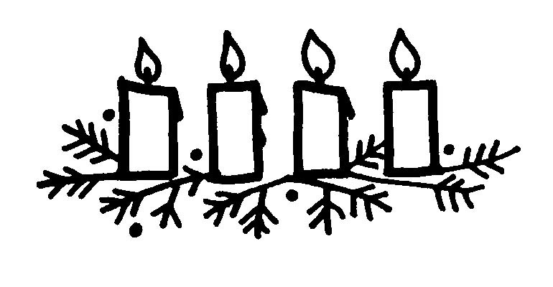

More often than I'd care to admit, in the midst of a busy winter day, we forget to tend to the wood stove in our home. When we open the stove, there's no flame, no warm heat emanating out...just a pile of ashes. But sometimes, after stirring the ashes with a fire poker, one or two embers start to glow, and it's just enough to ignite a small piece of well-seasoned wood. In a matter of minutes, the fire in the stove is glowing again with the light of a fire, filling our home with warmth and comfort.

God's light in my life often appears like those small burning embers. I can't say that I've ever had a singular "burning bush" moment, where God's light is seen all at once big and miraculous. It's more like small burning embers, almost buried among the mundane and routine of everyday life, that appear right when I need them most. These embers of light remind me of God's presence, and fill my heart. These embers, in writing this, seem so small and almost insignificant, but end up being what I need to stir my soul and reignite a faith filled with hope and joy and contentment. These embers, for me, are a big, goofy black lab resting her head on my lap after a stressful day; a quick, small breeze on the back of my neck reminding me of my grandmother's presence when I'm missing her the most; my best friend, who lives in Germany, texting a quick hello that makes the ocean separating us seem not so vast; a rambunctious five-year-old running back to the door for "one more hug and kiss" before he heads off to school. Small, fleeting moments like these, when woven all together, add up to something big and wonderful and miraculous. When ignited, these embers make obvious to me the light of God's presence in the ordinary and the everyday.

- Lisa Wallmeyer

In Advent I often think of the light of Christ coming into a dark world when He was born. Sometimes in this season I am reminded of a dark time in my own life. In June 2000 I was in a serious auto accident. When I was first admitted to MCV Hospital, it was not clear if I would survive. During that critical time, I had a vision of all these arms reaching out to me, encouraging me to move forward. In the end, I had a full recovery.

The memory of that vision has never left me. In fact, a few months after, Dee and I found an art work that reminded us of that experience, and we bought it for our home. At the time of the vision, I wondered if somehow God was speaking to me. I have always believed in God, but then I was not a Christian - I was a Unitarian-Universalist. More than fifteen years went by. In the fall of 2017, not long before Advent, Dee was called to be the music director at Grace. Very quickly we realized that we had found a new church home, and for both of us it was a return to the Christian faith in which we had been raised. Among so many wonderful discoveries and rediscoveries, my mind turned again to that vision soon after my car wreck. Now I realize that the arms reaching out to me were somehow from Jesus, not only calling me back to life, but also calling me back to faith in Him as the light of the world.

- George Crafts

Christmas is nearly here again. Advent, the coming of our Beloved Savior. That hallowed night, I can almost see it now in my mind’s eye. A tiny baby, innocent and new, with a halo, God’s sign that he sent a bright light into the dark, weary world.

And, I instinctively feel that I have always looked for the Light that has shown all around me since the night I was born, too. I have come from the light, been under the light, in the light, and around the light but never above the light. It tries to teach me how to live every day of my journey here so that I won’t have to die in darkness.

When I was a child, I would turn to my folks when I felt physically or emotionally bad. And, as I grew up they often acted as my light. But one day they were gone and I had to carry my own light. Just as Christ had passed his light to them before they left, they in turn passed it on to me so that I might have a well-lit path to follow. Sometimes the light grows dim and I travel in confusion. I become restless and sad or angry and afraid. For I feel myself no longer in the light. My lack of faith has snuffed it out. But then I know that I must believe because if I don’t, I won’t know the light of peace again or what God’s purpose for me is here. So when I do believe and my faith returns I can share Christ’s Light in my life with the joy and light that I find in others.

- Sally Sutherland

God’s Light – the people of this parish emanate God’s Light. They have reached right into my heart and pulled me in. I have been a lost lamb and Grace has embraced me. Warmth, friendliness and non-judgemental…not one parishioner, but ALL. So easy to become devoted! A sincere desire to be a part of everything because of the warmth and friendliness of everyone!

- Sherrie Farnsworth

FRIDAY NIGHT LIGHTS
A Reflection

The three of us - Leith, Grandaddy and I - rushed towards the lights and all the excitement of a three-year-old’s first football game.

Many Friday nights I had stood near this place, freezing through a football game-first as a high school student and later as a teacher here.

Much had not changed—curmudgeons along the fence, railing against our defense, even with the healthy lead we enjoyed; rusty boys capering behind the bleachers with footballs in the air; young lovers making themselves invisible in parked cars.

But this night was different. The light that beamed from one child’s eyes in a rush of joy was life changing. We could but look and feel and marvel in a new awareness of the perfect gift that comes from above.

Advent invites us to appreciate more keenly the abundant light of Christ in our lives. May we never lose sight of the gift.

- Ellen Bain Smith

“I said to the man who stood at the Gate of the Year, ‘Give me a light that I may tread safely into the unknown.’ And he replied, ‘Go into the darkness and put your hand into the hand of God. That shall be to you better than a light and safer than a known way.’”
- Minnie Louise Haskins. Also quoted by King George VI and Queen Elizabeth.

Those words have spoken to me so many times when I’ve been afraid, mostly strengthening my weak faith and helping me to move forward.

My reflections of the Light of Christ go back so many years. I am reminded that Christmas gives us the message of Christ’s birth and His coming Light into the world, especially during the reading and singing of the Nine Lessons and Carols. The ancient readings and the actual birth of Jesus in the manger, to me, are the most important parts of the whole of Christmas. The quiet and reverent scene in the stable, Christ’s Light appearing to the world so humbly. What awe I’ve felt and been reminded of that Light so intensely over the years.

Yet there have been many times when the Light seems to have disappeared, when life gets tough and I don’t have the strength to go on. Then something or some person will remind me that the Light of Christ is always shining and I can again turn to God.

I am reminded of the Light so often – on a sunny morning, the blue sky shining through the trees; the eyes of our pet animal family when they come to us; the brilliant colors of the flowers; the turbulence and calm of the ocean in its many moods; my care and love for my spouse and hers for me; the friends whom I care about unconditionally; my brothers’ love and my love for them and their families.

Jesus’ Light and beauty are all around us. Time, however, can take its toll and in the inevitable rush of life it’s good we are reminded, especially at Christmas, that we should stop and wonder at the beauty of all we have in our lives and remember the Light of Christ is really staring us in the face.

- Jackie Hobbs

