

Grantee User Guide – Smartsheet

Introduction
The Native Connections Resource Center (NCRC) is a comprehensive database that includes podcasts, webinars, and documents designed to provide resources to grantees as they work through their 5-year grant. The NCRC is easy to use, and resources are cross-referenced by topic and type of material.
All resources on the NCRC are available for you to download and to save to your computer. Grantees may submit resources they have developed (such as templates or sample materials) to share with colleagues for optimal peer-to-peer learning. Grantee- developed resources are differentiated on the NCRC by the tribal logo of the sharing grantee.
The NCRC is built on the Smartsheet platform and will be accessible only to Native Connections grantees and stakeholders. This is a private, password-protected site which will require all users to set up a (free) account to access the materials. Once an account is established, grantees can save their log-in information for future use.
The NCRC is also accessible through the Smartsheet app on a phone or smart device. Simply search Smartsheet in the app store. If using the app, log in using the same credentials you set up for logging in on the computer.
This guide will provide instructions for setting up an account in Smartsheet, downloading and sharing resources, and getting back to the NCRC for future use (including bookmarking the site for direct access. A few important notes:
- Smartsheet is free for grantees to use to access the NCRC. Once you are in, you will see at the top a green “Upgrade” button with a countdown of “Days Left” (it will also tell you have a 30-day free trial when you are getting set up). You can ignore this. Anything that is shared with you at the email address you used to

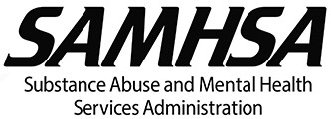

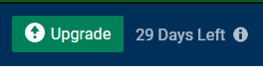
establish your Smartsheet account will still be accessible even after your “Free Trial” expires!

- The email address for your log in will be the same one they have provided to Grantee Technical Assistants (GTAs) for contact information (which is what is used to set up the viewing permissions to allow access to the NCRC).
- 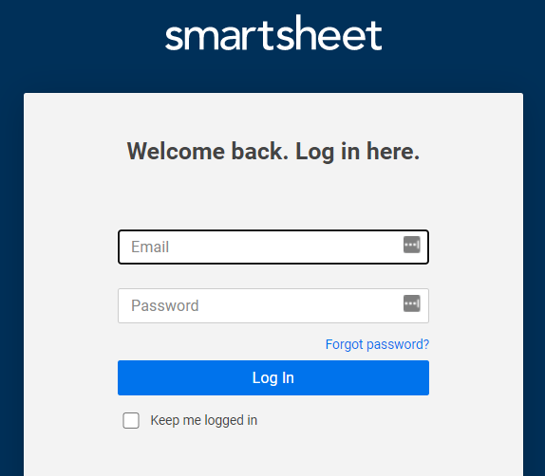It is strongly recommended that you bookmark the direct link to the NCRC home page for easy future access (see page 11 in this guide for instructions), and that you utilize your browser settings to save your login credentials so you don’t have to re-enter them every time. There is also a “Keep me logged in” box you can check whenever you log in to Smartsheet.

Steps for Accessing the NCRC
- Click the link you received to open the dashboard in Smartsheet.
https://app.smartsheet.com/dashboards/HXRMJrmvq8WwpQrVwXcRrWV6C2cvC82cWfPCWpR1

- The first time you go the NCRC, you will need to create a Smartsheet login. When you click on the link it will first take you to a Smartsheet login page. At the bottom of the grey box, click “Don’t have a login? Sign up.”
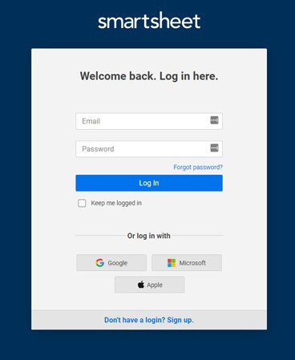

- Enter your email address and click “Continue.” Follow the instructions to finish setting up your Smartsheet account and save your login information.
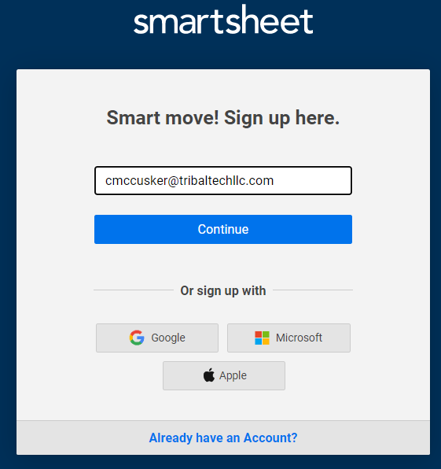

  - After you enter your email address and click Continue, it will ask you to verify your email address. You may need to check your spam/junk folder if you do not see a Smartsheet verification email in your inbox, and mark Smartsheet as a safe sender so you do not miss future messages.
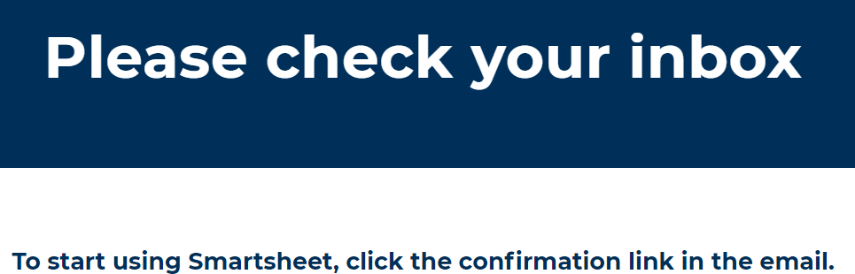

  - Once you get that email, click the blue “Confirm Email” button and it will take you back to Smartsheet to identify a password.
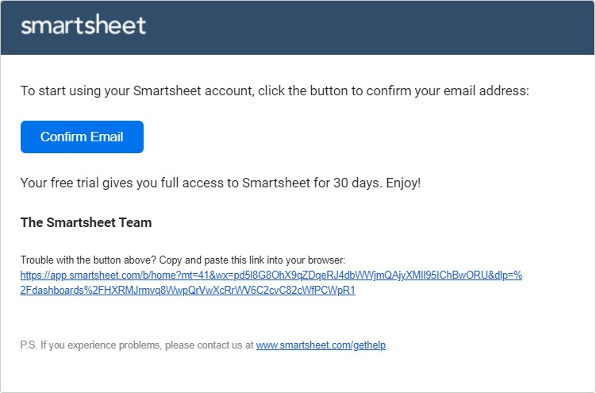

  - Enter your password in both boxes, check the “I agree to the Smartsheet User Agreement” box, then click “Continue.”

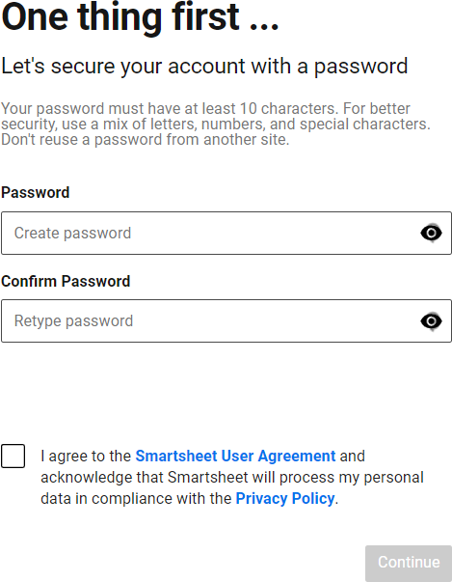

- After completing this process, the NCRC will open in Smartsheet!
The first time you go into Smartsheet, you will see a “Welcome” screen, where you can view the video or click “Learn More,” or just close out the box to view the dashboard.
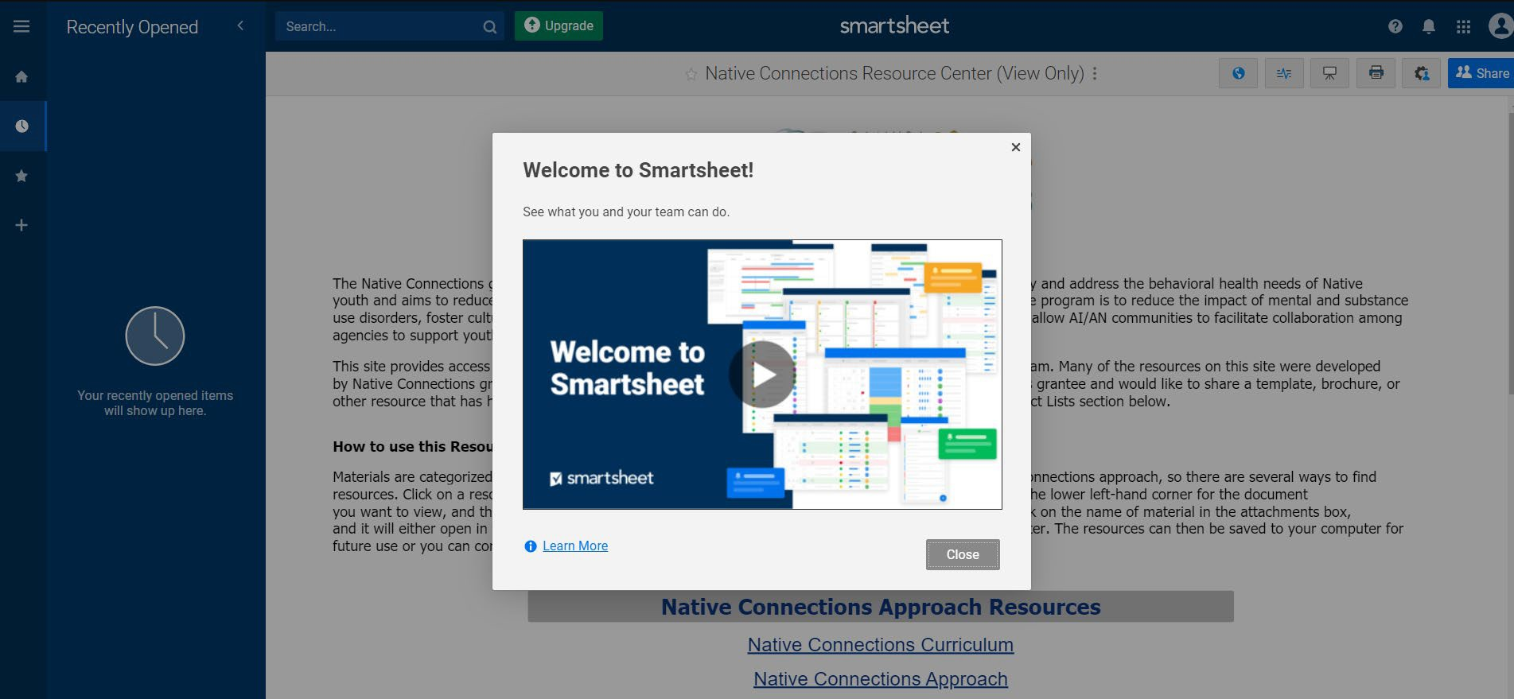

Accessing Resources in the NCRC

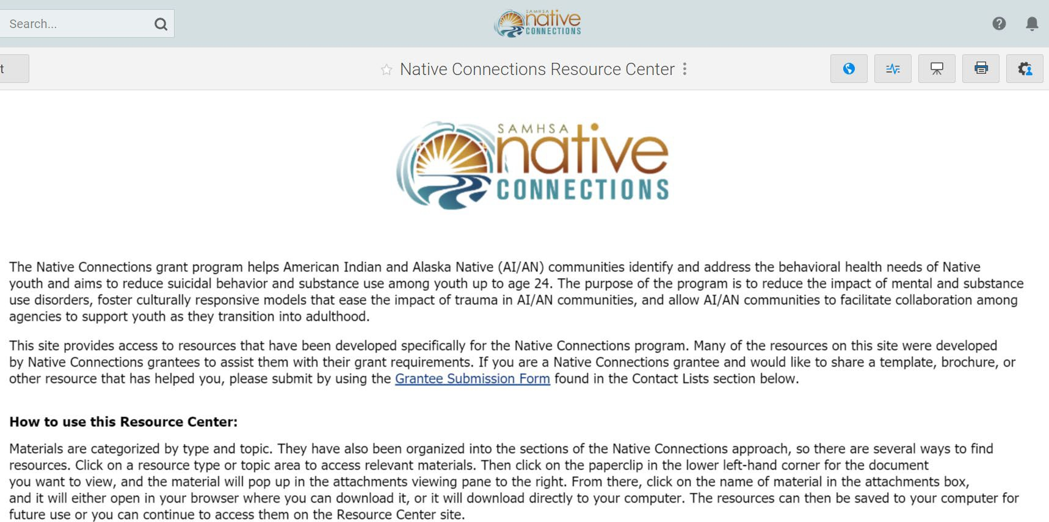
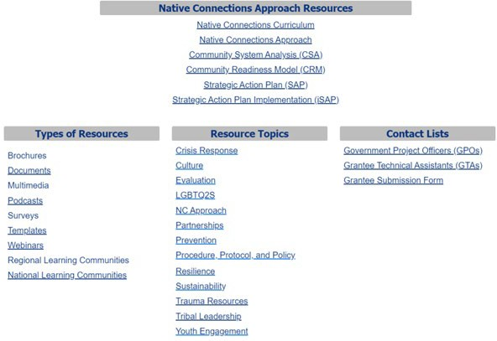
NCRC Home

You can click on the links in each section to access those resources. Once you are in a section, this is how to resources will show up:
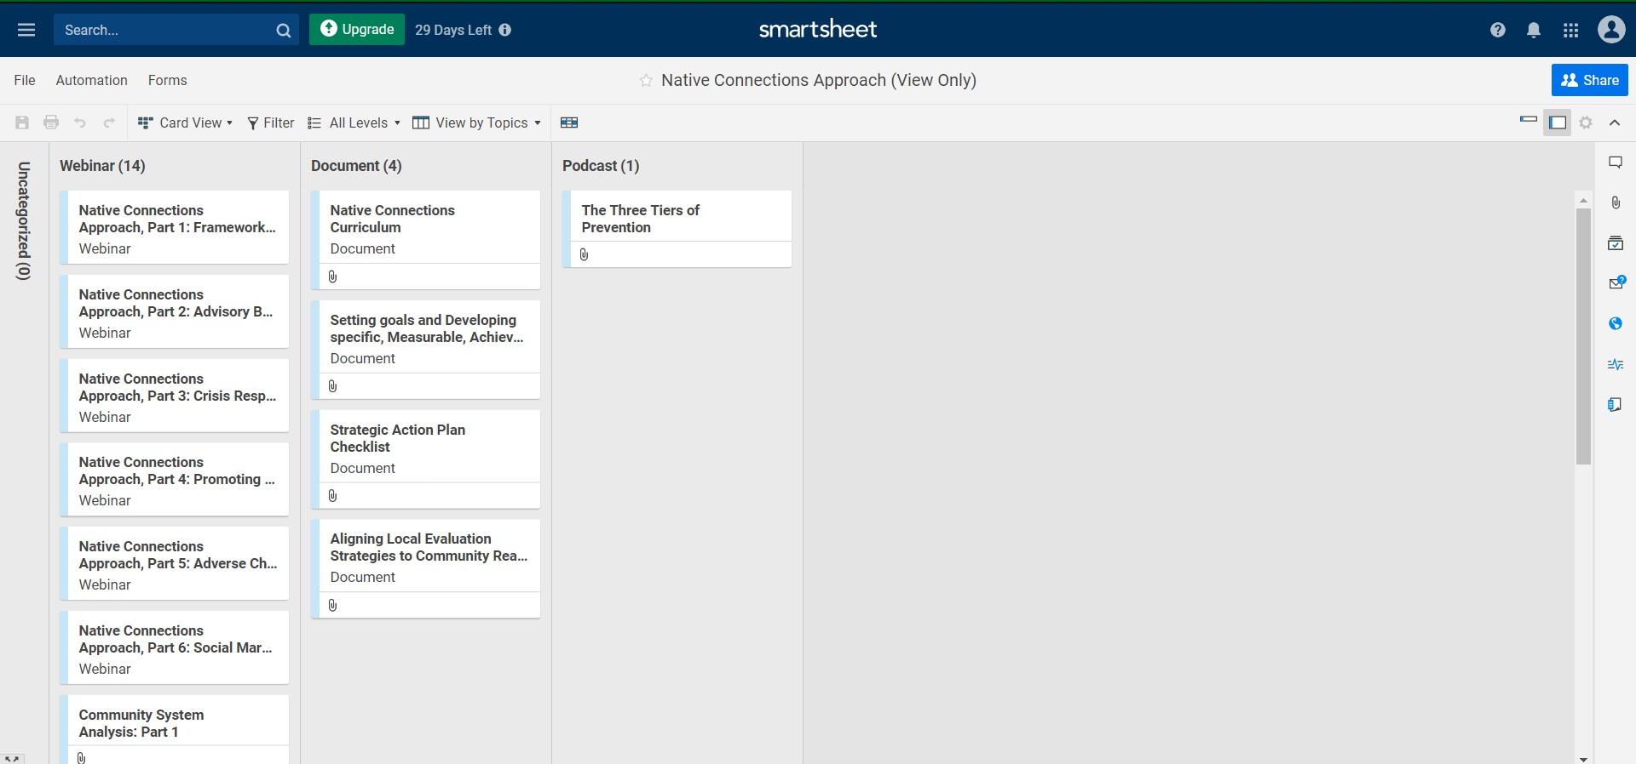
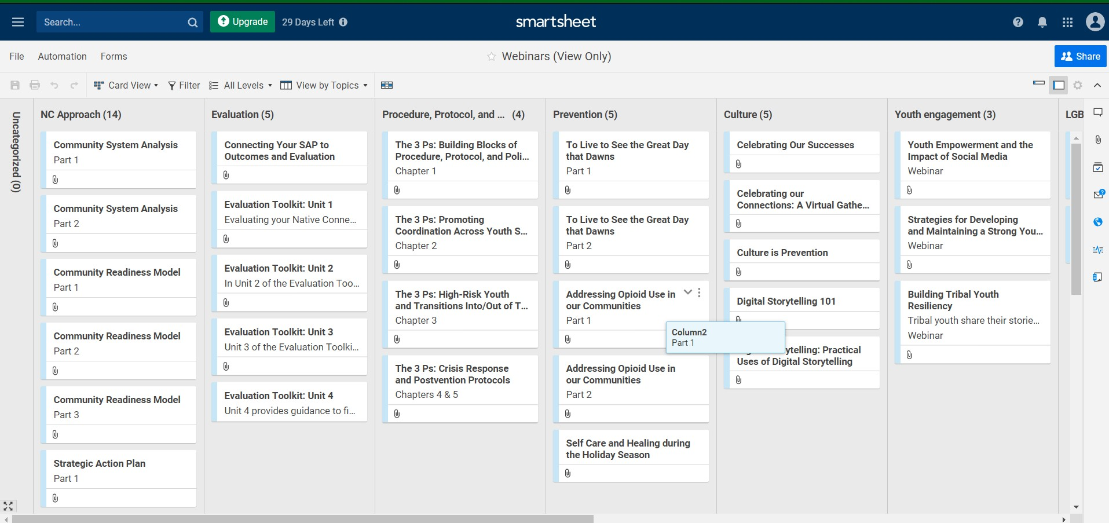

To view or download a document, webinar recording, podcast, etc., click the paperclip icon in the bottom left corner of the resource, which will bring up an “Attachments” box on the right-hand side:
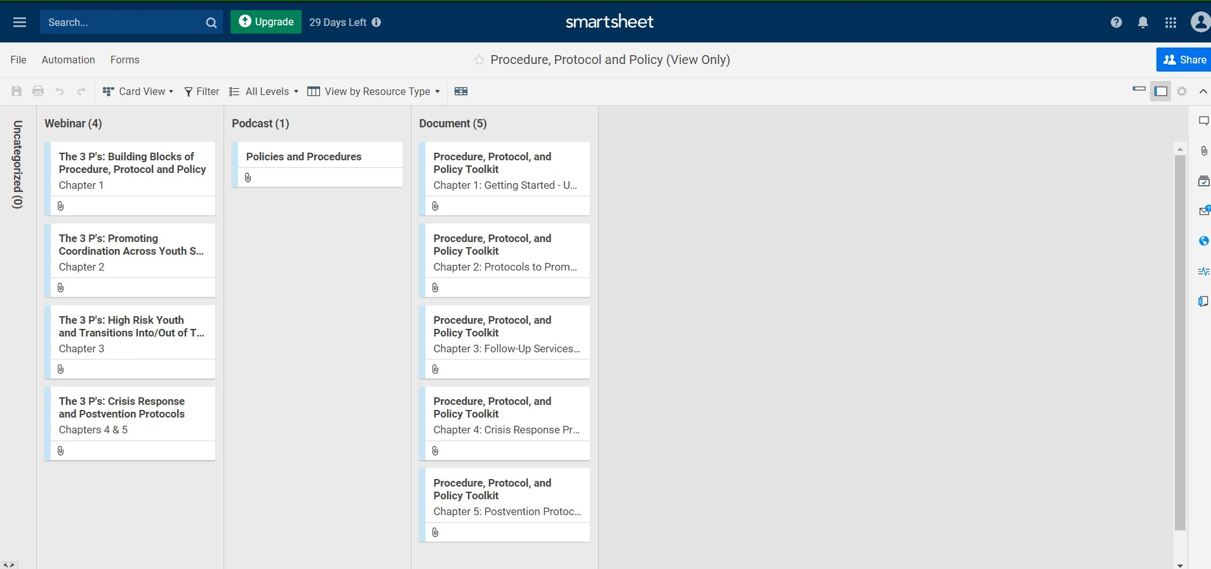

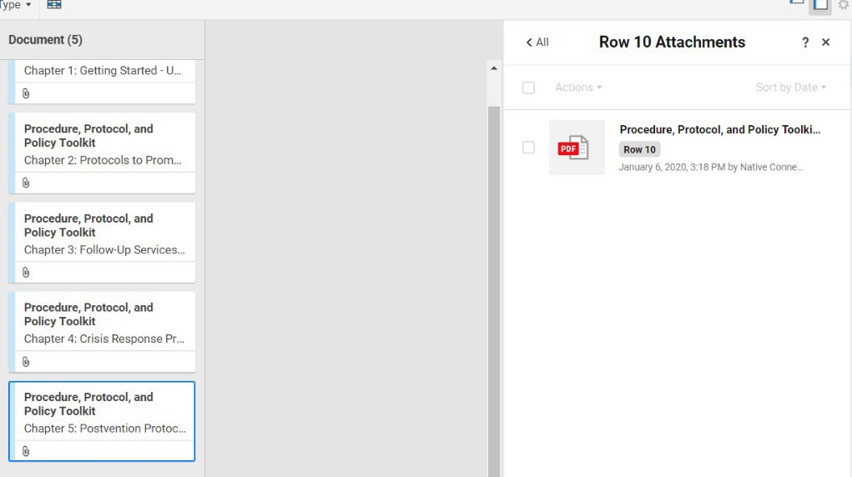

Downloading and Sharing Resources
From here you have a couple options:
- Click on the title of the resource and it will either download directly to your computer or will open in a browser window where you can download it that way (this may vary depending on your browser, individual settings, or type of resource).
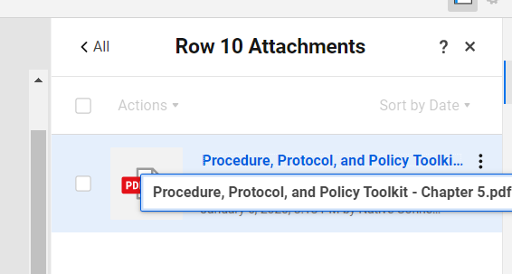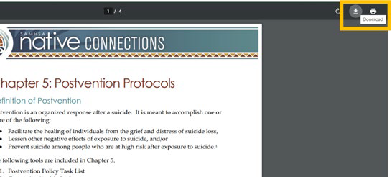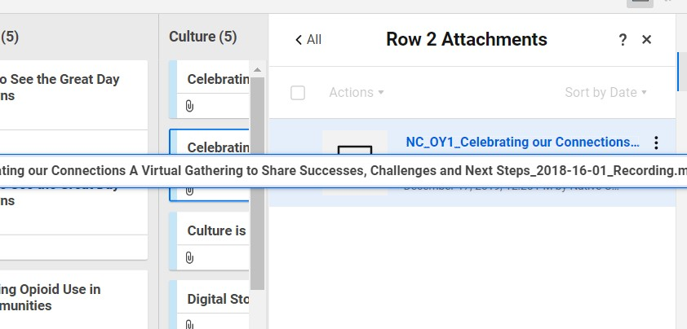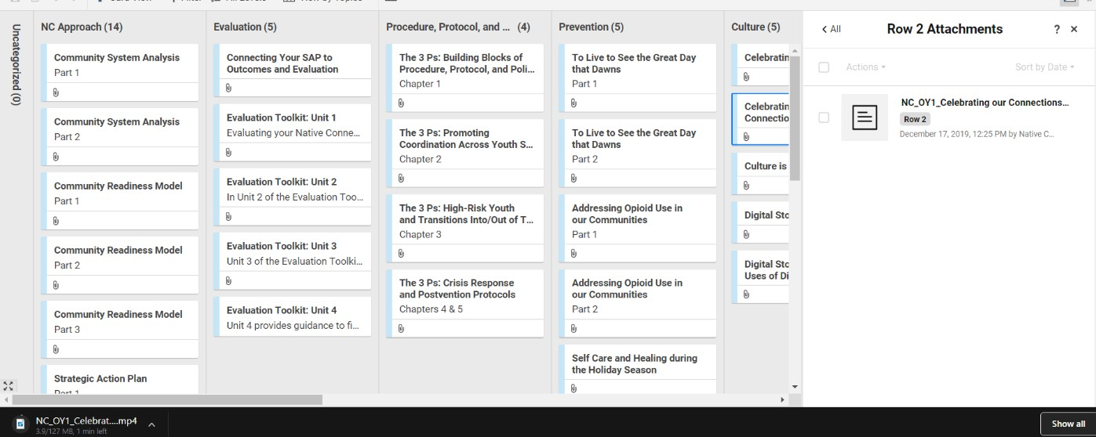

- Or you can click the box to the left of the file name.
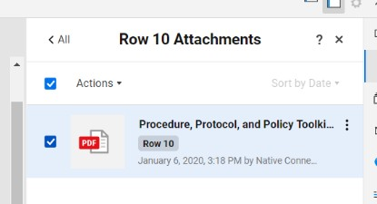

Then click the little arrow by “Actions” to pull up a drop-down menu, where you can select “Download File” (you also have the option to select “Send File” to share it via email directly from Smartsheet).
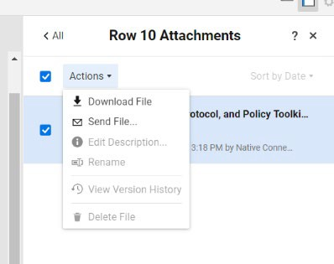

Returning to the NCRC Dashboard
To access the dashboard after you have established your Smartsheet account:
  - Log in to your Smartsheet account (go to Smartsheet.com and click the blue “Log in to your account” button in the center or the blue “Log In” button in the upper right-hand corner)

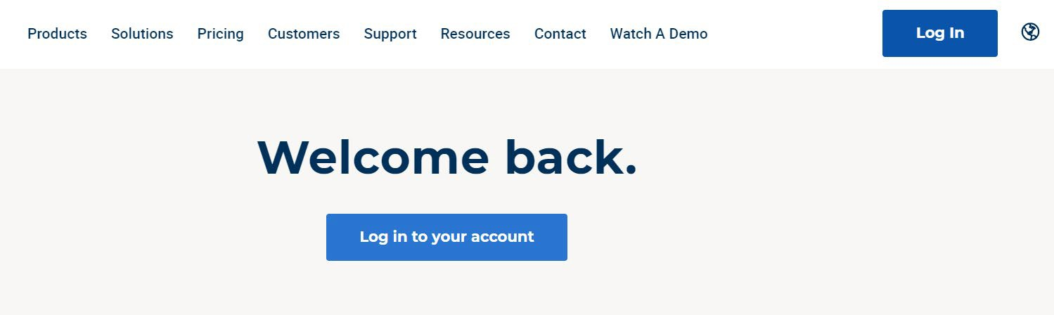

  - 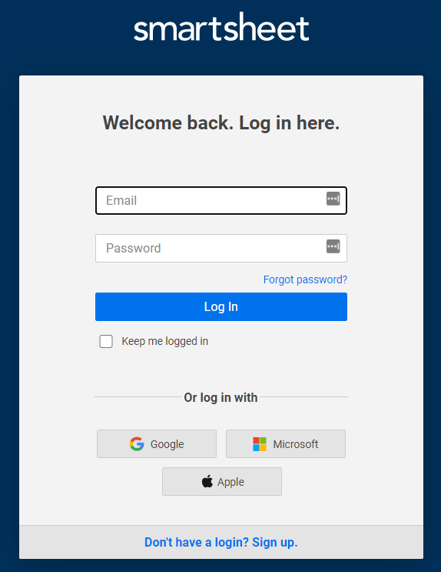Enter the email address and password you used to set up your account and click “Log In” (you can check the little box underneath “Log In” that says “Keep me logged in”).

Depending on your browser, you can choose to have it save your password, so you don’t have to re-enter your login information every time you access the dashboard (which is highly recommended)! For example, this is how it shows up in Google Chrome, and you can just click the blue “Save” button, so the next time you will not have to type in your username and password:
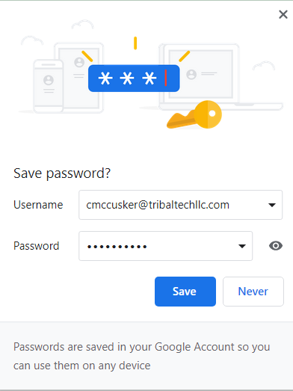

Once you are in your Smartsheet account, on the left-hand side you will see a few icons and menu items.
  - Click on the “Home” icon and then “Workspaces” and “Grantee Material.”
  - You will see a list of all the resource sections, and a direct link to the NCRC Dashboard itself – click on that link to take you to the NCRC home page.
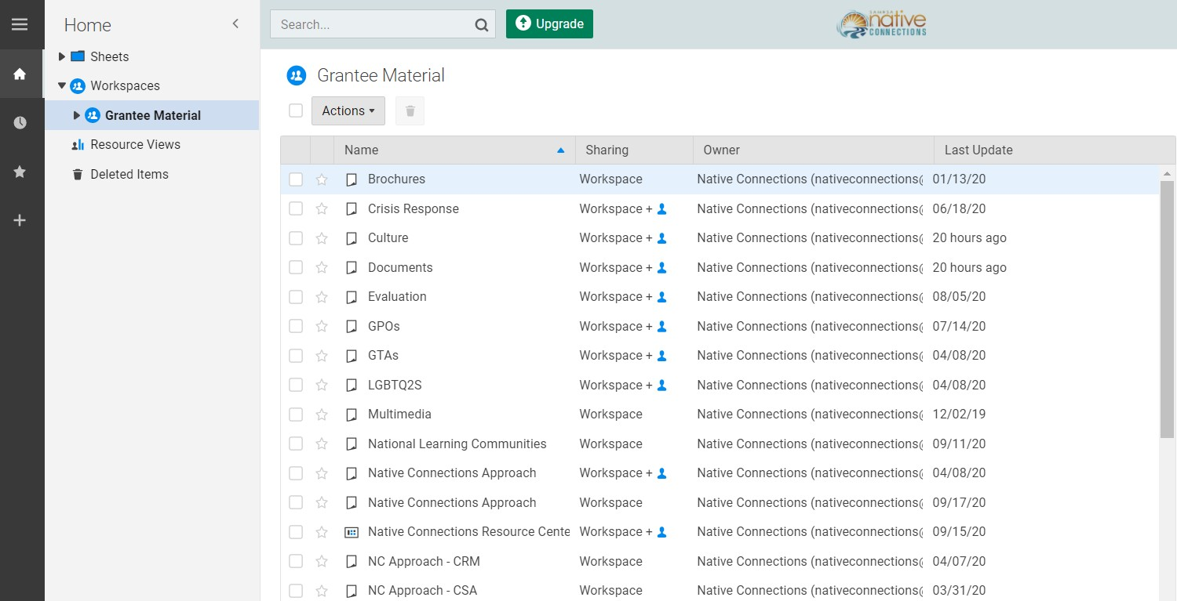

Bookmarking the NCRC
Rather than going in through Smartsheet that way every time, we strongly recommend bookmarking the direct link to the NCRC Dashboard:

https://app.smartsheet.com/dashboards/HXRMJrmvq8WwpQrVwXcRrWV6C2cvC82cWfPCWpR1

This process may differ slightly depending on which browser you are using and the settings. The following steps show instructions for Google Chrome, which works well with Smartsheet. If you are using a different browser, you can search its “help” features for how to set up bookmarks and save passwords.

- Click the 3 little dots in the upper right-hand corner of your browser window to open a drop-down menu, then select “Bookmarks” from the list.
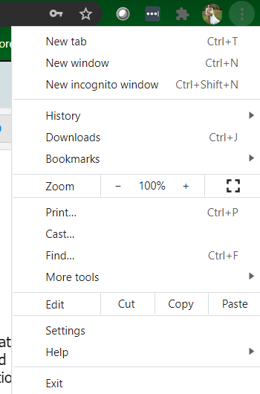

- That will bring up another list where you can select “Bookmark this tab” at the top.
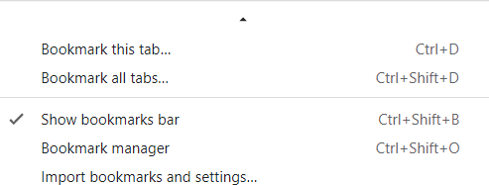

- Then you can name the bookmark how you want it to show up and click “Done.” If you need to manage the order or how your bookmarks show up, you can select “Bookmark manager” from the Bookmarks list.
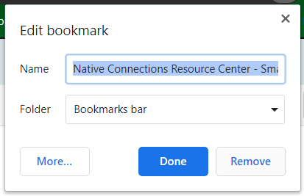

- When you click on the bookmark in the future, it will still take you to the Smartsheet login page first, and once you enter your credentials, it will open directly to the NCRC home page (again, you can use your browser to save your password so you don’t have to manually log in every time).

Need Assistance?
  - Reach out to your GTA
  - Contact Communication Manager Laura Porterfield at l.porterfield@3stargov.com
  - Explore the Smartsheet Help and Learning section
