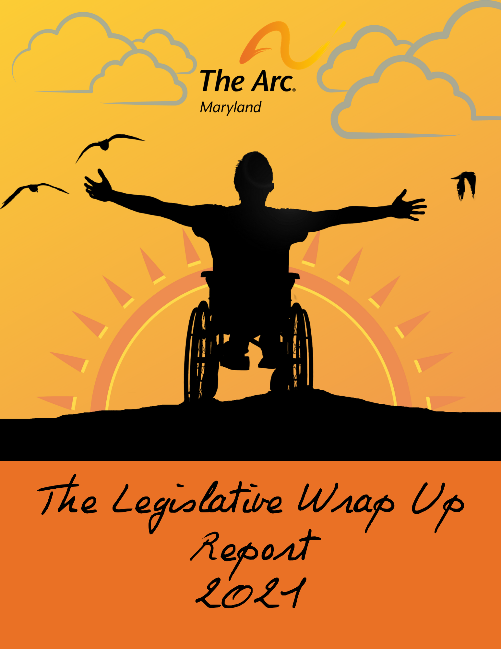

Our Mission: The Arc Maryland works to create a world
where children and adults with intellectual and development disabilities (I/DD) have and enjoy equal rights and opportunities.

LEGISLATIVE WRAP UP | 2021
The Maryland General Assembly completed its work for the 2021 Legislative Session and adjourned (Sine Die) on April 12, 2021 at midnight.
Thomas “Mike” Miller
The unique session, that was almost entirely virtual for the public, was punctuated by pandemic-related bills, a historic windfall of federal relief funding, and the loss of Maryland State Senator and former longstanding President of the Senate, Thomas “Mike” Miller.
The Arc Maryland’s Public Policy Team, Governmental Affairs Committee, and Coalitions of which we are partners, covered several bills in the session that presented challenges but also opportunities like we have never experienced before. As we were unable to assemble, advocate, educate, and testify in person, our advocacy strategy adjusted to include grassroots email campaigns, social media posts, print media, and story-telling; all critical to our successes. We relied heavily on our relationships with legislators and our many partners, some of which were new this session and grew out of both necessity and opportunity. Some advocates with disabilities, who previously had difficulty participating in the legislative process due to lack of transportation and the distance from their homes to Annapolis, found greater ease with which they could participate this year, while others found the session’s increased reliance on technology to be a hinderance to their participation.
Through it all, we are incredibly proud of our results and the impact our collective work will have on children and adults with intellectual and developmental disabilities (IDD), their families, and providers of community supports, now and in the years to come.
Highlights of the 90-day period between January and April include the historic $52.4 billion dollar state Operating Budget for FY22, provider impact bills (such as the RELIEF Act and the Maryland Essential Workers Protection Act), several education and access bills, and voting and other human rights bills.
The Senate got straight to work early on to override 16 of the bill vetoes that Governor Hogan made following the 2020 Legislative Session. Of the bill vetoes overrode was SB 796, a bill requiring DDA to make reports on their progress with LTSS, ensure that policies and procedures related to services are in place, conduct an impact analysis on how providers and people with IDD will be affected with the move to LTSS, create a service guide for families, and ensure that every provider has the opportunity to test the LTSS system with their software to identify issues prior to the full launch of the system.
The House followed with matching override actions and worked with the Senate to also restore The Blueprint for Maryland’s Future Act (HB1300); also known as the Kirwan Commission bill. The Blueprint for Maryland’s Future contains education policy recommendations in the policy areas of early childhood education, high-quality and diverse teachers and leaders, college and career readiness pathways, resources to ensure all students are successful, and governance and accountability. The legislation also includes numerous provisions relating to education funding and funding formulas.
The Arc Maryland took positions on 117 House and Senate bills that had implications for people with IDD and their families, and we monitored 58 others, to prepare in the event action was needed.
The Governor’s budget for the Developmental Disabilities Administration, as presented, was favorable for people with intellectual and developmental disabilities. Prior to the budget release, the Governor announced that he would be escalating the timeline for funding the mandate to provide a 4% increase, to Medicaid providers of community supports, 6 months earlier than expected. This increase continued in his proposed FY22 Operating Budget, along with funding for other important services and supports. The General Assembly added to the bounty through its budget committee recommendations and commitments that the increases in Federal Medicaid Matching Funds to the state for HCBS DDA services should largely remain within DDA. The guidance dictates that the funding be used primarily for provider infrastructure, personnel expenses, PPE, restructuring needed to support re-opening, and overall recovery.
They also added 2 million dollars to the budget for the Maryland State Department of Education to be dedicated to expanding autism waiver slots by 100 people, and provided additional funding in the budget for education to address transitional services, trauma identification and support, and learning losses sustained through the pandemic.
There were 2347 bills introduced for consideration this session, and despite the unusual session, our General Assembly was extremely productive, passing 817 of them.
Bills that passed as “high priorities” for The Arc Maryland include but are not limited to:
HB0714/ SB0300 Special Education - Learning Continuity Plan – Requirement
Bill Sponsors: Delegate Guyton and Senator Peters
Passed in the House (131-0) and in the Senate (47-0) to require, beginning October 1, 2021, that an IEP include a learning continuity plan to be implemented during emergency conditions, as specified. In the event of an emergency, within a specified time frame, an IEP team is required to make a reasonable attempt to notify the parent or guardian, of a child who requires an IEP, that a learning continuity plan is in place and to seek input from a parent or a guardian on how the learning continuity plan will best operate under the specific emergency conditions.
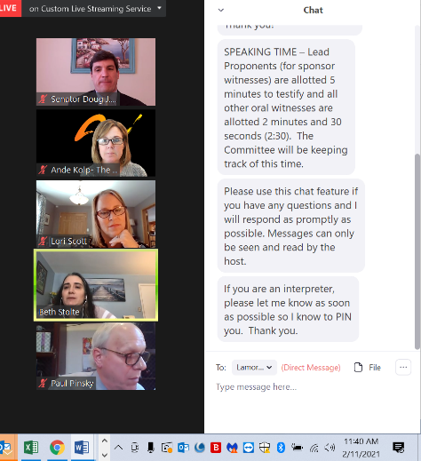
HB0716/ SB0371 Special Education - Individualized Education Programs - Educational Evaluations
Bill Sponsors: Delegate Griffith and Senator Peters
Passed in the House (137-0) and in the Senate (47-0) to expand the circumstances under which a parent may make a request for an Independent Education Evaluation. The Individuals with Disabilities Education Act requires that schools provide students with disabilities with a free and appropriate public education (FAPE) in the Least Restrictive Environment (LRE) for learning. In order to determine what supports and services a student may need to access FAPE, evaluations of the student’s educational strengths and needs must be conducted. Current Maryland law provides that a parent may request an independent educational evaluation at public expense if the parent disagrees with the educational evaluation conducted by the local school system, but there is no current law that provides remedies in the event that a parent or teacher requests an educational evaluation, and the school does not complete the evaluation within specified timeframes. During the pandemic, some school districts racked up a backlog of hundreds of students in need of educational evaluations, creating a barrier for students and families to access services and supports to address learning needs. This bill, if signed, will authorize a parent to submit a written request for the local school system to conduct an educational evaluation and (1) if the local school system does not respond to the request within 30 days or (2) the local school system responds affirmatively to the request but does not conduct the educational evaluation, through no fault of the parent, within 60 days after the date on which the local school system received the request (or within 90 days during a state of emergency), the parent may request an independent educational evaluation at public expense.
HB0321/ SB0061 Public Buildings - Changing Facilities - Requirements
Bill Sponsors: Delegate Ebersole and Senator Lam
Passed in the House (130-6) and in the Senate (47-0) to create a requirement that on or after October 1, 2022, newly constructed or extensively remodeled public buildings provide at least one public restroom (or 1 men’s and one women’s public restroom if restrooms are divided by gender) to have changing stations suitable for holding the weight of an adult.
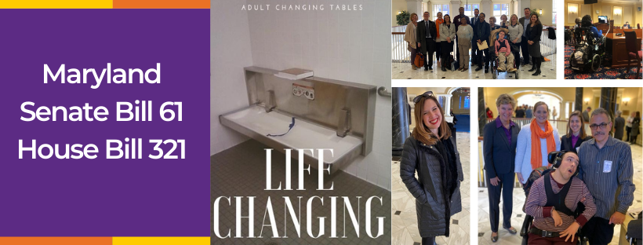
Additional bills of importance that passed are highlighted in the Bills section of this report.
There were several bills that were priorities for The Arc Maryland but did not move this session. These bills include, but are not limited to, the following:
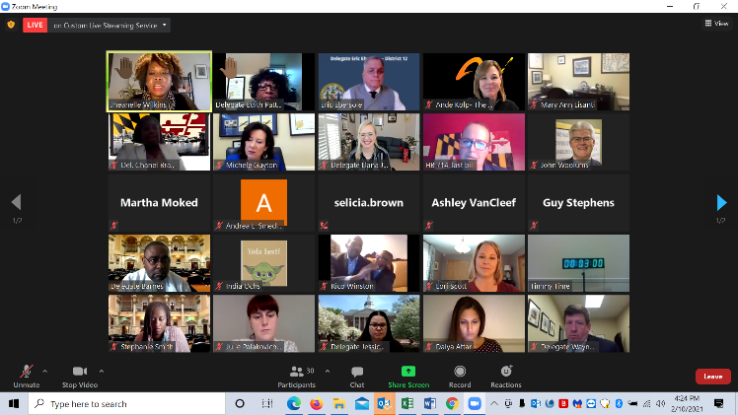
HB0724/ SB0209 Special Education - Prolonged School Closure - Extension of Education Services
The bill would have required county boards of education to offer and provide, to certain disabled and special education students, the option to continue attending school or receiving education services after the student's anticipated graduation/high school exit date. This bill was important to many parent advocates who provided written and oral testimony to the committees in support of the bill. During the pandemic, Transitioning Youth, in their final years of school, missed out on critical transition instruction and in-person experiences that are needed to prepare for independence and employment upon school exit. The bill unfortunately carried a large fiscal note, and although the bill scope was curtailed mid-session to address the cost of the measure, the momentum was not there to propel the bill forward.
HB1166 Education - Physical Restraint and Seclusion - Requirements, Reporting, and Training
The bill as enacted would have prohibited a public agency or nonpublic school from using a physical restraint on a student as a behavioral health intervention, except under certain circumstances, and would have prohibited a public agency or nonpublic school from using seclusion as a behavioral health intervention for a student, except under certain circumstances. It would have also required a certain risk assessment to be completed at certain points for a student who has an individualized education plan and experiences a seclusion.
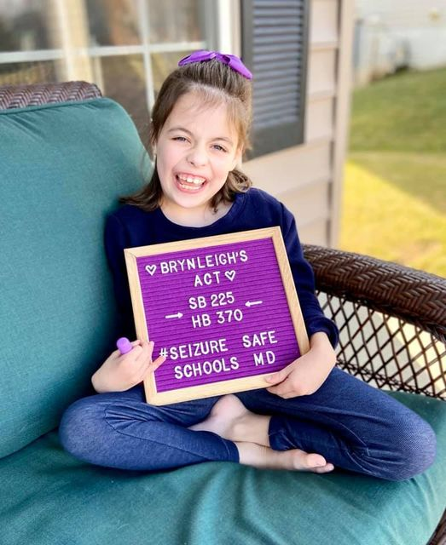
HB0370/ SB0225 Education - Public and Nonpublic Schools - Seizure Action Plans (Brynleigh's Act)
The legislation would have required an individualized, written seizure action plan for each student with a seizure disorder attending a public school. The bill would also have required training for at least 2 members of personnel in each school. There are approximately 7,900 children living with epilepsy in Maryland. This amounts to a ratio of roughly 913 students for every 1 school nurse.
Education, information, and training on seizure recognition would ensure school personnel are prepared and can recognize and respond appropriately and efficiently to a student experiencing a seizure, thus creating a safer environment for every student in Maryland’s public schools. Parents, as critical partners in education, would be actively involved in collaboration with school personnel to create a seizure action plan for their student with a seizure condition.
HB0392 Child Care Centers - Early Childhood Screening and Assistance
This bill would have increased childhood screening for early identification and intervention by requiring certain providers of Child Care services to provide early screening opportunities to families and, if needed, information and assistance to obtain an assessment.
HB0318/ SB0441 Developmental Disabilities Administration - Self-Directed Services (Self-Direction Act)
This bill sought to create an advisory council for Self Directed Services and to preserve and restore services and definitions in Self Direction that are important to many people.

HB0375/ SB0211 Labor and Employment - Family and Medical Leave Insurance Program - Establishment (Time to Care Act of 2021)

The Arc supported the intention of this bill and the establishment of an insurance program that would be created to allow for paid family leave. We provided information about our concerns related to the breadth of some of the definitions and the expense of the new insurance program to DDA providers, Direct Support Professionals, and people who self-direct. Without a provision in the bill to address the funding concerns related to creating this new trust fund and leave benefit, the program would amount to an unfunded mandate for DD providers and staff.

HB0715/ SB0665 Public Schools - Self-Contained Special Education Classrooms - Use of Video Recording Devices
This bill was important to many of the families who are members of The Arc. The sponsor limited the bill’s application to only self-contained classrooms at the urging of advocates and in recognition of costs. The advocates argued that this bill would help students as well as teachers in situations where there are unexplained injuries to a student. One concern that was voiced by a parent in opposition to the measure was whether the schools would be able to use the footage captured of a student to justify another placement or in disciplinary proceedings against a student. Despite assurances the video would not be used in this way, the bill was ultimately withdrawn and advocates have committed to addressing concerns/incorporating safeguards to a new version of the bill to be presented again next session.

There were bills, to which we responded with advocacy and education, that posed potential impact to the DSP workforce and Providers of Community Developmental Disabilities Supports. These included measures designed to provide additional paid leave to workers, provide safety assurances, require certain trainings, create occupational disease exposure presumption standards, and provide hazard pay. While all were well-intentioned, there were components of each bill which would have presented unintended consequences to the IDD community, families, and supporting providers. In these cases, The Arc worked with other advocates and partners to educate legislators. Through our work, we were able to accomplish amendments and compromises in many cases.
Several Workers Compensation-Occupational Disease Presumption (COVID-19) bills, that were presented this session, sought to assign a presumption of occupational exposure in cases where a worker contracted COVID within a certain time period after having been on the worksite. In the case of some of the bills, this presumption would have applied to “related institutions” such as those that support people with IDD. The bills did not advance, however, after the Maryland Workers Compensation Commission provided information to illustrate that they are typically able to effectively utilize contact tracing to determine exposure source, including workplaces and non-work places, and it was therefore determined in the committees that the change in law was not needed.
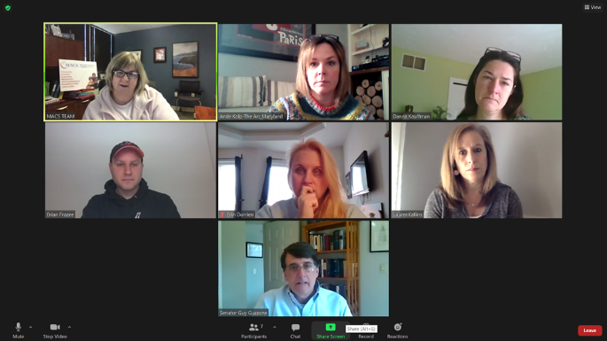
One bill that garnered a lot of attention this year in the general assembly was HB0581 Labor and Employment - Employment Standards During an Emergency (Maryland Essential Workers' Protection Act)
As the bill moved through several workgroup and subcommittee meetings, it was amended to reference safety standards and protocols already in place in Maryland with a couple of exceptions. While The Arc supported the intention of the bill and is committed to safe working environments, fair pay, and ensuring employees have access to testing and PPE at no expense to themselves, this bill, as originally drafted was overly broad. It included problematic definitions, would have required employers to navigate dual and possibly conflicting standards for safety plans and protocols, and would have required additional worker pay and benefits without identifying a funding source to support the pay and benefits.
Medicaid providers, like those operated by The Arc organizations in Maryland, are prohibited from passing along any additional costs associated with doing business to recipients of the service. The funding, needed to cover any increases in costs, would have to come from rate increases of state funds. There was no funding appropriation identified in the bill or budget to cover the costs associated with the bill, if it were to pass as written.
As amended (and passed by both Chambers), and if signed by the Governor, House Bill 581 would become effective immediately, and activate with the Governor’s proclamation of a “catastrophic health emergency due to a communicable disease.”
The bill defines “essential worker” as an individual who performs a duty or work responsibility during an emergency that is required to be completed at the worksite. An “essential worker” provides services that the essential employer determines to be critical to operations. The bill defines “Essential employer” as a person that employs an essential worker, including a unit of State or local government. Employers must provide safety equipment to their essential employees (subject to availability) and follow OSHA and MOSH safety standards as applicable. The bill also requires MOSH to develop emergency temporary standards if necessary. In addition, an essential employer must provide up to 14 days of paid public health emergency leave for full time workers (fewer days are required for part time workers) if there is a specified funding source from federal or state sources. An essential worker continues to have the right to refuse to perform an assigned task under current Occupational Safety and Health Administration (OSHA) standards.

Developmental Disabilities Administration (DDA)
FY22 Budget

Please note that these numbers of people to be served are estimates and the amounts are rounded.

The budget for FY22 includes the mandated 4% funding increase for DD Community Services.

RATES/WAGES FOR COMMUNITY SERVICES – 4%
The Minimum Wage Act of 2019 mandated a 4% rate increase for DD Community Services funding. $51.2 million for FY22 is included in the proposed budget to continue the 4% rate increase that was implemented 6 months early on January 1, 2021. (General + Federal Funds)
TRANSITIONING YOUTH
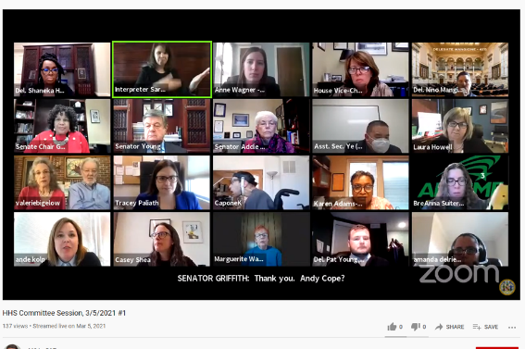
$23 million
600 Individuals
This is projected to support 600 Transitioning Youth who are exiting the school system in fiscal year 21 and who are eligible for DDA employment and other day supports in FY22. (General + Federal Funds)
EMERGENCIES
$2.37 million
39 Individuals
This is projected to support 39 people to access community supports and services, for individuals in emergency situations. (average 6 months actual) (General + Federal Funds)
WAITING LIST – CRISIS RESOLUTION AND PREVENTION
$13.7 million
296 Individuals
Community supports and services for people in the highest priority categories on the DDA Waiting list, including people in Crisis Resolution and Crisis Prevention categories. (average 6 months actual) (General + Federal Funds)
WAITING LIST EQUITY FUND
$6.3 million
38 Individuals
Support for individuals on the DDA waiting list – priority is given to people with the oldest caregiver. (Special Funds)
DSS AGING OUT PLACEMENTS
$4.1 million
21 Young Adults
DDA- funded community supports for individuals aging out of Department of Social Services programs. (General + Federal Funds)
LOW INTENSITY SUPPORT SERVICES (LISS)
$5.5 million
2000 Individuals and families
Short term, low-cost services that support children and adults who aren’t receiving other DDA services. (General Funds- No matching Federal Funds)
The General Assembly also passed budget language requiring the DDA to report on several things this year, including:
HCBS FMAP Usage Requirement:
At least 75% of federal funds attained by DDA resulting from any enhancement to the FMAP for home – and community –based services authorized in the American Rescue Plan Act of 2021 may be expended only on a one –time rate increase paid to community providers that are reimbursed under program M00M01.02 and are licensed, certified, or approved under Section 7 of the House General Article, including coordinators of community services.
DDA shall apply the rate increase retroactively to all services provided in the first two quarters of fiscal 2020 and shall pay community providers the rate increase in at least two payments.
DDA shall disburse the first payment no later than October 7, 2021, and the final payment no later than April 7, 2022.
Remaining federal funds attained from any enhancement to the FMAP for Home and Community Based Services authorized in the American Rescue Plan Act of 2021 may be expended only on a commensurate one–time rate increase applied to services provided in the first two quarters of fiscal 2020 for individuals enrolled in self–directed services as of October 1, 2021, and
grants to community providers and nonprofit organizations reimbursed under program M00M01.02 for the development of resources and infrastructure to enhance independence and inclusive opportunities, which shall include and not be limited to development of models to provide independent affordable housing, expanded use of technology, and technical assistance from subject matter experts, for individuals who receive DDA –funded services.

The General Assembly specified that no more than 5% of federal funds attained by DDA resulting from any enhancement to the FMAP for home – and community –based services authorized in the American Rescue Plan Act of 2021 may be expended for administrative costs, which shall be restricted to expenses to expedite new placements in DDA–funded Home and Community Based Services and to improve the processing of person centered plans.
Services for Transitioning Youth: Transitioning Youth Placements:
The budget committees are concerned that individuals who are eligible for adult services funded by the Maryland Department of Health Developmental Disabilities Administration (DDA) are not starting these services in a timely manner after aging out of youth services. The budget committees request that DDA submit a report including:
-the number of transitioning youth referred to DDA who have exited the State educational system, have not received approval for DDA funding since exiting, and/or have not begun DDA-funded services (aggregated by fiscal year from fiscal 2018 to 2022 year to date);
-a list of reasons that transitioning youth who exited the State educational system and were referred to DDA in fiscal 2018 through 2022 year to date have not begun to receive DDA-funded services;
-barriers and delays that have prevented transitioning youth from receiving approval and placement into DDA-funded services;
-DDA’s plan to ensure that services for transitioning youth are approved and provided in a timely manner for individuals who exit the educational system in fiscal 2022;
-a timeline and necessary steps to ensure that all transitioning youth who are deemed eligible for DDA-funded services throughout fiscal 2022 are able to begin services by July 1, 2022; and
-a discussion of how the COVID-19 pandemic and transitioning youth’s ability to extend services provided through the Autism waiver have impacted the approval and placement process for DDA-funded services.
Report on transitioning youth placements due October 1, 2021.
Community Service Utilization Data and Spending Forecasts: The Maryland Department of Health is required to submit a report to the budget committees that will be made available as the Developmental Disabilities Administration (DDA) Community Services program transitions to a fee–for–service (FFS) reimbursement system.
The report should include:
1. A plan and timeline for providing data to the Department of Legislative Services on utilization by service type on a monthly basis for DDA–funded services billed through the Long-Term Services and Supports (LTSS) system;
2. A plan and timeline for forecasting general fund spending in the Community Services program in fiscal 2023 and beyond based on actual utilization and reimbursements billed through the LTSS system following the transition to a FFS reimbursement model;
3. The number of individuals receiving DDA–funded services and providers that transitioned to the LTSS system before the start of fiscal 2022 and the number of individuals and providers transitioned to the LTSS system in fiscal 2022 year to date;
4. A cost analysis of the rates paid to providers that were transitioned to the LTSS system as part of the initial LTSS pilot program and how DDA’s reimbursements compare to the estimated payments that would have been made under the prospective payment model; a
5. A description of the utilization and spending data that is available through the LTSS system and would assist DDA in forecasting its spending needs; and
6. A plan and timeline for ensuring that providers, including coordinators of community services, have the ability to automatically exchange electronic data with the department through an application program interface with the LTSS system in accordance with Chapter 7 of 2021.
The report shall be submitted by November 1, 2021, and the budget committees shall have 45 days from receipt of the report to review and comment.

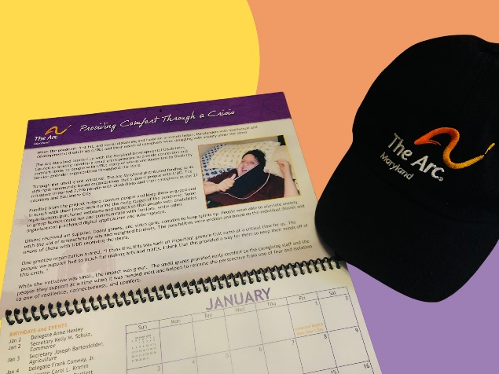
Calendar Day
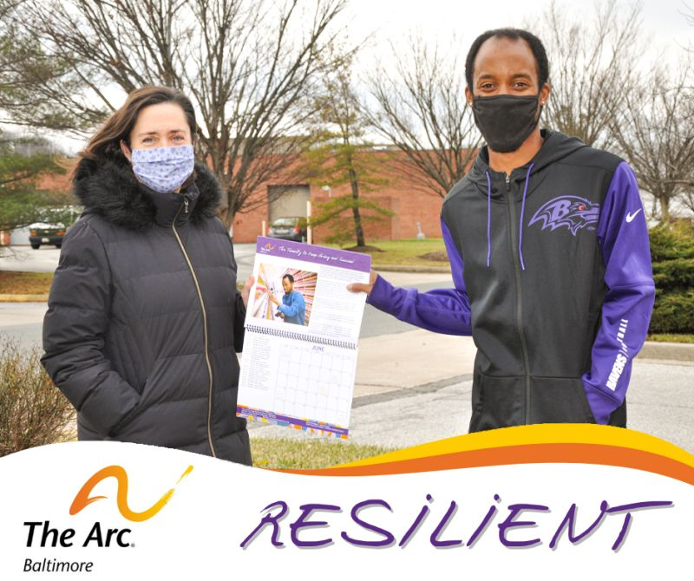
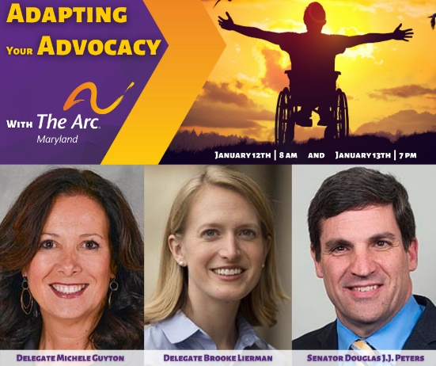

One of our biggest advocacy events of the year, Legislative Calendar Day, was expanded to four days, from January 12th to the 15th, where we provided advocacy training opportunities and chapters of The Arc held meetings with their legislators to set the stage with our session priorities.

The Adapting Your Advocacy training events provided participants with tips gathered from state legislators on “making your case,” and provided opportunities for attendees to learn about legislative priorities of The Arc while stepping through the procedural changes that were being made to support the virtual nature of the session including hearing witness procedures, submissions of testimony, floor session protocols, communications, visits with legislators, and more.

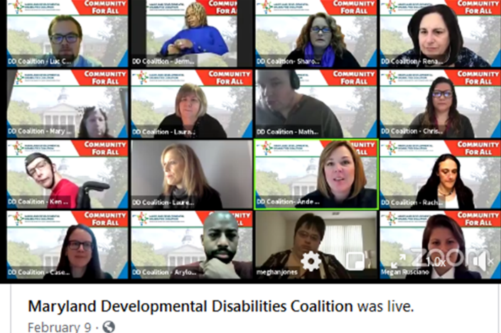
DD Day at the Legislature
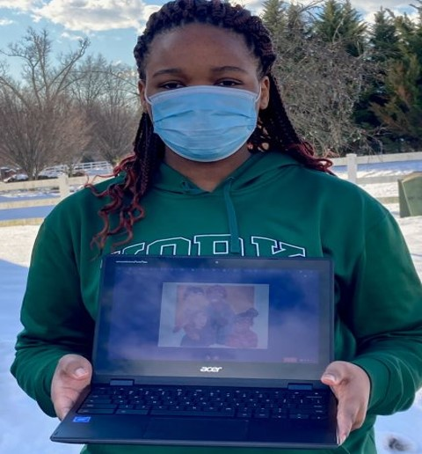
From February 9th to 12th, people with IDD, their families, Direct Support Professionals, provider organization employees, and legislators across the state celebrated Developmental Disabilities Days at the Legislature! The week of online advocacy began in earnest on the 9th during our main event, #CommunityForAll, where more than 1000 advocates logged in, joining together on Zoom and Facebook Livestream to hear about priorities during Maryland's 2021 Legislative Session.
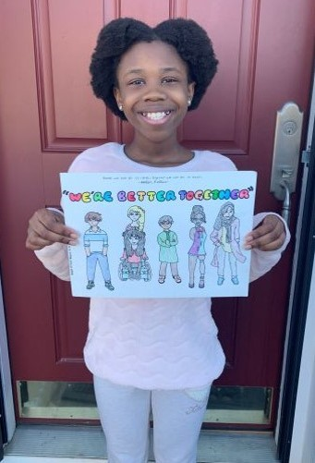
Throughout the morning, advocates heard from the Governor and First Lady Hogan, Members of our Senate and House leadership, the Maryland Department of Disabilities, the Developmental Disabilities Administration, and the Maryland State Department of Education. We also highlighted the Together We’re Better Art Contest and honored students whose works of art, depicting inclusion, were selected for award!
All speakers expressed their gratitude for the advocacy of Marylanders with IDD and their strength during a difficult 2020. Our champions in the legislature renewed commitments to our community and highlighted legislative priorities including the FY22 budget and other initiatives to protect and advance the rights of people with IDD.
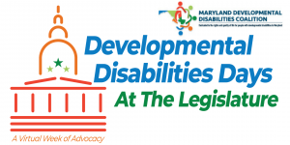
The fact sheets provided in DD Day packets were made available in modified formats through the mail and also online. DD Coalition partners took turns highlighting some of our coalition’s priorities to include Changing Facilities, bills impacting supports to children and families, the DSP Workforce, the SAFE Act (Financial Exploitation Bill), the RELIEF Act of 2021, Voting Access bills, and the DDA Proposed Budget for FY22.

World Down Syndrome Day
The Arc Maryland and our partners at the Chesapeake Down Syndrome Parent Group, the Maryland Department of Disabilities, Maryland Managed Care Organization Association, Maryland Catholic Conference, Ashlar Government Relations, and Bellamy Genn Group celebrated World Down Syndrome Day (WDSD) with an online event and dance party on Friday, March 19th. We were joined by parents and advocates who told their stories of joy and success. Maryland’s First Lady, Yumi Hogan, who has supported the event every year, provided a heartfelt address to everyone in attendance, and several legislators attended to present citations and to provide messages of hope and solidarity.

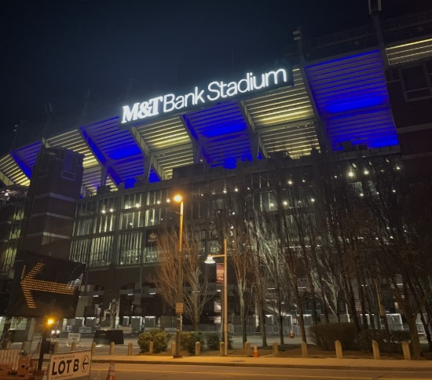
After the talking was done, participants celebrated with a wild Dance Party where everyone showed off their colorful and mismatched socks: A WDSD tradition!

The Friday event was the perfect pre-party to the world-wide celebration on Sunday, March 21st. People in Baltimore and Annapolis witnessed beautiful spectacles of light on some iconic Maryland architecture, as the Orioles and Ravens lit up their stadiums blue and yellow, and the Governor's Mansion shined blue for WDSD.
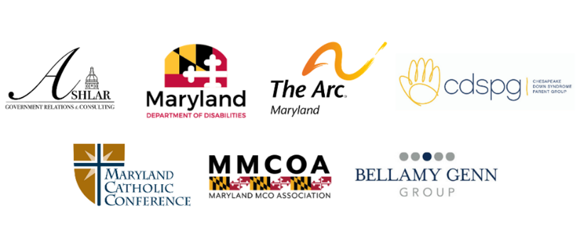

Bills
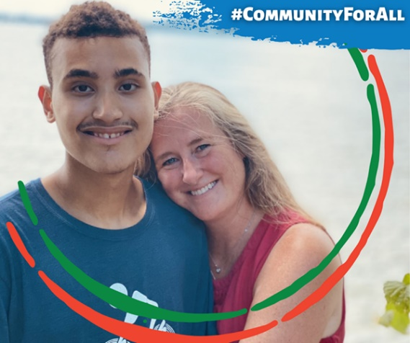
The Arc Maryland tracked several bills throughout the 2021 Legislative Session.
We are highlighting bills that passed, our positions taken on “followed” bills, and outcomes of the session. Bills are listed in this section of the report under the topics of Community Living and Working, Education and Child Care, Health Care, and Justice and Civil Rights. Please note that, in many cases, the Governor has not yet taken action to sign, not sign but allow to pass, or to veto any of these bills. By law, the Governor has until June 1, 2021 to take any actions he intends to take on this legislation.
Community Living and Working
SB0496 Recovery for the Economy, Livelihoods, Industries, Entrepreneurs, and Families (RELIEF) Act
Passed Enrolled; Signed by the Governor.
Support
SB0496 (Ch. 39), was an emergency bill (now signed into law) that provides tax relief, economic impact support, and other forms of funding assistance to businesses struggling to recover from the COVID-19 pandemic. Among many things, the Act includes funding for special education, tutoring and summer school, and 5 million dollars for providers of community supports to assist with funding losses during COVID, recovery, and transformation/reopening needs. The RELIEF Act allocated $586 million in State support in the current fiscal year budget for one-time only emergency relief. This funding has time-limited status and will not carry forward into the FY22 budget.

HB0056/ SB0473 Labor and Employment - Leave With Pay - Bereavement Leave
Returned Passed
Letter of Information
Under the Maryland Flexible Leave Act, a private-sector employer who provides paid leave to its employees must allow an employee to use earned paid leave to care for an immediate family member. Senate Bill 473/House Bill 56 (both passed) expand Maryland’s Flexible Leave Act by authorizing employees of employers with at least 15 employees to use earned paid leave for bereavement leave. An employee is allowed to use bereavement leave for the death of the employee’s immediate family member, including an adult child of the employee.

HB0581/ SB0486 Labor and Employment - Employment Standards During an Emergency (Maryland Essential Workers' Protection Act)
Returned Passed
Opposed
See reference to this bill earlier in this wrap up report.

SB0307 Labor and Employment - Direct Care Workforce Innovation Program
Returned Passed
Support
The Arc Maryland supported this bill with coalition testimony. The bill establishes a Direct Care Workforce Innovation Program and provides matching grants to eligible entities to create and expand on successful recruitment and retention strategies for direct care workers in the State. Beginning in fiscal 2023 and each fiscal year thereafter, the Governor must include in the annual budget bill an appropriation of at least $250,000 for the program.

HB0718 State Coordinator for Autism Strategy and Advisory Stakeholder Group on Autism-Related Needs - Mandated Appropriation
Returned Passed
Letter of Information
Last legislative session, Chapter 341 of 2020 created a Coordinator of Autism Strategy position and an advisory stakeholder group on autism-related needs in the Maryland Department of Disabilities (MDOD). However, the fiscal 2022 budget, as presented by the Governor, did not include funding for these purposes in MDOD. House Bill 718 (as amended and passed) will move the position from MDOD to GOCI without requiring a specific amount for an appropriation, however funding was included for the position in the budget upon passage. Our letter of information supported the need for a funded position that can assist individuals with disabilities and their families to access needed services and supports, locate needed resources/coordinate services, and generally improve options and access for people with disabilities.

SB0610 Lodging Establishments - Accessible Rooms for Individuals With Disabilities – Deadlines
Returned Passed
Opposed
The sponsor sought and was given approval, through bill passage, to move the timeline for law compliance back by one year for lodging establishments to have 25% of its ADA rooms contain a bed of accessible height and with space underneath to accommodate the legs of a hoyer lift. Given that the law passed last year had already provided a fair runway for changes, we opposed an extension to that timeline change.

Education and Child Care
HB0097/ SB0066 Department of Housing and Community Development - Office of Digital Inclusion - Established (Digital Connectivity Act of 2021)
Passed Enrolled; Signed by the Governor.
Support
There has been a great inability for children to access virtual education due to gaps in service and income. This needs to be addressed for equity in access. This bill establishes an Office of Digital Inclusion in the Department of Housing and Community Development to ensure that every resident of the State is supported by high-quality broadband Internet service at an affordable price, and has the tools necessary to use and benefit from the use of the Internet.

SB0218 Maryland Child Tax Credit
Returned Passed
Support
Senate Bill 218 (Ch. 40), which became law on March 5, 2021, will allow certain taxpayers to claim a care credit against the state income tax for a qualified dependent child, defined as a child that is under the age of 6 years OR is under the age of 17 years and is a child with a disability.
HB0714/ SB0300 Special Education - Learning Continuity Plan - Requirement
Passed Enrolled
Support
See reference to this bill earlier in this wrap up report.

HB0716/ SB0371 Special Education - Individualized Education Programs - Educational Evaluations
Returned Passed
Support
See reference to this bill earlier in this wrap up report.

HB0547/ SB0485 Maryland Medical Assistance Program - Dental Prophylaxis Care and Oral Health Exams
Returned Passed
Support
Expands Medicaid coverage of dental claims to allow for more frequent cleaning appointments as indicated to be needed by dentists.

Health Care
SB0096 Public Health - Behavioral Health Programs and Health Care Facilities - Safety and Community Relations Plans
Returned Passed
Letter of Information
While the safety plan component of the bill was a positive component, the community communication plan was of concern to The Arc. People with disabilities have the right to access the community and be in and of the community with preservation of privacy. NIMBY is an ongoing concern, and we had concerns this bill, as written, could fan that fire. Clarifying conversations and amendments resolved concerns and it is clear that the scope of this bill is limited to certain facilities applying for certain credentialing.
HB0368/ SB0100 Task Force on Oral Health in Maryland
Passed Enrolled
Support
The Arc Maryland supported this bill with the DD Coalition as it will create a task force to look at equity in access to dental care for underserved populations.

HB0463/ SB0172 Maryland Health Equity Resource Act
Passed Enrolled
Support
The bill will establish a process for designating Health Equity Resource Communities (HERCs) in which State resources must be targeted to reduce health disparities and improve health outcomes. The bill also requires the establishment of a Pathways to Health Equity Program, which will sunset on June 30, 2023. The Pathway will provide the blueprint for the development of a permanent HERC program and provide grant funding to specified entities.

HB0123/ SB0003 Preserve Telehealth Access Act of 2021
Passed Enrolled; Signed by the Governor.
Support
Telehealth has been critical for people with disabilities and the ability of providers in our system to support people through this virtual mechanism has been important for continuity of services and supports. In many cases, the timely assessment that telehealth provided resulted in greater identification of illness and for more prompt and appropriate treatment. It is important to our community for physical and mental health access and we anticipate this bill will help aid in the expansion of this service well beyond the pandemic.

HB0548/ SB0299 Human Services -Trauma-Informed Care - Commission and Training
Returned Passed
Support
This bill creates a Trauma-Informed Care Commission composed of members of various state agencies and advocates, to make recommendations for the design of training, as well as services and supports needed to address the needs of citizens for trauma-informed care.

HB0636/ SB0546 School Buildings - Drinking Water Outlets - Elevated Level of Lead (Safe School Drinking Water Act)
Returned Passed
Support
The bill alters the definition of "elevated level of lead" for purposes of certain provisions of law and requires the periodic testing for the presence of lead in drinking water outlets in occupied public and nonpublic school buildings. Reducing the amount of “allowable” lead in drinking water consumed by school children is an important step toward reducing incidents of lead exposure and poisoning. Lead exposure and lead poisoning is linked to an increased prevalence of the development of disabilities in children.
Justice and Civil Rights
HB0090/ SB0687 State and Local Housing Programs - Affirmatively Furthering Fair Housing
Passed Enrolled
Support
The bill provides the opportunity to track housing assistance waiting lists and ensure there is an adequate housing stock of accessible and affordable housing to meet the shelter needs of people with very low income and disabilities.

HB0234/ SB0607 Criminal Law - Harm to Service Animals
Passed Enrolled
Support
The bill will prohibit a person from willfully and maliciously killing, injuring, or interfering with the use of a certain service animal in a certain manner, or allowing a certain animal to kill, injure, or interfere with the use of a certain service animal in a certain manner and establishes severe penalties for violations of the Act.
HB0321/ SB0061 Public Buildings - Changing Facilities - Requirements
Returned Passed
Support
This bill creates a requirement for newly constructed or extensively remodeled public buildings to provide changing stations suitable to hold the weight of an adult.
See reference to this bill earlier in this wrap up report.

SB327 Civil Actions - Financial Exploitation of Susceptible Adults and Older Adults (Maryland SAFE Act)
Passed Enrolled
Support
This bill is important because it is an unfortunate fact that some adults with disabilities are vulnerable and at risk of a range of exploitative or coercive behaviors including financial, physical, or emotional abuse. Those who are elderly or have significant support needs are susceptible to increased risk of losing their assets to those exerting undue influence on them.

This legislation redefines the term “undue influence” and adds factors the court must consider when determining whether property was obtained from a person with disabilities as the result of financial exploitation. The bill defines what civil actions may be faced by someone guilty of exploiting susceptible and older adults.

HB1000 Estates and Trusts - Guardian of Property of Minor or Disabled Person - Prohibition on Distribution or Disbursement
Returned Passed
Support with Amendment
The bill will prohibit a guardian of the property of a minor or disabled person from distributing or disbursing property of the minor or disabled person without court authorization or confirmation, if the guardian is not a family member of the minor or disabled person under certain circumstances. The bill states that if a guardian of the property violates the Act, the guardian is liable for breach of the guardian's fiduciary duty to certain persons to the same extent as a trustee of an express trust.
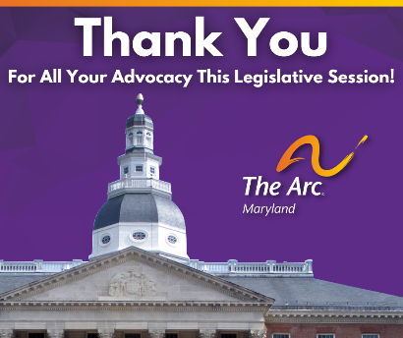
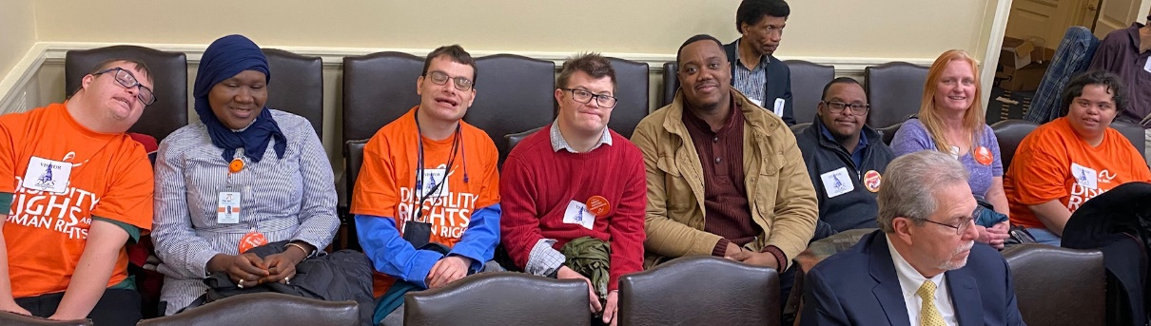
The Arc Maryland extends our sincere thanks to Governor Larry Hogan and the members of the Maryland General Assembly who worked tirelessly to protect and advance the rights of children and adults with intellectual and developmental disabilities; to support families with needed changes to the law as they recover from the pandemic; and to provide critical infrastructure funding and support to community DD providers this session. Notable efforts were made by Senators Douglass JJ Peters, Guy Guzzone, Melony Griffith, Craig Zucker, Jeff Waldstreicher, Paul Pinsky, and Clarence Lam; and Delegates Michele Guyton, Mike Griffith, Joseline Peña-Melnyk, Brooke Lierman, Eric Ebersole, Kirill Reznik, April Rose, and Geraldine Valentino-Smith. We appreciate the thoughtful action taken by the Legislative Committees; in particular, the Budget Committees, EHEA, and Ways and Means where many of our priority bills were heard.
Thank you for your commitment to people with IDD and their families, and your work to create equitable communities that are inclusive and welcoming to all.

The Arc Maryland 2021 Public Policy Team
Ande Kolp, Executive Director
Mat Rice, Director of Public Policy
Dorothy Plantz, Board Member and Governmental Affairs Committee Co-Chair
Beatrice Rodgers, Board Secretary and Governmental Affairs Committee Co-Chair
Ray Marshall, Board President with Session Focus on Vaccine Equity
Lori Scott, Board Vice President and Education Advocacy Co-Chair
Kim Tart, Board Member and Education Advocacy Co-Chair
Guy Stephens, Board Member with Session Focus on Student Rights Advocacy

2021 LEGISLATIVE SESSION

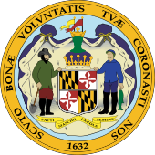
BY THE NUMBERS

439TH SESSION MARYLAND
GENERAL ASSEMBLY

47 SENATORS
(32 DEMOCRAT; 15 REPUBLICAN)
141 DELEGATES
(99 DEMOCRAT; 42 REPUBLICAN)
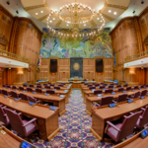

967 NUMBER OF SENATE BILLS
1,380 NUMBER OF HOUSE BILLS

NUMBER OF BILLS TRACKED: 175
117 POSITIONS TAKEN
58 MONITORED
The Arc Maryland ∙ 8601 Robert Fulton Drive, Suite 140 ∙ Columbia, MD 21046 www.thearcmd.org

