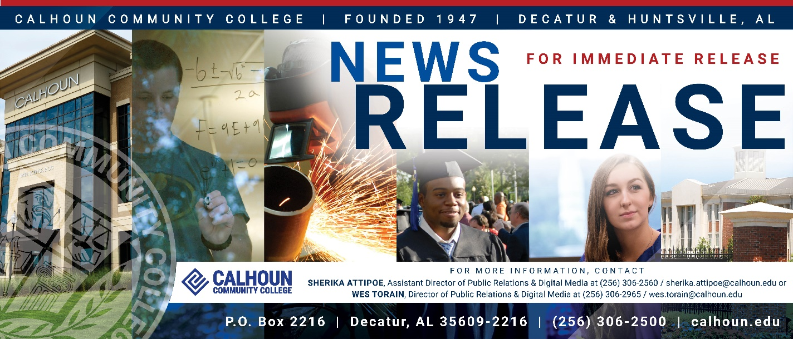

July 29, 2025

FROM HOMESCHOOL TO HIGHER ED: 12-YEAR-OLD PRODIGY ENROLLS AT CALHOUN
Now 13, Van-Houston Begins His College Journey at Calhoun this Fall

While most students his age are preparing for seventh grade, Van-Houston McMillion is preparing for college. Enrolled at just 12 years old, he became the youngest student in Calhoun Community College’s history. Now 13, this remarkable young scholar will begin classes this fall, working toward an Associate of Science in General Education with a focus on chemistry.

His story is more than remarkable. It is a powerful reminder of what is possible when talent is matched with opportunity and supported by intention, encouragement, and the right educational environment.

Van-Houston’s academic journey began early. His mother, Emma-Sara McMillion, noticed his exceptional ability to learn when he began identifying letters and sounding out words around the age of two. By the time most children were learning their ABCs, Van-Houston was reading street signs aloud, watching science documentaries, and asking thought-provoking questions well beyond his years.

"We always knew he was curious and bright, but we didn’t focus on how far ahead he was. We focused on feeding his love of learning," said Emma-Sara. "From reading street signs to discussing systems in society, Van-Houston’s thirst for understanding has always led the way."

After years of individualized homeschooling focused on mastery rather than memorization, and a growing interest in advanced concepts, Van-Houston took the SAT as a benchmark. His high scores confirmed what his family already suspected: he was ready for a more structured and academically challenging setting.

That next step became clear following a series of thoughtful and thorough conversations with Calhoun’s admissions team and faculty. These discussions centered on more than just academic readiness. They also considered his emotional maturity, learning style, and long-term aspirations. What followed was more than a typical enrollment process. It marked the beginning of a collaborative partnership between Van-Houston’s family and Calhoun’s educators, all working to ensure a learning experience that would be both supportive and appropriately challenging.

"We knew we needed a college that would challenge him academically while also offering the support and flexibility needed for a young learner," said Emma-Sara. "Calhoun stood out not just for its strong programs, but for the warmth and intentionality of everyone we encountered."

This fall, Van-Houston will take a combination of in-person and online courses, which will include American National Government, English Composition I, Freshman Seminar, Intermediate College Algebra, Precalculus Algebra, and Music Appreciation.

Dr. Jimmy Hodges, President of Calhoun Community College, shared that Van-Houston’s enrollment aligns with the college’s mission to meet students where they are and provide inclusive, flexible educational pathways.

"Van-Houston is a shining example of what happens when curiosity, hard work, and community come together," said Dr. Hodges. "Calhoun is honored to be a part of his journey, and we are proud to provide a place where students of all ages can thrive and feel valued."

Even before attending his first class, Van-Houston has already connected with academic advisors at the college and received enthusiastic support from faculty members, many of whom have expressed admiration for his maturity, dedication, and humility.

According to his mother, despite his academic achievements, those who know Van-Houston best say it is his character that leaves the greatest impression. "He’s grounded. He’s kind. He never acts like he’s better than anyone else," she says. "His goal has never been about being the youngest. He just genuinely wants to learn and make a difference,” she adds.

Looking to the future, Van-Houston hopes to explore innovative ways to solve real-world problems, start impactful businesses, and study systems deeply in order to improve them.

His story is a testament to the power of personalized education, intentional parenting, and strong community partnerships. With the right support system, even the most nontraditional paths can lead to extraordinary success.

"Calhoun meets its students where they are," said Wes Rakestraw, Calhoun’s Vice President of Academics. "And we feel that is exactly what we have done with Van-Houston. Though he may be young in age, he brings a level of discipline and drive that inspires us all. We are excited to help him reach his goals while supporting his development both academically and personally."

To learn more about Calhoun Community College and the programs that help students of all ages succeed, visit www.calhoun.edu.
For all media inquiries, please contact Calhoun’s Public Relations team at 256-306-2560 or 256-306-2965.
###

