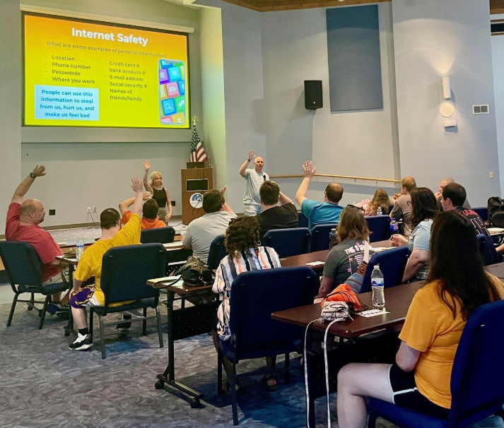

TOPICS TO BE PRESENTED
────
Internet Safety
────
Relationship Safety
────
Stranger Danger
────
Medication Use & Misuse
────
High Risk Alcohol Use
────
Dangers of Smoking, Vaping, and Marijuana Use
────
Interacting with Law Enforcement

Tues, July 29, 2025
TIME: 6:00-8:00

SAFETY NIGHT
We are excited to present our 3rd annual Safety Night in collaboration with Devastated, Talbert House, Safe on Main, Warren County Health Department, Warren County Safe Communities, and Springboro Police Department. Adults 18 years and older are welcome to join us for a fun evening learning strategies to keep yourself safe. You will learn about making safe choices at home, online, and as you navigate your community.

WARREN COUNTY BOARD OF DEVELOPMENTAL DISABILITIES
801 Drake Road
Lebanon, OH 45036

Please RSVP by Friday, July 25th to Amy Hiday at
937 543-2075 or
amy.hiday@warrencountydd.org

WARREN COUNTY


Board of Developmental Disabilities

