St Francis of Assisi Celebration 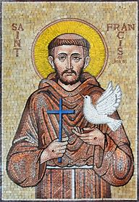
Saturday October 4, 2025: from 8:00 am to 12:00 pm
St Bernadette Catholic Church Social Hall
9020 E 51st Terrace, Kansas City, MO 64133
St. Francis of Assisi is known as the patron saint of ecology, and is well recognized and beloved among Catholics, other Christians, and non-Christians, particularly for his love of Creation, but this celebration will show you some sides of Francis with which you may not be familiar. Bring your friends and family, Catholics and non-Catholics alike!
Bring your friends and family, Catholics and non-Catholics alike!
We will have prayers, learn more about Franciscan Spirituality, watch and discuss the movie, The Letter, and talk about how we can all live a Franciscan life in today’s world.
Light refreshments will be served, including St. Francis’ favorite treat.
Sign up after Mass, Sept. 13 & 14, or Sept 20 & 21. We look forward to seeing you there! Or contact Linda Lysakowski, MTS-FT at Linda@LindaLysakowski.com

