Leadership in all Pathways

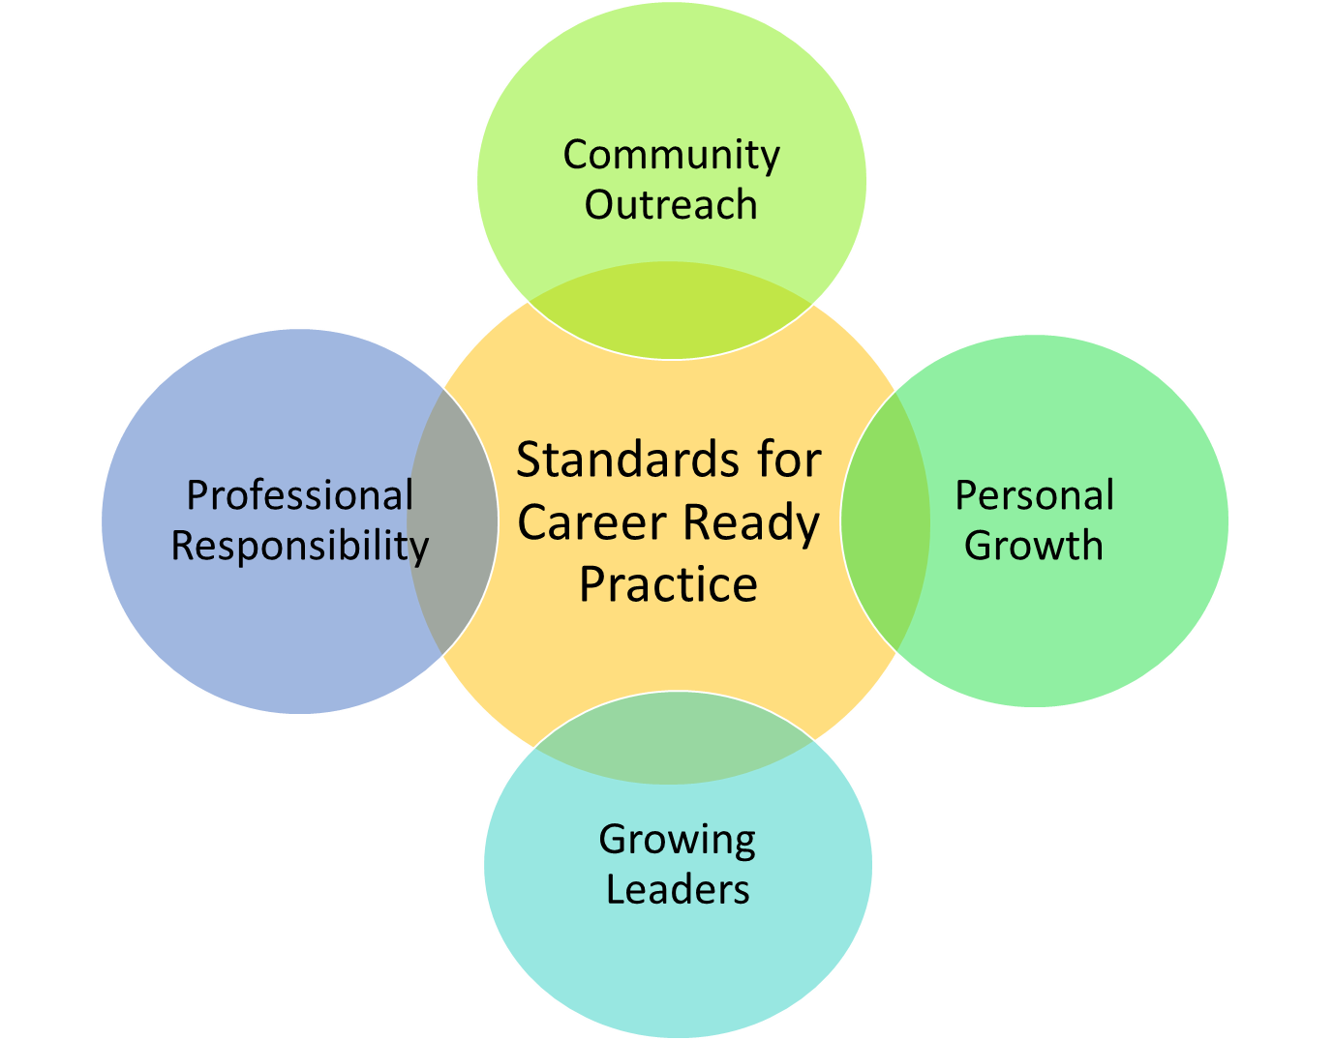

Leadership in all Pathways

Why Teach Leadership? Pg 3

CTSO’s by Industry Sector Pg 4

Standards for Career Ready Practice Pg 9

Leadership Areas:

Personal Growth & Professional Responsibility Pg 10

Growing Leaders Pg 11

Community Outreach Pg 12

Sample Leadership Themes by Course Pg 14

Real World Leadership Example Pg 15

Allowable and Non-allowable Expenditures Pg 16

Why Teach Leadership?

“First, it is nearly impossible to accurately predict which high school or college students are going to develop into our best, most visible leaders—even under traditional definitions.” (Ferguson, D., “Why Teach Undergraduate Leadership”, Andrews University, 2017)

“Learning about leadership is not the same as learning to be a leader.” “But students—along with executives, public servants, clergy, physicians, etc.—can't be leaders by restricting their learning of leadership to the classroom.” (Posner, B, “Be Leaders: Do Leadership”, Wiley, 2000-2017)

“Being a great leader means both managing tasks and functions well, but also understanding how to behave and ‘show up’ as a leader. It can be hard to grasp for some, but it can be learned.”
(Caprino, K, “What Great Leadership Training Does Now That It Didn’t 10 Years Ago”, www.Forbes.com, Aug 1, 2014)

“We learn to lead through the experience of leading — and following. Even if ‘leader’ has never been your job title, you have surely led, at work and outside of it.”
(Petriglieri, G., “Who Can Teach Leadership?”, Harvard Business Review, August 28, 2012)

California Career Technical Student Organizations

Cal-HOSA  HOSA is a national student organization with a twofold mission: to promote career opportunities in the health care industry and to enhance the delivery of quality health care to all people.  HOSA’s California affiliate, Cal-HOSA, provides a unique program of leadership development, motivation, and recognition exclusively for secondary, postsecondary, adult, and college students enrolled in Health Occupations Education programs. | www.cal-hosa.org  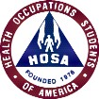  Contact: Cindy Beck  CA Department of Education 1430 N Street, Suite 4202  Sacramento, CA 95814  916-319-0470 cbeck@cde.ca.gov
DECA  California DECA is a student organization whose program of leadership and personal development is designed specifically for students interested in marketing, management, and entrepreneurship. DECA helps students develop skills and competence for marketing careers, to build self-esteem, experience leadership, and practice roles in the community. | www.cadeca.org  Contact: Michelle McIntosh  CA Department of Education 1430 N Street, Suite 4202  Sacramento, CA 95814  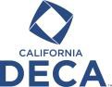  916-327-6367 mmcintosh@cde.ca.gov
FBLA  As an integral part of an instructional program, the Future Business Leaders of America provides opportunities for secondary students in business education and business-related fields to develop career supportive competencies and to promote civic and personal responsibility. | www.cafbla.org  Contact: Gary Page  CA Department of Education 1430 N Street, Suite 4202  Sacramento, CA 95814  916-319-0499 gpage@cde.ca.gov
FFA  California FFA, a student organization for agricultural education students in grades nine through twelve, is an integral part of agricultural education that focuses on developing leadership and interpersonal skills. Today, through their involvement in the FFA, thousands of young people are preparing for successful careers in agriculture and other related industries and contributing to their communities. | www.calaged.org  Contact: Josiah Mayfield  CA Department of Education 1430 N Street, Suite 4202  Sacramento, CA 95814  916-319-0486 jmayfield@cde.ca.gov
California FCCLA  Family, Career, and Community Leaders of America (FCCLA) is the career technical student organization for students in grades six through twelve who have been or are currently enrolled in Family and Consumer Sciences Education courses relating to the following industry sectors: Education, Child Development, and Family Services; Fashion and Interior Design; and Hospitality, Tourism, and Recreation. As an intra-curricular part of the Family and Consumer Sciences Education instructional program, FCCLA activities provide members with the opportunity to apply skills in leadership, in the community, and in the workplace. | www.ca-fccla.org  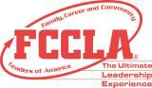  Contact: Melissa Webb  CA Department of Education 1430 N Street, Suite 4202  Sacramento, CA 95814  916-319-0773 mwebb@cde.ca.gov
Skills USA  Skills USA is a partnership of students, teachers, and industry working together to ensure a skilled workforce for America. Skills USA is a national organization serving teachers and high school and college students who are preparing for careers in technical, skilled, and service occupations. | www.skillsusaca.org  Contact: Clay Mitchell  CA Department of Education 1430 N Street, Suite 4202  Sacramento, CA 95814  916-445-5568 cmitchel@cde.ca.gov

CA Department of Education
CTE State Plan for Career Technical Education

In order to be compliant with Perkins and CTEIG legislations, grantees must provide for the development of student leadership skills through an established career technical student organization (CTSO) or an alternate strategy that incorporates this instruction in ALL of the courses that make up the sequence. (2008-2012 California State Plan for Career Technical Education, pg 128)
Leadership must be:
  - integrated into the CTE pathway curriculum and taught by an appropriately CTE credentialed teacher
  - available to ALL students in the pathway
CTE Leadership is NOT just:
  - an after school club
  - competitions
  - checking off boxes

Best Practices for High Quality
CTE Pathways

The CDE strongly supports the CTSO’s and our first recommendation will be to join one of the six recognized organizations.

CTSO Conferences and Skill Attainment
- All students demonstrate their skills and are evaluated by industry at the Local, Regional, State and National Conferences.
- The leadership conferences are the culminating activity, benchmarking the student growth and skill attainment at each level.
- The outcomes of these conferences should also be used to evaluate the CTE program.

Leadership through Alternate Strategies

There are four recommended leadership areas with a final summative portfolio/project. The areas are:
- Personal Growth
- Professional Development
- Growing Leaders
- Community Outreach

Each area has defined outcomes. The expectation is all the outcomes be completed by the end of the CTE pathway.

Final Summative Portfolio/Project

Each student completing a CTE pathway should have a portfolio containing evidence of the skills developed in the pathway including:
- Technical skill development
- Personal development
- External and self-assessments
- Presented in a format of the student’s choosing, i.e. written, digital, performance, video.

The student should complete a formal presentation of the portfolio to someone other than the classroom teacher.

The goal is ownership, recognition, and the ability to advocate for themselves and the program.

Standards for Career Ready Practice (SCRP)
1. Apply appropriate technical skills and academic knowledge
2.Communicate clearly, effectively, and with reason
3. Develop education and career plan aligned with personal goals
4. Apply technology to enhance productivity
5. Utilize critical thinking to make sense of problems to persevere in solving them
6. Practice personal health and understand financial literacy
7. Act as a responsible citizen in the workplace and the community
8. Model integrity, ethical leadership, and effective management
9. Work productively in teams while integrating cultural and global competence
10. Demonstrate creativity and innovation
11. Employ valid and reliable research strategies
12. Understand the environmental, social, and economic impacts of decisions

Personal Growth and Professional Responsibility

Outcomes | SCRP | Resources
Develop, implement SMART Goals | 3
Develop a personal code of conduct including attendance, personal health, and financial actions. | 6, 7
Conduct self assessment | 3 | CA Career Zone
Maintain personal portfolio | 1, 2, 3
Participate in peer review process | 9
Demonstrate knowledge of local, state, national, and international issues | 7, 9, 12
Obtain industry certification or external evaluation of proficiency | 1
Use professional communication with industry partners and peers | 2
Manage time and tasks, meet deadlines | 8
Participate in competitive events at local, sectional, regional, state or national levels | 1, 4, 5, 9, 10, 11
Partner with industry mentor to build a skill or to prepare for competition | 2, 4, 9

Growing Leaders
Outcomes | SCRP | Resources
Serve as an club officer, team captain, project manager | 2, 5, 8, 9
Participate in leadership conferences | 1, 11, 12
Mentor a younger student | 1, 2, 6, 7, 8
Organize a fundraiser for a cause (approved by teacher/advisor)  - Define tasks  - Develop budget and fundraising goal  - Select people  - Set deadlines | 1, 2, 4, 5, 8, 9, 10, 11, 12
Participate and lead team building activities | 2, 5, 6, 9
Develop a real world problem solution | 1,2,4, 5, 6, 9,10,11,12
Provide opportunities for others to grow | 2, 8, 9
Give recognition to another team member | 2, 8

Community Outreach

Outcomes | SCRP | Resources
Prepare and deliver a community presentation | 2, 7, 8, 12
Procure industry partners for work-based learning activities | 2, 9
Speak at a public event | 2, 7
Create a CTE pathway recruitment program or event | 1, 2, 4, 5, 10
Plan, organize, and complete a community event. | 1, 2, 4, 5, 8, 9, 10, 11, 12

As Perkins Coordinator/Administrator, what should you be looking for?

Leadership must be integrated into the entire CTE pathway!

Student Centered
- All students are engaged, encouraged and motivated to take a leadership role, not just those elected to be in charge, include graded activities

Connect to other students, the community, the state, and beyond where possible
- Public relations, outreach to the community, advocacy for themselves and the CTE program; knowledge of local, state, national and international issues

Organization of events to benefit the CTE pathway and others
- Recognition events, recruitment, publicity; community service: choosing the cause, fundraising

Partner with professionals from the industry
- Mentors, internships, employment, job shadowing; real-world problem solving

What will CDE be looking for in a Federal Program Monitoring Site Visit?

Evidence of leadership outcomes in the entire CTE pathway!

- Artifacts
- Student samples
- Portfolios
- Invoices
- Teacher Speak
- Administrator Speak

An alternate strategies leadership rubric is being developed that will have to be submitted to CDE annually to show compliance.

Sample Leadership Themes by Course

Introduction Course Leadership Theme: “Getting Things Done”
- Learn and use teamwork, communication, organizational, and decision-making skills.
- Provide activities and projects that promote global thinking and positive personal interaction. Making a difference in the world today – at all levels.
- Helping students become responsible, positive citizens.
- Read the book Seven Habits of Effective Teens and use the tools in the book to set goals and manage their time.

Concentrator Course Leadership Theme: “Get Involved”
- Providing opportunities for students to use their collective strengths and talents towards making their school a more spirited and energetic place.
- Students will learn about themselves, classmates, staff while create lasting memories by becoming involved with activities.
- Focus is on the development of strong communication skills, integrating all modes of expression: reading, writing, and speaking.
- Key Projects: 1) Involvement in two major projects, two term projects, and service hours. 2) Small written assignments, reflections, or homework sheets.

Capstone Course Leadership Theme: “Lead By Example”
- Provide opportunities to develop leadership skills through a variety of in-school and out-of-school- experiences.
- Develop a positive attitude for leadership roles.
- Be given opportunities to develop individual and co-operative leadership skills in school and community environments.
- Learn to plan, organize, implement meetings, school programs, special events, and community services with increasing autonomy and leadership.
- Mentor students in tutoring, planning, organizing, and leadership.
- Supervise, organizing and running of events in the school and community
- Fundraising and overseeing the class budget.
- Learn about various leadership models and styles.
- Goal setting/time management.
- Organization, communication skills, problem solving and conflict resolution.
Real World Example:
American Cancer Society - Relay for Life
Cordova High School Public Safety Academy

This was an annual event for the Public Safety Academy students. Each year the students took on different levels of leadership. Below is a breakdown how leadership was developed at each grade level.

Introductory Level: Getting Things Done
- Attend presentation on the purpose of ACS – Relay for Life
- Sign up for logistic tasks to assist with including physically setting up the event, assist with maintaining clean site, refill water stations, walking the track as a team member, tearing down the event
- Team leaders assigned for each shift during the event
- Participate in team fundraising events

Concentrator Level: Getting Involved
- Assist with presentation on the purpose of ACS – Relay for Life
- Sign up to work at Relay Event booths such as Luminaire Sales, Survivor Tent, Registration
- Create a theme lap for the event including budget for supplies
- Walk the track as team members
- Team leaders assigned for each shift during the event
- Participate in team fundraising events

Capstone Level: Lead by Example
- Develop and present on the purpose of ACS – Relay for Life
- Create themed team booth including materials list, budget, and time schedule for completion
- Organize team fundraisers including location, signups for helpers, budget
- Create Relay event fundraiser or activity for participants
- Research a type of cancer and early detection
- Prepare public information presentation i.e. flyer, poster to teach the public about cancer
- Walk the track as team members
- Organize overnight camping site – Seniors only

Alternate Strategy Leadership
Allowable Expenditures with Perkins & CTEIG

- Uniforms – Jackets, ties, dress pants, skirts – must remain the property of the school. (no T-shirts or Polos)
- Curriculum and Supplemental Resource Books
- Materials & Equipment
- Field Trips, Work Based Learning Events
- Transportation to Leadership Activities for all students in the course
- Substitute costs for the CTE Teacher only

NON-Allowable Expenditures with Perkins & CTEIG

- Stipends/Extra Pay for Leadership Advisors
  - After school is optional, therefore Perkins and CTEIG cannot be used to pay for after school hours when using alternate strategies
- Competition Entry Fees
- No hotel or food costs for students

Resources

http://www.skillsusa.org
https://www.cte.cornell.edu/teaching-ideas/engaging-students/collaborative-learning.html
http://ddi.cs.uni-potsdam.de/Lehre/WissArbeitenHinweise/teachingassistant/hand/leader.html
http://www.waisman.wisc.edu/cedd/pdfs/products/community/Leadership.pdf
http://www.edweek.org/tm/articles/2012/02/14/tln_ferlazzo_leadership.html
https://www.nde-ed.org/TeachingResources/ClassroomTips/Teamwork.htm
http://blog.cengage.com/top_blog/tips-for-students-leadership-qualities-staying-on-target/
http://everfi.com/k12/everfi-k-12-finliteracy/
https://www.cacareerzone.org/
https://www.ffa.org/home
http://www.fcclainc.org/
http://hosa.org/
https://www.deca.org/
http://www.fbla-pbl.org/
http://www.californiacareers.info/

Yes I can do this, AND…..
Next Steps:

1) ___________________________________________________AND
2) ___________________________________________________AND
3) ___________________________________________________AND
4) ___________________________________________________AND
5) ___________________________________________________AND
6) ___________________________________________________AND
7) ___________________________________________________AND
8) ___________________________________________________AND
9) ___________________________________________________AND
10) __________________________________________________AND

