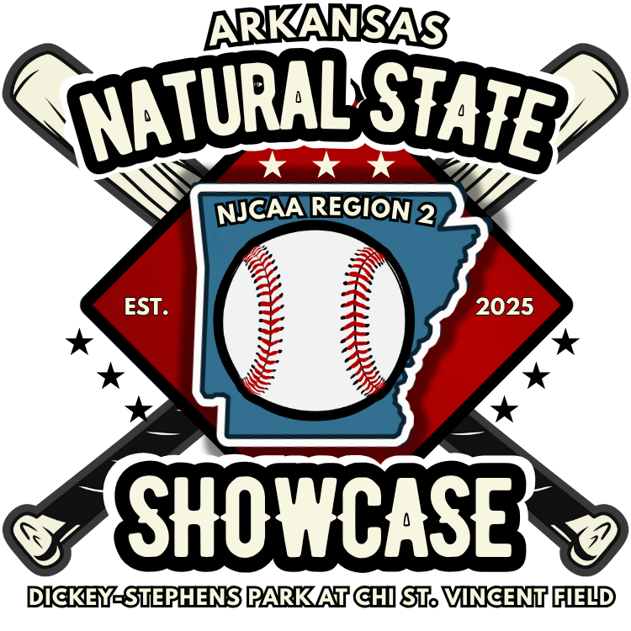
FOR IMMEDIATE RELEASE
July 31, 2025

ARKANSAS TWO-YEAR COLLEGES TO ANNOUNCE INAUGURAL NATURAL STATE BASEBALL SHOWCASE AT DICKEY-STEPHENS PARK
North Little Rock, Ark. – Baseball talent from across the Natural State will take center stage this fall, as nine Arkansas two-year colleges unite for the inaugural Natural State Baseball Showcase, scheduled for October 10–11, 2025 at Dickey-Stephens Park at CHI St. Vincent Field.
To officially announce the event, a press conference was held Thursday, July 31 at 1:00 PM at Dickey-Stephens Park. Media, college representatives, and baseball fans were in attendance for the announcement to learn more about this groundbreaking showcase.
“This is more than just a game—it’s a celebration of Arkansas’s rising talent and the strength of our two-year college baseball programs,” said Dr. Steve Rook, ASU Three Rivers Chancellor and event spokesperson. “The showcase will give student-athletes a chance to shine on a larger stage and open doors for future opportunities.”
The Natural State Baseball Showcase will feature athletes from nine two-year colleges across Arkansas. The participating programs announced at the press event on July 31 include Arkansas State University Mid-South Greyhounds, Arkansas State University-Mountain Home Trailblazers, Arkansas State University Three Rivers Eagles, National Park College Nighthawks, North Arkansas College Pioneers, South Arkansas College Stars, Southeast Arkansas College Sharks, Southern Arkansas University Tech Rockets, and University of Arkansas Rich Mountain Bucks.
Sponsors for the event are Arkansas Division of Higher Education and Arkansas Scholarship Lottery.
The two-day October event is designed to offer exposure to four-year programs, professional scouts, and local baseball fans, while building connections among institutions that are helping shape the next generation of baseball talent.

About the Natural State Baseball Showcase
The Natural State Baseball Showcase is a new, statewide initiative created to spotlight the student-athletes competing at Arkansas’s two-year colleges. The event offers an opportunity for athletes to compete in front of scouts, recruiters, and the public—while celebrating the high level of baseball being played at the two-year college level in Arkansas.
###
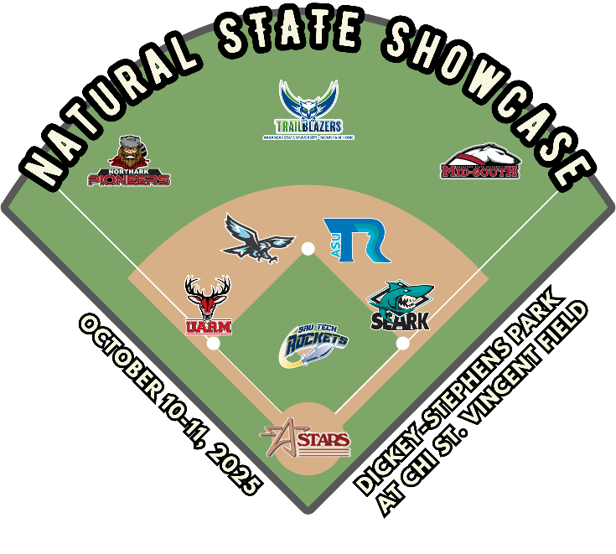

For questions or more information, please contact:
Amber Childers, Associate Vice Chancellor for College Advancement
Arkansas State University Three Rivers |One College Circle | Malvern, AR 72104
Office: 501.332.0234 | amber@asutr.edu

