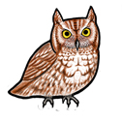
Do you enjoy nature, wildlife, helping people of all ages, and meeting interesting people
from around the country and other countries?

Volunteering at our Magee Marsh Visitor Center store in the Magee Marsh Wildlife Area
may be a perfect opportunity for you!

The bookstore in the recently renovated Magee Marsh Visitor Center
is operated by the Friends of Magee Marsh. Sales of nature books,
t-shirts, hats, etc., support projects at Magee Marsh.
Volunteers are needed.

There will be an Information Session
March 25 at 1 p.m.
at the Ida Rupp Library in Port Clinton.
This is an opportunity to learn about volunteering
in the bookstore and to ask questions.
There will be refreshments.

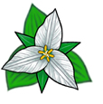
If you are interested, please, attend our Information Session or contact Mary Warren 419-656-5141 or Sandy Burris 419-625-2696. Visit our website at:
www.friendsofmageemarsh.org.

The Friends of Magee Marsh is a non-profit organization that is dedicated to preserving the Magee Marsh Wildlife Area and the Magee Marsh Visitor Center.

