
Presents the 2018:


Give the gift of creativity this holiday season by ordering greeting cards or a 12-month calendar with images created by FHR's Studio 35 artists. This year, we’re not only offering holiday artwork, but also a selection of greeting cards you can use all year – perfect for a holiday gift! Proceeds raised will make a direct and immediate impact, helping the individuals in our care achieve greater independence and an improved quality of life.

Pricing: $5 for 5 cards, $10 for 12 cards (envelopes included), $18 for a 12-month calendar. Shipping: Free on orders of $25 or more!

Card #1  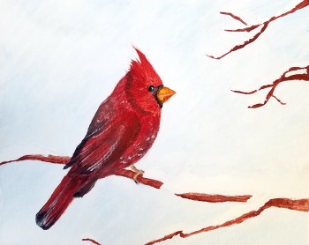 | Card #2   | Card #3  
Card #4   | Card #5  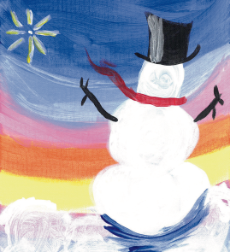 | Card #6  
Card #7   | Card #8   | Card #9  
Card #10   | Card #11  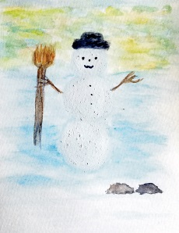 | Card #12  
Presents the 2018:

Give the gift of creativity this holiday season by ordering greeting cards or a 12-month calendar with images created by FHR's Studio 35 artists. This year, we’re not only offering holiday artwork, but also a selection of greeting cards you can use all year – perfect for a holiday gift! Proceeds raised will make a direct and immediate impact, helping the individuals in our care achieve greater independence and an improved quality of life.

Pricing: $5 for 5 cards, $10 for 12 cards (envelopes included), $18 for a 12-month calendar. Shipping: Free on orders of $25 or more!

Card #13   | Card #14   | Card #15  
Card #16   | Card #17   | Card #18  
Card #19  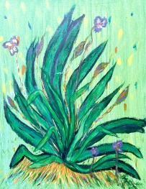 | Card #20   | Card #21  
Card #22   | Card #23   | Card #24  

Order Form:
Pricing: $5 for 5 cards, $10 for 12 cards (envelopes included), $18 for a 12-month calendar. Shipping: Free on orders of $25 or more!
(Cards measure 4.25” x 5.5” – Spiral-bound calendars measure 11.5” x 14.5”. See cover image below)

Item | Quantity
Card #1
Card #2
Card #3
Card #4
Card #5
Card #6
Card #7
Card #8
Card #9
Card #10
Card #11
Card #12
Card #13
Card #14
Card #15
Card #16
Card #17
Card #18
Card #19
Card #20
Card #21
Card #22
Card #23
Card #24
12-Month Calendar

Your Contact Information:
Name:
Email:
Mailing Address:
City: |  | State: |  | Zip code:

Order Instructions:
Please email your order form to btulino@fhr.net and include ‘Studio 35 Holiday Sale’ in the subject line. Once your email is received, a total price will be calculated (including your shipping amount if the order is less than $25) and will be emailed back to you in an invoice. Upon receiving your invoice, you will have the option to pay for your order online on FHR's secure website (www.fhr.net/donate) or to mail a check to:
Fellowship Health Resources (FHR), Attn: Beverly Tulino, 24 Albion Road, Suite 420, Lincoln, RI 02865

When payment is received, we will mail your Studio 35 holiday card order in a timely manner.
Please note that there is a $10 minimum transaction on FHR’s website.

Studio 35 is a therapeutic arts program of FHR (Fellowship Health Resources, Inc.), an organization providing behavioral health services to individuals living with mental illness and addictions across 7 states. Studio 35 enables individuals to further explore the arts, art history, coping skills, and self-expression. By integrating the arts as a therapeutic approach, Studio 35 positively impacts individuals served, staff, and the greater community. This therapeutic arts program helps individuals become more engaged in the community, reduces isolation, and teaches both vocational and arts based skills.

For more information, visit www.fhr.net

