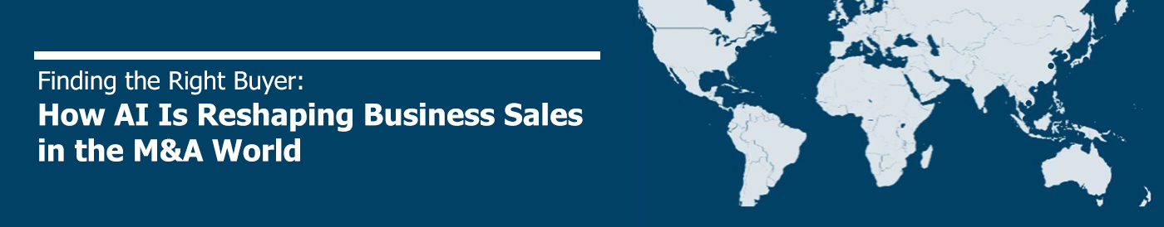

In today’s globalized and fast-paced M&A environment, finding the right buyer for a sellable business is both an art and a science. Traditionally, this process relied heavily on networks, intuition, and manual research. But with the rise of artificial intelligence (AI), M&A intermediaries are now equipped with smarter tools to match sellers with the most suitable buyers, faster and more accurately than ever before.

The Challenge of Buyer Identification

M&A professionals face a persistent challenge: identifying qualified, interested buyers from a sea of potential acquirers. The ideal buyer is not just financially capable but strategically aligned with the target company’s operations, culture, and growth vision.

Traditionally, sourcing these buyers involved:
- Leveraging personal networks and past deal history
- Scouring industry databases
- Attending industry events
- Relying on inbound interest and referrals

While effective to some extent, these methods are time-intensive and often miss out on hidden or non-obvious buyers — especially in cross-border deals where local market knowledge is limited.

Where AI Enters the Equation

Artificial Intelligence is transforming this process by augmenting human expertise with data-driven insights. Here's how:

- Predictive Buyer Targeting

AI algorithms can analyze past transaction data, industry trends, and buyer behaviors to predict which companies or investors are most likely to pursue acquisitions in a specific sector or geography. These algorithms can prioritize potential buyers based on:
- Acquisition history
- Strategic fit (based on company descriptions, product lines, and public statements)
- Growth objectives
- Financial capacity

2. Intelligent Matching Platforms

Advanced AI-enabled platforms can ingest detailed profiles of sellable businesses — including financials, industry specifics, intellectual property, and client base — and match them with a global pool of buyers. These platforms use natural language processing (NLP) and machine learning (ML) to find connections that may not be obvious to human intermediaries.

For example, a mid-sized German manufacturer might be a perfect target for a North American industrial conglomerate looking to expand its European footprint — a match AI could suggest based on deal data, market expansion signals, and product synergies.

3. Behavioral Analysis

AI tools can monitor buyer behavior in real-time across digital platforms, identifying those who are actively seeking acquisition opportunities. Signals such as increased web traffic to M&A sites, engagement with specific industry content, or corporate hiring patterns can indicate a buyer’s intent and readiness.

4. Dynamic Shortlisting and Scoring

Rather than presenting a static list of leads, AI can generate dynamic, ranked shortlists that evolve with new data. Buyers are scored not only on traditional metrics (revenue, sector) but on alignment factors like ESG strategies, digital capabilities, and cultural fit — based on analysis of public records, news articles, and company communications.

The Role of CBA in the AI-Driven M&A Ecosystem

As a global alliance of independent M&A intermediaries, CBA is uniquely positioned to harness AI technologies for superior deal-making. Here’s how:

- Shared Data, Enhanced Algorithms: With member firms operating across continents, we can leverage anonymized deal data and buyer insights to feed AI tools, making them smarter and more context-aware over time.
- Global Reach, Local Expertise: AI can surface global buyers, but our Associates provide the essential local insights and human judgment to validate matches and guide negotiations.
- Faster, Smarter Processes: AI-driven buyer identification drastically reduces time spent on manual research, allowing intermediaries to focus on higher-value activities — from strategic positioning to deal structuring and closing.

Looking Ahead: Augmentation, Not Replacement

AI is not replacing the trusted advisor. Instead, it's amplifying the capabilities of M&A professionals. By embracing these technologies, alliances like CBA and VR can offer their clients a significant competitive edge: smarter buyer targeting, faster execution, and better deal outcomes.

In a landscape where speed, relevance, and strategic fit are critical, AI has become an essential ally in finding the right buyer — anywhere in the world.

Gundo Kahle, CEO
Cross Border Associates

