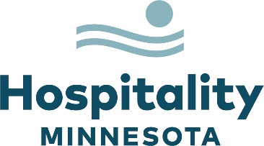

Statement on Passage of HF31 on Federal Tax Conformity

Many hospitality businesses across Minnesota sought and received much-needed pandemic relief in the form of EIDL advances and Restaurant Revitalization Fund and Shuttered Venue grants. This support has been a crucial lifeline to remaining solvent. The prospect of being taxed on those funds, especially as labor and supply chain constraints and inflationary pressures continue to cause hardship, makes full recovery an even greater challenge. This legislation brings Minnesota into conformity with the federal position that these funds are not taxable as another form of relief, and we are grateful to House and Senate leadership, members and Governor Walz for swift action on this issue.

Key Context

- Conforms state taxes with federal tax exclusions on 46 provisions, including EIDL loan advances, Restaurant Revitalization Fund grants and Shuttered Venue grants.

- The Restaurant Revitalization Fund was a significant lifeline to the 1700 establishments across Minnesota restaurants who received it.

- 66% of restaurants took on debt due to COVID with an average debt over $500,000.

- Half of restaurants do not expect revenue to return to normal until 2023 or later.

Liz Rammer
President and CEO

#####

For more information, contact:
Ann Kirby
VP, Member and Community Engagement
ann@hospitalitymn.com
(651) 925-4010

