CDC MASK GUIDANCE
I have read the CDC Interim Public Health Recommendations for Fully Vaccinated People as updated on May 28, 2021 and understand the guidance.
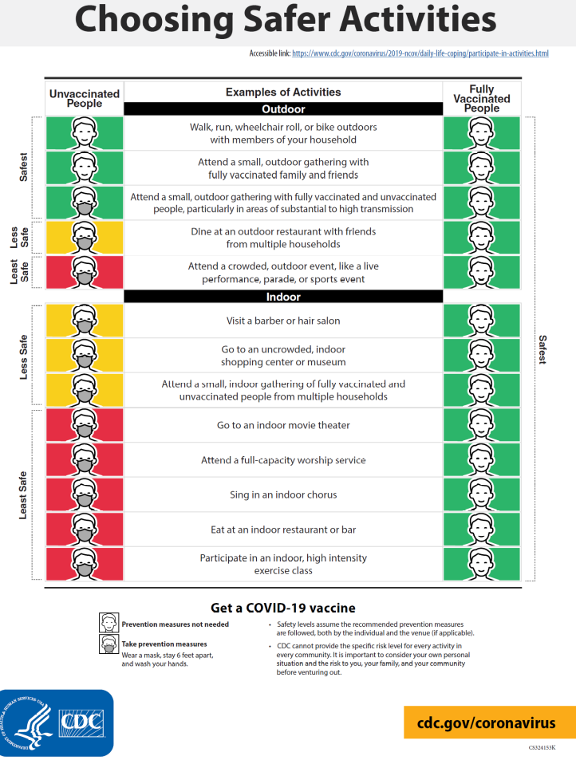

PRINT NAME | SIGNATURE | DATE

CDC Guidance URL - https://www.cdc.gov/coronavirus/2019-ncov/vaccines/fully-vaccinated-guidance.html

