What Is Microneedling? 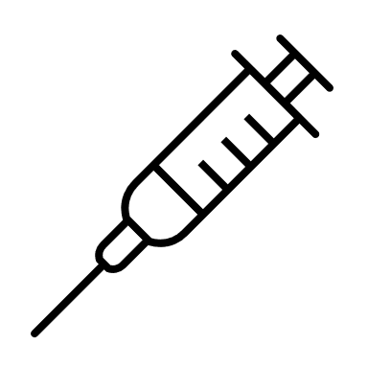
Microneedling is a cosmetic procedure. It involves pricking the skin with tiny, single use sterile needles. The small wounds cause your body to make more collagen and elastin, which heal your skin and help you look younger. You might also hear it called collagen induction therapy.

HOW IS MICRONEEDLING PERFORMED?
Our Microneedling procedure uses a state-of-the-art medical device that has tiny “microneedles” which gently create tiny channels in the skin’s top layer. We can apply a topical anesthetic before beginning the treatment to ensure you remain comfortable throughout the treatment. The tiny wounds prompt the skin to regenerate damaged cells and increase the production of collagen and elastin to naturally repair itself. The depth of the needle penetration may be adjusted to the condition and thickness of the skin you want to target.

WHAT DOES MICRONEEDLING TREAT?
Microneedling addresses many common concerns including fine lines and wrinkles, acne scars, hyperpigmentation, and uneven skin texture. These versatile treatments benefit the skin in a variety of ways such as:
- Improving elasticity
- Increasing firmness
- Softening fine lines and wrinkle
- Repairing acne scars
- Minimizing pore size
- Can deduce pigmentation.

