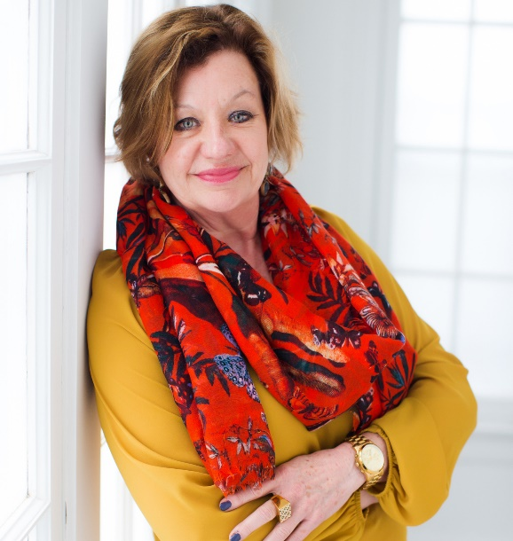
Sally Davis Berry Bio

Sally Berry is a U.S. tourism industry expert and has an industry blog, www.SallyDavisBerry.com which helps attractions and destinations get more visitors through their doors.

Berry was the Global Sales and Marketing manager at The Corning Museum of Glass in the Finger Lakes Region of Upstate New York, a top visitor attraction for both groups and individuals.
Berry has more than 20 years of experience in the travel and tourism industry. She was program director at Finger Lakes Tourism Alliance, a regional DMO, and has also worked for a variety of attractions in the Finger Lakes Region.
In 2016, she was also named a Top 10 Most influential women in the Group tour market by Groups Today magazine and was also named a Top Innovator in the Group tour market by Groups Today in 2015.
TourOperator.com named Sally a Top Tourism Networker in 2018 and a Top 20 US Tourism Industry Professional in 2015.
While working at the Corning Museum of Glass, Berry helped the organization win various tourism industry awards. This included Best of the Best, from the American Bus Association, a Distinguished Dozen award from Courier magazine for the National Tour Association and Best Hands on experience from Groups Today magazine.

Berry is known as a China market expert and has been speaking on becoming China ready and WeChat at conferences and DMO events. She also speaks on Group tour ready topics and business efficiency topics such as the 80/20 Principle. Berry’s experience at both DMOs and attractions helps her connect easily with attendees.

Linkedin profile: https://www.linkedin.com/in/sally-davis-berry-ctp-cmp-5351368/

Website About page: http://sallydavisberry.com/about/

Testimonials

Sally Davis Berry conducted a seminar on doing business with the Chinese tourists at one of City Guide's Tourism Marketing Forum for 50 marketing professionals. We received excellent feedback from attendees. They commented she offer both general market overview information and practical, actionable advice. This was a very worthwhile program for our marketing partners and we are thrilled to have hosted Sally. She is an expert in marketing to the Chinese tourism market and a great presenter.
David L. Miller, CEO Davler Media Group, publisher of City Guide (NYC)

Hello, Sally!

Thank you so much for speaking at the National Tour Association’s Travel Exchange. You conceptualized and led a panel discussion on the 80/20 Principle, and the session had relevancy for the personal, professional and management aspects of our attendees’ lives.

And they loved it. When asked what they most liked about the session, our members said, “Everything!” and called the conversation “Lively and relevant.”

Thank you, Sally, for bringing this topic to NTA!

Catherine Prather, CTP
NTA Executive Vice President

What a pro! The WeChat webinar for Travel South USA partners was a huge hit – thank you, Sally, for patiently walking thru how to use WeChat and even more importantly, taking the time to explain in “real world” language, why it is important to every tourism professional to understand and use this powerful communication tool. What we Chat is not optional in the Chinese relationship landscape, and we appreciate your savvy explanations and “translations.” The Webinar format worked even better than I had hoped.
你太好啦! nǐ tài hǎo la! – You’re the Best!

Liz Bittner, President and CEO
Travel South USA

now, as an attraction.
She is one of those rare professionals who is always helping colleagues by freely sharing her accumulated wisdom with them as well as sales advice.
Sally was recruited as a speaker for our Summer Sales retreat. Her topic " The 80/20 rule for Tourism professionals" was presented to the suppliers in attendance. While I was not able to attend her presentation, multiple attendees came up to me afterward and praised Sally's session. They said they had learned a lot and had great takeaways. Her handouts proved useful and attendees were happy to have a tool to take back to the office.
I would easily recommend Sally as a speaker at a tourism event.

Elaine Farrell, CAE
Executive Director
Pennsylvania Bus Association

