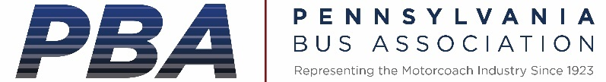

June 10, 2021

Senator Pat Toomey
PA Senator and Ranking Member Senate Banking, Housing and Urban Affairs Committee

RE: Charter Bus Protections Needed

Dear Senator Toomey,

The Pennsylvania Bus Association (http://pabus.org/) was founded in 1923 and has functioned without interruption and with an unrelenting commitment to the safety of the traveling public and the economic well-being of its member companies. PBA boasts a well-rounded program of activities for both bus operator and supplier members and carries a current membership of over 750 entities. Governmental affairs, travel and tourism marketing, education, safety, and communication constitute the major areas of involvement for this, one of the oldest public passenger transportation associations in the United States.

On behalf of members of the Pennsylvania Bus Association and our members, we write to register our strong objections to any provisions weakening the charter bus protections in transit law in your surface transportation reauthorization transit title.

As you know, public transit agencies are prohibited from doing charter work in competition with private bus operators. These protections have been in the law for over 47 years. Private bus operators cannot compete fairly with subsidized transit agencies.

Charter work is the bread and butter of much of the bus and motorcoach industry. Private school bus operators also do charter work on evenings and weekends outside of regular home to school bus transportation. The charter regulation was revised significantly in 2008 at the direction of Congress through a multi-year negotiated rulemaking process which our industry participated in, along with public transit agencies, transit labor and the Federal Transit Administration.

The rule was significantly clarified and improved through this process and has worked extremely well since. We do not believe any major issues exist with it on either the public transit or private operator side. We implore you to avoid any weakening of this important and long-standing protection. At a time when our industries remain crippled from the pandemic with loss of travel and tourism and schools not doing in-person learning for the bulk of the last year, any reduction in this protection would be devastating. The $2 billion Covid relief program created to help these industries, the CERTS Act, was passed by Congress in December but still has not been released, making our members’ situations even worse. While some work is returning, many of our companies are just hanging on to keep their doors open and we do not expect a full recovery for any of these industries until 2022.

We implore you to avoid any reduction of these protections which would be devastating to these companies and their valued employees. Appreciate your consideration of these important issues.

Sincerely,

John W. Bailey
PBA Chair and President of Bailey Coach
jbailey@baileycoach.com

