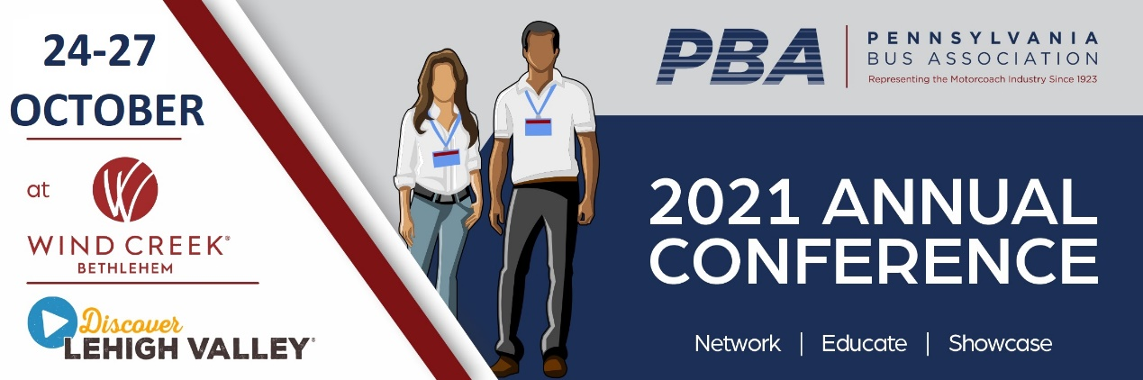`

Annual Meeting Sponsorship Commitment Sign-Up Form

Check item(s) you are interested in sponsoring.
Diamond receives 2 free Annual Meeting registrations and Platinum receives 1 free Annual Meeting registration.
$2,500 Diamond  SOLD Operator only Breakfast (Mon)  SOLD Operator only Breakfast (Tues)  SOLD Industry Expo Luncheon (Mon) SOLD All-Delegate Lunch (Tues)  SOLD Industry Panel  ___ Key Educational Workshop:  A Blueprint for Motorcoach Success by Tom Garrity of Compass Point  SOLD Hospitality Suite - Sunday  ___ Hospitality Suite - Tuesday |  | $1,500 Platinum  ___ Sales Retreat Session A  SOLD Sales Retreat Session B  ___ PBA Board Meeting  SOLD Wind Creek Casino Room Keys  SOLD Operator Educational Session  SOLD Supplier Educational Session (Mon)  ___ Supplier Educational Session (Tues) | $1,000 Gold  SOLD Printed Program  SOLD General Membership Mtg
$300 Supporter
___ Supporters:
2 SOLD
$750 Silver  SOLD Name Badge w/ lanyards  SOLD PBA Booth  SOLD Mini-Pocket Schedule  SOLD Refreshment Breaks |  | In-Kind Sponsorship  ___ Bus transportation for FAMs and/or Evening Events (demo buses). | Program Ads  SOLD Full page back cover $150  ___ Full page inside $100  ___ 1/2 page inside $60  ___ 1/4 page inside $40
COMPANY:

Company __________________________________________________________________________________________________________________________

Contact ________________________________________________________________Email ______________________________________________________

Address _______________________________________________________________________________Telephone____________________________________
(street, city/town, state, zip code)
PAYMENT TYPE:

INVOICE ME or Check Enclosed or Charge my credit card: VISA ___________ MC ______________ AMEX____________

_______________________________________________________________ _______________________________ __________________________________
Credit Card Number Expiration Date Security Number

Credit Card Billing street, city/town, state, zip code:
___________________________________________________________________________________________________________________________________

Card Holder Signature: ________________________________________________________________ DATE__________________________________________

RETURN TO: Pennsylvania Bus Association, PO Box 597, Easton, PA 18044
Email: Patricia Cowley director@pabus.org

