Dogwood Track Team
for 3rd, 4th & 5th Graders

Teacher Sponsors: Linda Fredrick and
Cassidy Fernandez
Coach: Stacey Schwarzmann
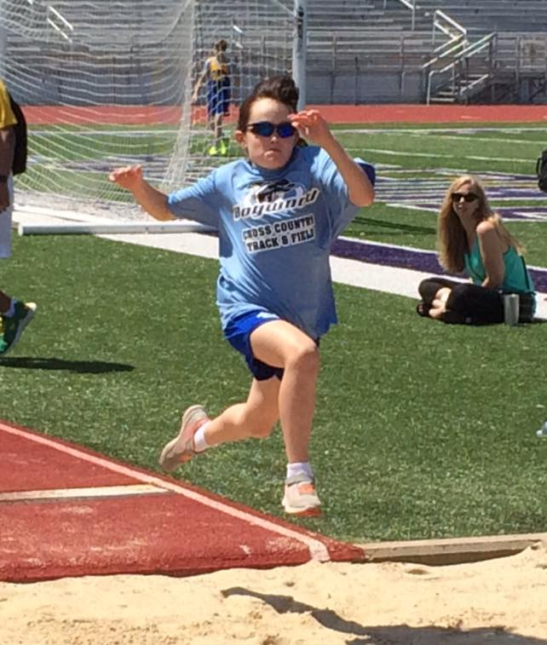
Dogwood Track is recruiting beginner to advanced runners for the 2019 spring track season. Our track team will participate in the Memphis Youth Athletic league where we will tentatively run in six track meets beginning in March through the middle of May. The meets will be around 4 hours long; some meets will take place from 10 a.m. to 2 p.m. and other meets will take place from 1 p.m. to 5 p.m.
What Are the Events?
- 1600m (4 laps around the track) Shot Put
- 800m (2 laps around the track) High Jump
- 400m (1 lap around the track) Long Jump
- 200m
- 100m

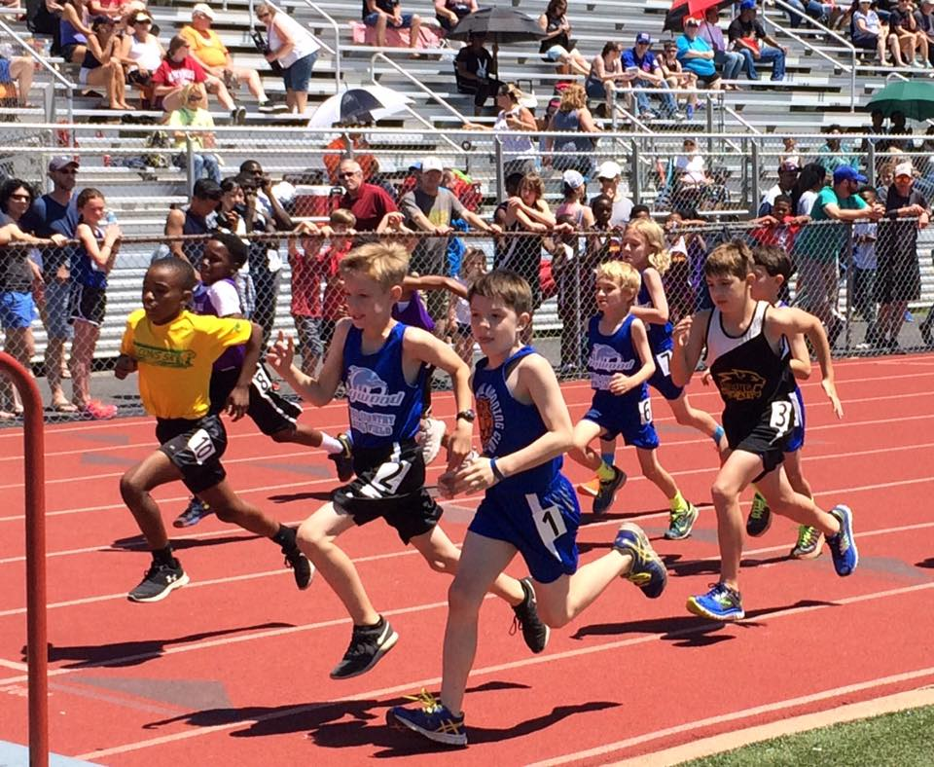
Practices will start in March. They are tentatively scheduled for Wednesday evenings from 5:30-6:30 and Sunday afternoons from 3:00-4:00. As the season progresses, we may also practice on Friday mornings before school at 7:30. Practice is strongly encouraged, but it is not necessary to be at every practice to be part of our team. We realize that your children may have other commitments, and we are flexible. Parents are always welcome and encouraged to run with us at practice and help supervise.
The fee for joining the track team is $65. If you are new to our team and do not have a uniform, you will need to order one. For returning runners, you may order shorts, a hoodie, or a short sleeve tech shirt if you would like. Good running shoes are a must-have to participate on a running team. Fleet Feet and Breakaway are great resources to find appropriate shoes for your child.
Dogwood Track Team
If you would like to sign up for this year’s track team, you will need to do so on your MySchoolBucks account. You will be able to sign up beginning on February 14, and the sign-up period will close on March 4th. Do not send the money to school. The form below lets you know the cost to join and cost for uniforms. If you have a uniform from cross country, there has been no change. You will not need to purchase any additional uniforms.
Below you will find a tentative schedule for the MYA Track & Field Meets.

March 16 @CBHS
March 30 @CBHS
April 14 (Sunday) @CBHS
*April 28 (Sunday) @CBHS
*May 4 @Arlington
**May 11 Championships TBA

*We will pick one or the other on these two dates but we are waiting on a confirmation.
**This may turn into a two day meet

(Mandatory for everyone) Track Team Fee
(covers 3 events per meet, awards, incentives) $65
(Mandatory if you do not own one already) Singlet--Uniform Tank Top
YS YM YL

AS AM AL $12
(Optional) Hoodie Size:
YS YM YL YXL

AS AM AL $15
(Optional) Shorts Size:
YS YM YL

AS AM AL $12
(Optional) Short sleeve tech shirt size:
YS YM YL

AS AM AL $12

