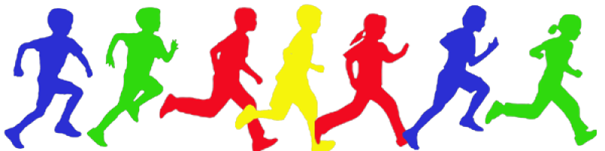
DOGWOOD TRACK TEAM
It is time to sign up for the DES Track Team!

TEAM SCHEDULE:

Optional Conditioning begins in February and will be Thursday afternoons after school from 3:45-5:00 (weather-dependent).

Regular season practice will begin in March and is dependent upon the HHS track time slot the DES team is given. There will be two afternoon practices (time TBD) and one before school practice (7:30-8:15).

Track meets (4-5) are on Saturdays (scheduled by MYA).

TEAM FEE:

$80.00 team fee – paid via TeamSnap app (invite will be sent after registration of your child)
**fee includes Meet fees, coaching staff support, incentives and end of year celebration**

Uniforms are ordered separately from the team fee. The purchase of a jersey is required. 2019 XC runners can wear the jerseys they wore during the XC season.

REGISTRATION:

Last day to register is January 31st
Link to register:
https://docs.google.com/forms/d/1H6Suy3ZPFCyu3EdjGIZ3wgHUvurt8s_kFouwAjyGaDY/edit

INTERESTED IN VOLUNTEERING?

If you would be interested in helping with practices, please contact Coach Laura Vidal at lvidal.rd@gmail.com. There will be opportunities to sign up for drinks and track meet assistance during the season.

General Questions – contact Coach Laura at livdal.rd@gmail.com or Coach Robin at randmpleasants@yahoo.com

