
2020-2021 PTO Board Nominations Form
The Dogwood PTO is currently accepting nominations for the 2020-2021 school year. These positions are a huge part of our students, teachers and families’ success at Dogwood. You can make an impact by bringing your fresh perspective, ideas and energy to our school.
Please consider nominating yourself or someone you know for one or more of the positions below by completing this form and turning it into your child’s teacher or Katie Laird (katielaird07@gmail.com) by February 4th.
Name _______________________________________________________
Phone: _____________________Email_________________________
Please check all that apply. If you are interested in more than one position please rank in order of interest. If you are nominating someone else simply write that person’s name next to the position below. 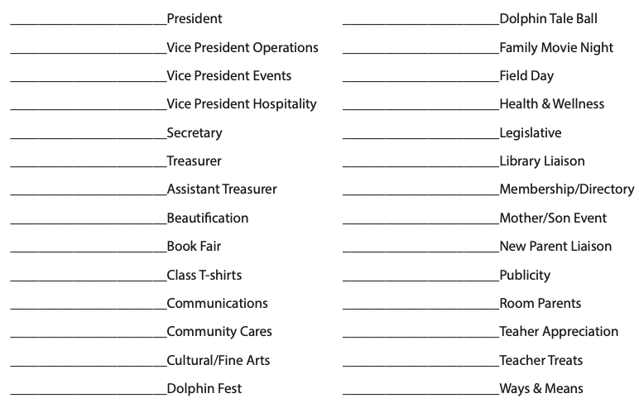

____________________________Yearbook
Attached is a more detailed description of each position

