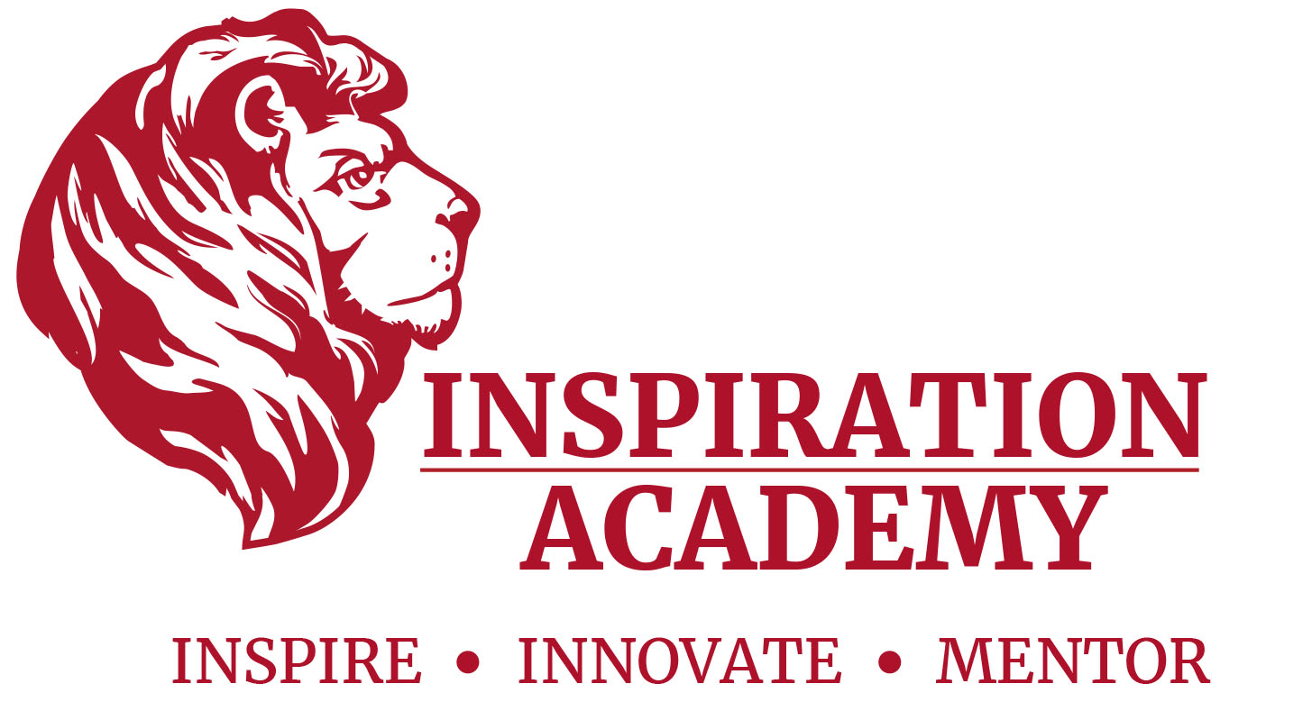

Inspiration Academy Lions Athletic Booster Club
Presents our 4th Annual…. Monte Carlo Night

To be held at Gold Coast Eagle Distributing
7051 Wireless Court
Sarasota, 34240
Friday October 18, 2019 Doors open at 6:30

SPONSORSHIP/TICKET SALE INFORMATION

Name/Company

Billing address

City, State, Zip Code

Phone | Email

☐ TICKET PURCHASE ($100.00 per ticket) No. of Tickets _____ Total $__________
☐ Bronze Sponsor $300 Includes 2 tickets to event,2 Raffle tickets, $2000 gamming money, Table signage with logo and appreciation displayed at a gaming table.
Silver Sponsor $500 Includes 4 Tickets to event,4 Raffle tickets, $4,000 gamming money, Table signage with logo and appreciation displayed at a gaming table.
☐ Gold Sponsor $1,000 Includes 8 tickets to event,8 Raffle tickets, $8000 in gamming money, Logo displayed on a large banner sign with appreciation.
☐ Raffle or Silent Auction Donation __________________________________________
********PLEASE RETURN THIS FORM WITH YOUR DONATION OR RAFFLE ITEM********

Please make checks payable to:
Inspiration Academy Lions
7900 40th Ave W
Bradenton, FL 34209
Booster Club Contacts
Sponsor questions or credit card orders
Call 941-448-5105 or email:
Jeff.Morrison@Inspirationacademy.com

Inspiration Academy’s Athletic Booster Club is a 501 (c)3 and as such is considered a charitable organization.
Your sponsorship of a banner, table or any cash donation is therefore eligible for tax-deduction.
Inspiration Academy Lions #81-3174450 as part of Group Exemption of the AAU #1155.

