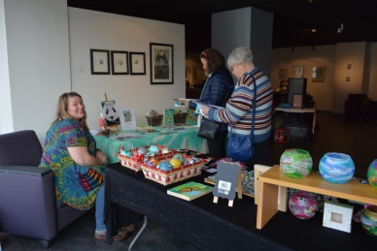
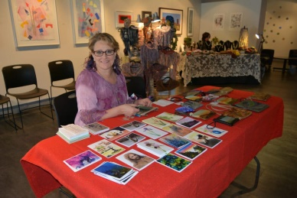
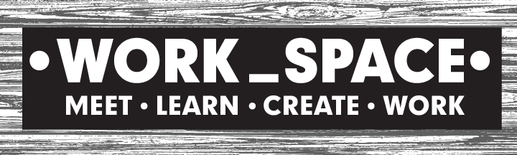

2018 Holiday Pop-Up Shoppe – Vendor Application

903 Main Street | Manchester, Connecticut 06040 | 860.647.6029
Thursday, Nov. 29th - 3 pm – 8 pm
Friday, Nov. 30th - 10 am – 3 pm
Saturday, Dec. 1st - 10 am – 3 pm

• Pottery • Jewelry • Woodcraft • Textiles • Glass • Fine Arts • Artisanal Packaged Food •

WORK_SPACE* is hosting a Holiday Pop-Up Shoppe the week following Thanksgiving to coincide with the Town of Manchester’s annual Tree Lighting on Main Street on 11/29/18.

We want to feature a diverse and talented array of local artists and locally made artisan gifts during this 3-day event. Vendors are not required to be present for all 3 days; however, at least 9 hours must be spent on-site to help to tend to their individual booth as well as the event as a whole.

Participating vendors must:
- Deliver their pieces to WORK_SPACE on Wed., November 28th between 4 pm - 7 pm
- Supply an inventory list of all pieces to be displayed
- During your 9-hr scheduled shifts, in addition to caring for your own booth, you will be asked to help the WORK_SPACE management welcome and engage visitors and ensure that neighboring booths remain safe and secure
- Sign a Participating Artist Agreement specifying terms, conditions, expectations, and a liability waiver

Vendor Fee:
- $25 (one-time payment)
- 30% commission of products sold to WORK_SPACE
- PayPal fees if WORK_SPACE processes credit card revenue for you (no fees for cash or check purchases)
- Payment due only if selected

Application Process:
- Please complete and submit the form below by 2pm on November 9th
- The review period has extended to November 9th with notifications happening on a rolling basis.
- We wish we had the ability to showcase everyone with a desire to participate, however space is limited. Our goals are to showcase a wide variety of high quality displays and avoid excessive duplication of product and gift options.

Thank you for your interest,
Emma, Lori & Stacey, the Hospitality Team @ WORK_SPACE
*WORK_SPACE is a hospitable, flexible, and affordable Meeting Center & Collaborative Coworking Space designed to meet the unique needs of small businesses, non-profits, creative professionals, and all those with an entrepreneurial spirit, desire for strategic partnerships, and determination to succeed.

2018 Holiday Artisan Pop-Up Shoppe – Vendor Application

903 Main Street | Manchester, Connecticut 06040 | 860.647.6029

Thank you for your interest in participating in this event. Return this form along with several pictures or a link to your online gallery via email (info@workspacemanchester.com) by the end of October. This review period will end on November 1st, 2018 and artists will be notified by the end of the day November 2nd. Space is limited.

Name: | Phone:
Business Name: | Email:
Style of Craft: | Website:
WORK_SPACE has a limited number of tables which we are happy to supply until we run out. Please indicate if you would like a table or will bring your own display. Also let us know what other tools or racks, etc. that you will bring.  (We do not have table clothes nor the ability to hang things from the walls.) | Instagram:
 | Twitter:
 | Facebook:
 | Other Social Media Platforms including Blogs:

Each vendor or their representative is required to work at least 1 day of the 3 day pop-up shoppe plus an additional 3 hours on a different day. Please mark your selections below in the order of 1st, 2nd, and 3rd choice for each shift.

6-hour shift | 3-hour shift
____: Thursday, November 29th (2:30pm – 8:30pm) | ____: Thursday, November 29th (2:30pm – 5:30pm)
 | ____: Thursday, November 29th (5:30pm – 8:30pm)
____: Friday, November 30th (9:30am – 3:30 pm) | ____: Friday, November 30th (9:30am – 12:30 pm)
 | ____: Friday, November 30th (12:30pm – 3:30 pm)
____: Saturday, December 1st (9:30am – 3:30pm) | ____: Saturday, December 1st (9:30am – 12:30pm)
 | ____: Saturday, December 1st (12:30pm – 3:30pm)

Applicant Signature: Date:

