St. Andrew’s Episcopal Church
An Evening Service of Holy Eucharist
Recorded Service for weekend of August 1-2

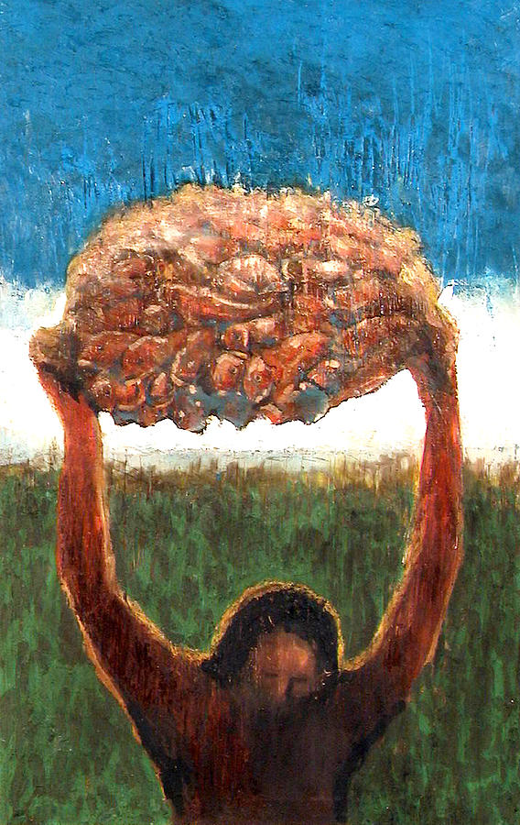

“Taking the five loaves and the two fish, he looked up to heaven, and blessed and broke the loaves, and gave them to the disciples, and the disciples gave them to the crowds. And all ate and were filled; and they took up what was left over of the broken pieces, twelve baskets full.”

OUR WELCOME TO YOU
WE GATHER
We gather in the heart of the Risen Christ.
Musical Offering:
Hymn #304 I come with joy to meet my Lord.

EVENING PRAYER
O Gracious Light,
pure brightness of the ever-living Father in heaven.
O Jesus Christ, holy and blessed!
Now as we come to the setting of the sun,
And our eyes behold the evening Light, we sing your praises,
O God: Father, Son, and Holy Spirit.
You are worthy at all times to be praised by happy voices,
O Son of God, O Giver of Life,
and to be glorified through all the worlds.

WE OPEN OURSELVES TO THE HOLY SCRIPTURE

Musical Offering:
WLP Heal me, hands of Jesus.

GENESIS 32:22-31

The same night Jacob got up and took his two wives, his two maids, and his eleven children, and crossed the ford of the Jabbok. He took them and sent them across the stream, and likewise everything that he had. Jacob was left alone; and a man wrestled with him until daybreak. When the man saw that he did not prevail against Jacob, he struck him on the hip socket; and Jacob’s hip was put out of joint as he wrestled with him. Then he said, “Let me go, for the day is breaking.” But Jacob said, “I will not let you go, unless you bless me.” So he said to him, “What is your name?” And he said, “Jacob.” Then the man said, “You shall no longer be called Jacob, but Israel, for you have striven with God and with humans, and have prevailed.” Then Jacob asked him, “Please tell me your name.” But he said, “Why is it that you ask my name?” And there he blessed him. So Jacob called the place Peniel, saying, “For I have seen God face to face, and yet my life is preserved.” The sun rose upon him as he passed Penuel, limping because of his hip.

Psalm 17: 1-7, 16 (chanted)

1 Hear my plea of innocence, O Lord;
give heed to my cry; *
listen to my prayer, which does not come from lying lips.
2 Let my vindication come forth from your presence; *
let your eyes be fixed on justice.
3 Weigh my heart, summon me by night, *
melt me down; you will find no impurity in me.
4 I give no offense with my mouth as others do; *
I have heeded the words of your lips.
5 My footsteps hold fast to the ways of your law; *
in your paths my feet shall not stumble.
6 I call upon you, O God, for you will answer me; *
incline your ear to me and hear my words.
7 Show me your marvelous loving-kindness, *
O Savior of those who take refuge at your right hand
from those who rise up against them.
16 But at my vindication I shall see your face; *
when I awake, I shall be satisfied, beholding
your likeness.

ROMANS 9:1-5

I am speaking the truth in Christ-- I am not lying; my conscience confirms it by the Holy Spirit-- I have great sorrow and unceasing anguish in my heart. For I could wish that I myself were accursed and cut off from Christ for the sake of my own people, my kindred according to the flesh. They are Israelites, and to them belong the adoption, the glory, the covenants, the giving of the law, the worship, and the promises; to them belong the patriarchs, and from them, according to the flesh, comes the Messiah, who is over all, God blessed forever. Amen.
Musical Offering:
Alleluia

Matthew14:13-21
When it was evening, the disciples came to him and said, “This is a deserted place, and the hour is now late; send the crowds away so that they may go into the villages and buy food for themselves.” Jesus said to them, “They need not go away; you give them something to eat.” They replied, “We have nothing here but five loaves and two fish.” And he said, “Bring them here to me.” Then he ordered the crowds to sit down on the grass. Taking the five loaves and the two fish, he looked up to heaven, and blessed and broke the loaves, and gave them to the disciples, and the disciples gave them to the crowds. And all ate and were filled; and they took up what was left over of the broken pieces, twelve baskets full. And those who ate were about five thousand men, besides women and children
Silent Reflection

WE ENGAGE IN PRAYER,
OFFERING OUR NEED FOR GOD’S HEALING GRACE

Musical Offering: O Lord, hear my prayer.
Let us pray.
O living Christ, make us conscious now of your healing nearness. Touch our eyes that we may see you; open our ears that we may hear your voice; enter our hearts that we may know your love. Overshadow our souls and bodies with your presence that we may partake of your strength, your love, and your healing life. Amen.

Let us name before God those for whom we offer our prayers, silently
or aloud. (pause)
God the Father, your will for all people is health and salvation;
We praise you and thank you, O Lord.

God the Son, you came that we might have life, and might have it more abundantly;
We praise you and thank you, O Lord.

God the Holy Spirit, you make our bodies the temple of your presence;
We praise you and thank you, O Lord.

Holy Trinity, one God, in you we live and move and have our being;
We praise you and thank you, O Lord.

Lord, grant your healing grace to all who are sick, injured, or disabled,
that they may be made whole;
Hear us, O Lord of life.

Grant to all who seek your guidance, and to all who are lonely,
anxious, or despondent, a knowledge of your will and an awareness of
Your presence;
Hear us, O Lord of life.

Mend broken relationships, and restore those in emotional distress to
soundness of mind and serenity of spirit;
Hear us, O Lord of life.

Bless physicians, nurses, and all others who minister to the suffering,
granting them wisdom and skill, sympathy and patience;
Hear us, O Lord of life.

Grant to the dying peace and a holy death, and uphold by the Grace
and consolation of your Holy Spirit those who are bereaved;
Hear us, O Lord of life.

Restore to wholeness whatever is broken by human sin, in our lives, in our nation, and in the world;
Hear us, O Lord of life.

You are the Lord who does wonders:
You have declared your power among the peoples.

With you, O Lord, is the well of life:
And in your light, we see light.

Hear us, O Lord of life:
Heal us, and make us whole.

O Lord our God, accept the fervent prayers of your people; in the multitude of your mercies look with compassion upon us and all who turn to you for help; for you are gracious, O lover of souls, and to you we give glory, Father, Son, and Holy Spirit, now and forever. Amen.

Musical Offering:
There is a Balm in Gilead

WE ENGAGE IN COMMUNION WITH CHRIST.

Before Jesus gave up his life for us, he shared himself,
his flesh and blood with his friends.
He took bread, gave thanks for it, and gave it to them saying:
“This is my body given for you. Do this to remember me.”

So too after they had eaten, he took the cup, gave thanks for it,
and gave it to them saying:
“This is my blood poured out in love for you. Do this to remember me.”

Come now Spirit of God upon us and upon these gifts of bread and wine, that they may be for us the Body and Blood of our Savior Jesus Christ.

Musical Offering:
Veni Sanctus Spiritus

As we offer our hearts and spirits in our love of Christ, we pray, Holy Spirit,
make us like Jesus: one body, food for the world, one blood, poured out for the life of all.

Touch us with your gentle creativity and ignite in us a longing for the new age of justice and peace. We ask this through Jesus Christ our Lord. With him, and through him, and in him, be to you, O Father, in the unity of the Holy Spirit, all honor and glory forever. AMEN.

And now, as our Savior Christ has taught us, we are bold to say,
Our Father in heaven, hallowed be your Name, your kingdom come, your will be done, on earth as in heaven. Give us today our daily bread. Forgive us our sins, as we forgive those who sin against us. Save us from the time of trial, and deliver us from evil. For the kingdom, the power, and the glory are yours, now and forever. Amen.
The Breaking of the Bread
These are the gifts of God, for you, the people of God.

Musical Offering
Let us break bread together
Prayer of Spiritual Communion
My Jesus, I believe that you are truly present in the Blessed Sacrament of the Altar. I desire to offer you praise and thanksgiving as I proclaim your resurrection. I love you above all things, and long for you in my soul. Since I cannot receive you in the Sacrament of your Body and Blood, come spiritually into my heart. Cleanse and strengthen me with your grace, Lord Jesus, and let me never be separated from you. May I live in you, and you in me, in this life and in the life to come. Amen.

WE INVITE CHRIST’S PRESENCE TO GROW OUR HEARTS.
Risen Christ, when we have the simple desire to welcome your love, little by little a flame is kindled in the depths of our being. Grant that this flame of love, faint at first, is fueled by the Holy Spirit to grow steadily into a radiant flame that warms and draws others to you.

Musical Offering:
LEVAS 231: Choral Benediction

WE WELCOME GOD’S BLESSING INTO OUR LIVES.
My friends, life is short, and we do not have much time to gladden the hearts of those who make this earthly pilgrimage with us, so be swift to love, and make haste to do kindness, and the blessing of God, who comes to us as Creative Presence, Saving Grace and Life-giving Spirit be upon you and all whom you love this night, and forever more. Amen.
WE CLOSE OUR EYES AND TURN OUR HEART IN PRAYER.

At the close of day,
As busyness fades and light dims and footsteps soften,
we open again the inner door of our being to enter stillness
to feel our way through the dark
to You
the Silence from whom we are born,
the Name before names were spoken,
the Love of life’s beginnings.
at the close of the day,
we come.

Musical Offering:
Taize #25 When the night becomes dark

