Pull up the account in the core (Navigator)

Click on Codes
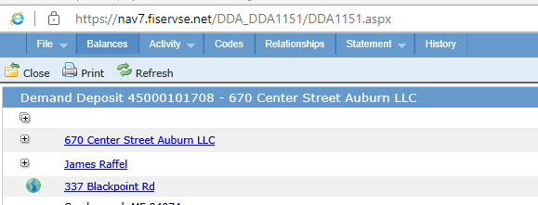

Under Additional Information click the change icon in the right hand side

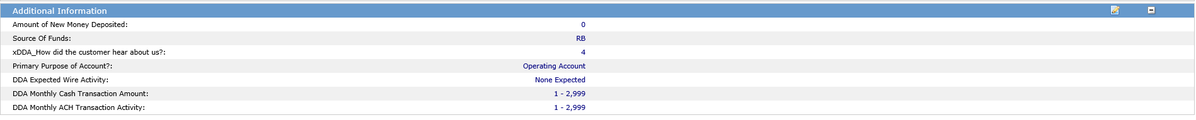

Change the line that says XDDA_How did the customer hear about us by putting a 2 in the value section. This equals “Client Referral”

Click on the carrot in the bottom of the Additional Information box and find DDA Name of client who referred you and click Add Field
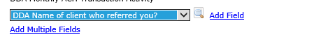
Type in the name of the person/business who referred

Click save in the top left corner.

