
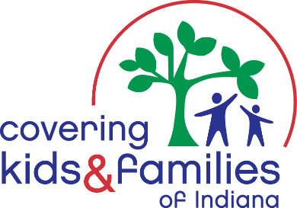

1/25/2023

Senator Greg Walker
Chair, Senate Family and Children Services Committee
Senator.Greg.Walker@iga.in.gov

Chairman Walker,
Thank you for your attention to Senate Bill 376: Lawfully Residing Immigrants and Eligibility, on behalf of Covering Kids & Families of Indiana and the Indiana School Health Network. We would like to offer our formal support for this piece of critical legislation, particularly in regard to the elements outlined below:
- The legislation allows Indiana to use a specific, narrow federal permission to allow Medicaid or Children’s Health Insurance Program (CHIP) eligibility for immigrant children and pregnant woman who are lawfully residing in the United States and meet all other program eligibility requirements.

- Currently, these individuals must wait a full 5 years after becoming residents before they are eligible for Medicaid or CHIP, with emergency-only Medicaid as their sole option. For those without other coverage options, this creates a major gap in accessing care such as developmental screenings, well-child visits and prenatal care.

- The legislation does not make anyone automatically eligible for Medicaid or CHIP.
A health coverage program application must be submitted and approved by the state, according to the same standards and eligibility requirements of all other Hoosiers. Undocumented immigrants, student and visitor Visa holders and DACA recipients are not eligible under this permission.

- Those who would become eligible by closing this gap are the most directly impacted, but many other entities benefit including:

  - Hospitals that face uncompensated care costs for uninsured patients.
  - Employers that value healthy employees but are unable to provide coverage.
  - All Hoosiers who rely on front line and agricultural workers, service providers and healthcare staff - leading industries employing recent immigrants.

Who may gain health coverage?
▪ Children: 4,513 - 5,961
▪ 19 to 21-year-olds: 475 - 627
▪ Pregnant women: 481 - 634
This equates to an approximately a 1/4
of 1% increase to Indiana enrollment.
What would Indiana’s investment be?
The federal government will pay 76% of
The cost for CHIP and 66% for Medicaid.
Estimated state costs are $3.8 - 5 million per the LSA fiscal analysis, about 1/5 of 1% of the 2023 total state Medicaid budget
We believe that Senate Bill 376 is an excellent example of respecting our frontline workers, promoting maternal and child health, and caring for our Hoosier neighbors when they are in need. Any legislation the embraces workforce needs, keeping our youth healthy and school-ready while ensuring healthy pregnancies and deliveries deserves the utmost attention. Thank you for granting this bill a hearing and working to ensure its path through the legislative process.

Thank you for your time and attention,

Mark A Fairchild, MSW, LSW
Director of Policy & Communication
Covering Kids & Families of Indiana
mfairchild@ckfindiana.org
c: 317.508.9317

cc: Senate Family and Child Services Committee

Senator Jon Ford Senator.Ford@iga.in.gov
Senator John Crane s24@iga.in.gov
Senator Stacey Donato Senator.Donato@iga.in.gov

Senator Tyler Johnson Senator.Johnson@iga.in.gov
Senator Linda Rogers Senator.Rogers@iga.in.gov
Senator Mike Young Senator.Young@iga.in.gov
Senator J.D. Ford s29@iga.in.gov
Senator Andrea Hunley s46@iga.in.gov

