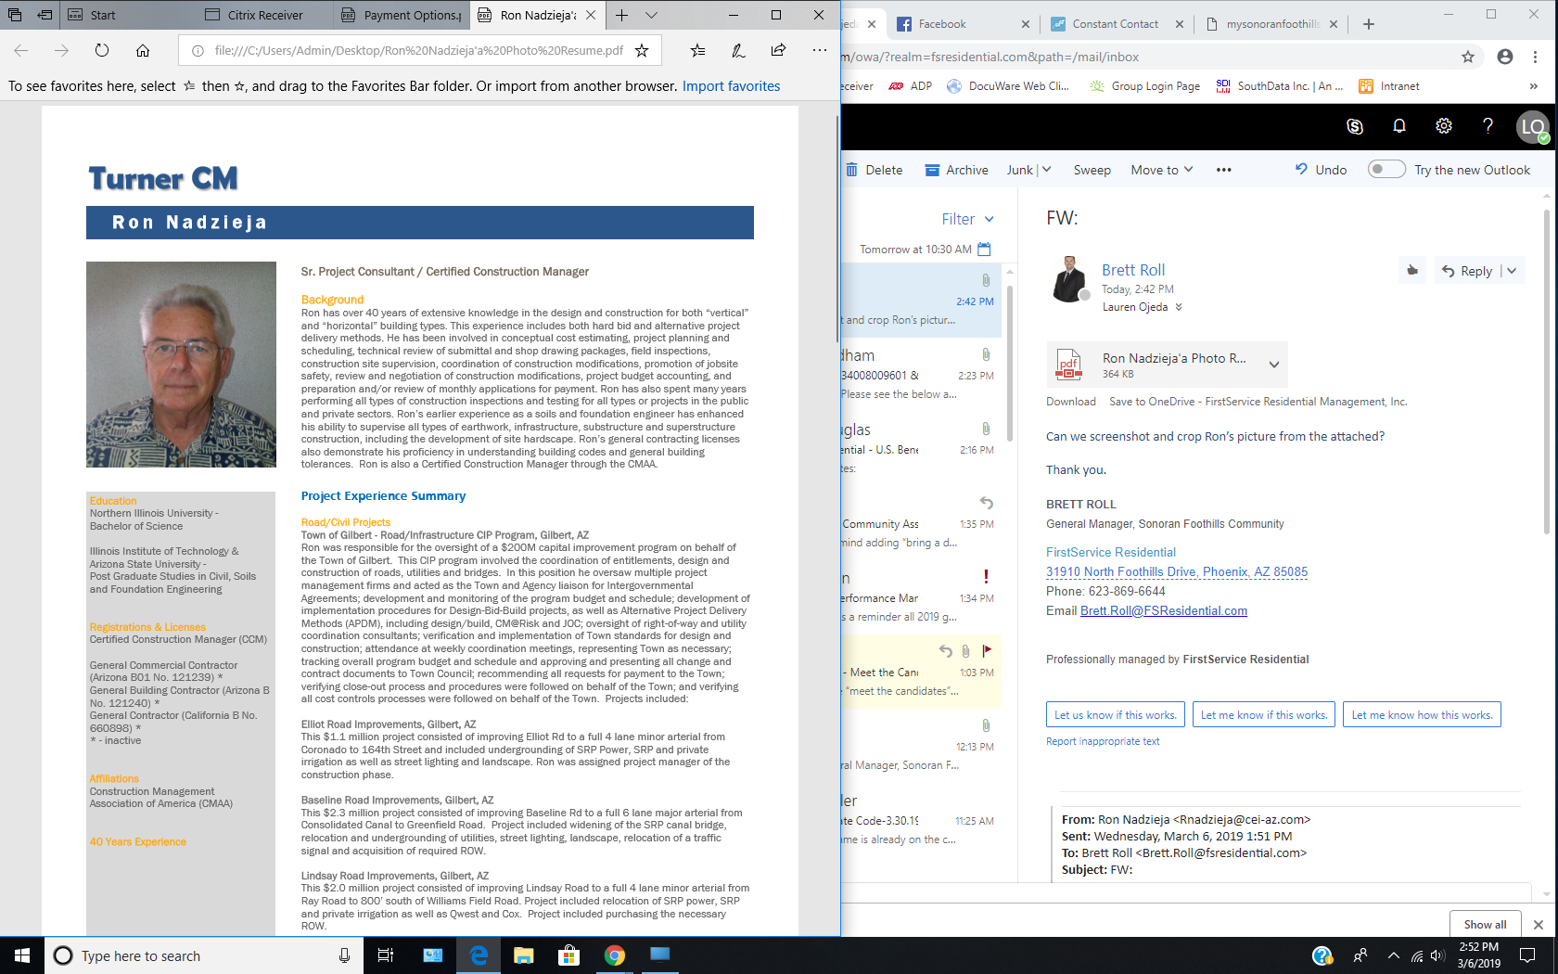
Ronald Nadzieja:
Previous experience as HOA President, Chairman of the Design Review and Landscape Committees for Pinnacle Reserve Subdivision in Scottsdale, AZ. I am a certified construction Manager and have General Contractor Licenses in AZ, NV, & CA. Experienced in drafting design and construction contracts and have supervised design and construction for Res & Comm projects. Have also performed as Expert Witness for several Contract disputes and construction accident litigation.

