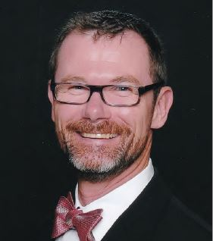

Robert Baxter:
Geologist and Safety Professional (and former contractor) I have varied career experience ranging from landscape and irrigation trade work to developing and leading corporate programs. I enjoy rolling up my sleeves and digging into the details. I am relatively new to our community, with only two years as a resident. I have been active with our community committees and a frequent participant at Board meetings.

