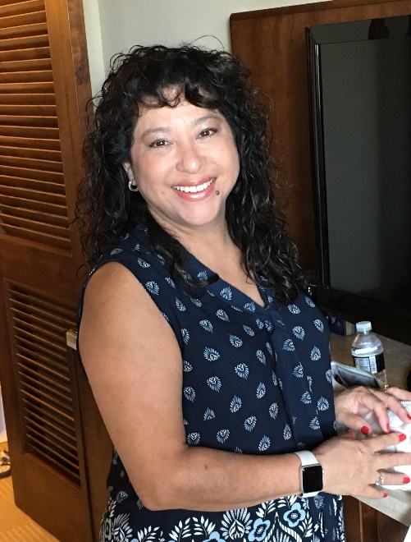

Diana Duran:
Over four years of prior HOA board member experience at another association and two of those years serving as Treasurer. Currently on the finance committee of Sonoran Foothills HOA. My reason for serving on the board would be to serve as a positive advocate for the community and ensure we stay on track with budgets.

