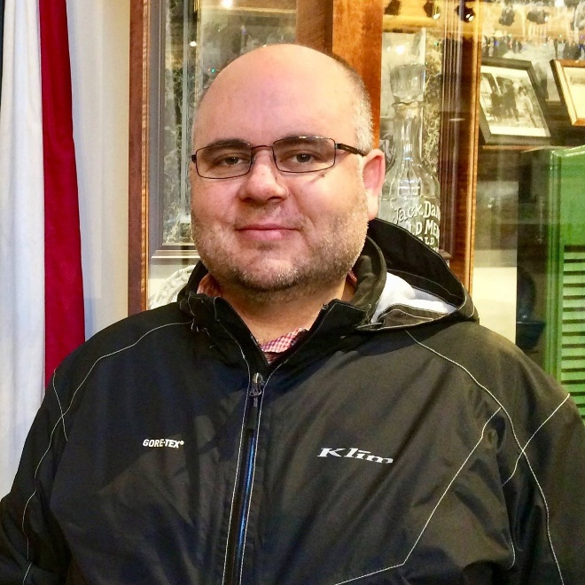

Gannon Burleigh:
I have lived in the community since 2011, and have recently taken an interest in getting more involved with community governance following the significant increase in our assessments. I trust that good decisions are being made by the current board, but hope to influence more communication and visibility for the homeowners. I am a Certified Public Accountant and Certified Internal Auditor with over 20 years of professional experience.

