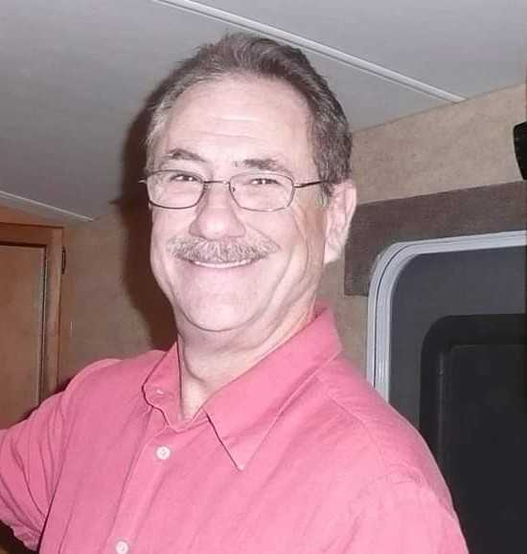

Robert Markarian:
Chairman-Landscape Committee, Member of Finance Committee, Attends all Board Meetings. Retired CPA (39yrs), CEO (35yrs) of West Coast Technology Corporation. Experience includes Budget Management, staffing and problem solving. Provided leadership on SF Budgets and Landscape cost savings proposals. Proponent of Water/Utility savings and use of funds for property improvement.

