GDC Retains Dell Technologies Platinum Tier with 25% Growth
Chambersburg, Pennsylvania – March 25, 2021

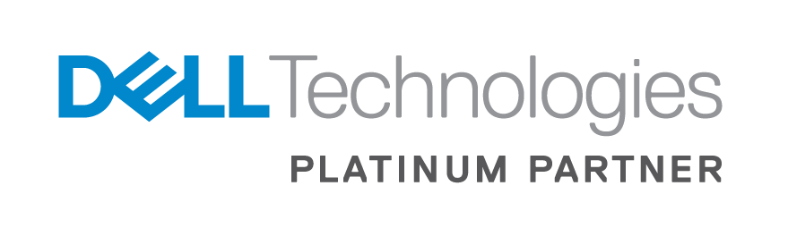
Global Data Consultants, LLC (GDC), a leading provider of technology and IT solutions headquartered in Chambersburg, Pennsylvania, announced today it has retained the Platinum Solution Provider tier in the Dell Technologies Partner Program with 25% growth year-over-year.

As a Platinum member of the Dell Technologies Partner Program, GDC serves a key role in providing innovative products and service solutions for our clients. With over 25 years of experience in converged and hyper-converged infrastructure, storage, server and core client, and an extensive track record delivering business results, GDC has demonstrated unmatched expertise that distinguishes them as a Platinum Dell partner.

“We are extremely proud of our teams and thankful to our clients who contributed to GDC maintaining Dell’s Platinum Partner status. This is a testament of our strong commitment to our partnership with Dell Technologies, and our credentials and capabilities to offer more value to our clients and deliver successful outcomes, commented Jeff Sauve, Vice President of Hardware Sales at GDC. “Being a Platinum tier solution provider allows us to lead with a quality product and build cost effective IT solutions, that are both highly available and resilient.”

The Dell Technology Partner program is a multi-tier program that helps partners build innovative and competitive business solutions using Dell platforms. Program resources keep customer costs low and helps to sustain competitiveness. With the Dell Technologies Partner Program, Partners have the full weight of the Dell Technologies brand behind them. The program provides partners with the competitive advantage to cross-sell and procure products and solutions across the Dell Technologies family of brands.

About Dell Technologies

Dell Technologies (NYSE:DELL) is a unique family of businesses that helps organizations and individuals build their digital future and transform how they work and live. The company provides customers with the industry’s broadest and most innovative technology and services portfolio spanning from edge to core to cloud. The Dell Technologies family includes Dell, Dell EMC, Pivotal, RSA, Secureworks, Virtustream and VMware. Learn more at delltechnologies.com.

About Global Data Consultants, LLC

GDC empowers businesses to increase employee productivity, maximize investments and improve operational efficiencies. With experienced and certified professionals, GDC delivers services in the areas of application development, data center, 24/7 multilingual service desk, desktop lifecycle management, project management, and business process consulting. Learn more at gdcITsolutions.com.

