PRESS RELEASE
FOR IMMEDIATE RELEASE

August 6, 2020

Plamondon Companies Celebrates 40 Years in Business
Plamondon family marks special anniversary with drive-by celebration

Frederick, MD—Plamondon Companies is proud to celebrate 40 years of business in the hospitality industry. The organization owns the Roy Rogers brand, as well as Marriott and Hilton franchises in Maryland, Pennsylvania, and Georgia. This milestone marks an exciting point in time for the family- owned organization and signifies a new era of expansion and growth for the future. Whether a guest visits a Roy Rogers or stays at one of their hotels, they’ll find that attention to the guest is relentless, gracious and urgent–each an important key to successful hospitality.

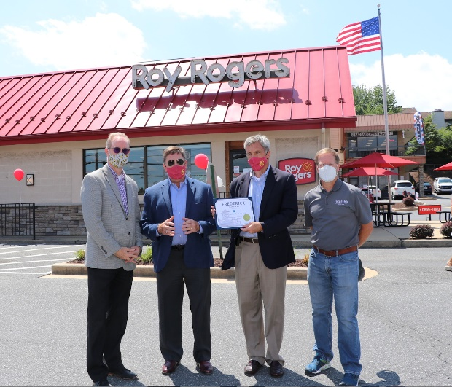
Jim and Pete Plamondon received a proclamation from Mayor Michael O'Connor and Richard Griffin, Director of Economic Development at the City of Frederick

Over the years, Plamondon Companies has become a major pillar in the Frederick community thanks to their business practices and charitable contributions. Not only does it employ a large number of people, both in and out of the state, but also consistently gives back to the communities in which they operate.

To celebrate 40 years, Plamondon Companies hosted a “drive-by” event on August 5 at the Roy Rogers on Route 40, the first Roy Rogers developed by Peter Plamondon Sr. in 1980. Tamar Osterman, Senior Business Development Representative with Maryland Department of Commerce also made an appearance to congratulate co-presidents Pete, Jr. and Jim Plamondon and present a secretarial citation from the state.

The event was an opportunity to recognize many of these local figures and patrons for their support and contributions throughout the years. As a thank you, guests received a certificate for a free Roy Rogers family meal and a complimentary, one-night stay at a Marriott or Hilton Plamondon Hospitality Partners property in Frederick, MD. Roy Rogers also provided first

responders 40% off their purchase for the day as an expression of appreciation for all their hard work and dedication to helping others.

Decades of History
Plamondon Companies was founded in 1980 by Peter Plamondon Sr. After 16 years as a corporate executive vice president for Marriott overseeing its restaurant division, he left in 1979 to become an entrepreneur. At the time, Marriott owned the Roy Rogers brand, which led Peter to opening his first restaurant on August 5, 1980.

Peter’s two sons, Pete, Jr. and Jim, chose to follow in their father’s business-minded footsteps. Pete, Jr. joined the company in 1993 and Jim joined in 1995.They both went through a management training program. They expanded their business into the lodging side of hospitality, opening their first hotel, a Fairfield Inn by Marriott, in Frederick in 1996. Then, in 1998, the two brothers bought the business from their father.

“To see our dad working a fry station was a bit humbling,” Pete Plamondon, Jr. reflects. “Here’s this guy who led an entire division as an executive vice president, and now he is working a fry station. This is one of the reasons why we encourage everyone who works in the corporate office to go out and spend time working in the field in our restaurants and hotels. It’s critical to our corporate mission and the values we strive to achieve.”

When the brothers purchased the company, they developed a corporate mission, The Values You Respect, that emphasized the importance of family, safety, community, education and relentless attention to guests. These were the principles that made the company successful under the ownership of Pete Sr., and the brothers wanted to continue the legacy. The mission not only benefits their customers and guests, but the associates who are truly the cornerstone of the company.

In 2002, Jim and Pete, Jr. purchased the Roy Rogers brand and trademark, and became the chain’s official franchisor.

Today’s Success

Plamondon Companies credits much of its success to their associates, the mission and culture Jim and Pete have cultivated as a company, and the values their father passed onto them.
Because the associates are the key to the companies’ long-term success, the two give back by providing opportunities for its associates to flourish. Plamondon Companies currently employs over 1,000 associates, often promoting from within, and providing educational opportunities and tuition reimbursement programs.

“When hiring, we look for a certain kind of person that loves hospitality, loves to serve others and has the spirit to serve,” said Jim Plamondon. “Our associates are the ones that make us a successful hospitality company.”

Associates and their families remain a top priority, even as the hotel side of the business expands geographically into Pennsylvania and Georgia.

“Just because we have a hotel in Georgia doesn’t mean that the associates there aren’t part of the Plamondon family,” said Pete Plamondon, Jr. “It is a little bit more challenging to build those connections and to know everyone, but we continuously make it a priority.”

Community Involvement
Plamondon Companies has always been heavily involved in the communities they serve, both in the business community and in public service. Owners and executives of the company have served as members and board chairs for a variety of nonprofits. They have hosted a United Way campaign for 40 years. Peter Sr. started the beloved Frederick tradition Historic Houses of Worship Tour during the holiday season, as well as assisted in starting the culinary arts program at Frederick Community College.

Plamondon Companies has supported educational organizations, disaster relief, and public service efforts, and have received numerous recognitions including the Maryland Chamber of Commerce Award, "Wellness at Work" Award, part of Maryland's Healthiest Businesses, Diversity and Inclusion Award, and Outstanding Contribution Award, presented at the Marriott Owners Conference.

The Future of Plamondon
Just as the past 40 years have proven, the future of Plamondon Companies looks bright. Plamondon Companies will continue to strategically plan for growth, expanding Roy Rogers through franchise efforts and bringing a full-service hotel to downtown Frederick.

Media Contact: Katrina Wyand-Yurish, VP of Human Resources, Plamondon Companies,
301-695-5051, ext. 121

Roy Rogers restaurants, based in Frederick, MD, is a chain of western-themed, quick-service restaurants. The menu and current promotions are available at www.RoyRogersRestaurants.com, and on Twitter, Facebook, and Instagram.

Plamondon Hospitality Partners is a hotel management and business development company based in Frederick, Maryland. Their current portfolio includes Marriott and Hilton properties in Maryland, Pennsylvania and Georgia. For more information, visit www.PlamondonHospitalityPartners.com.

###

