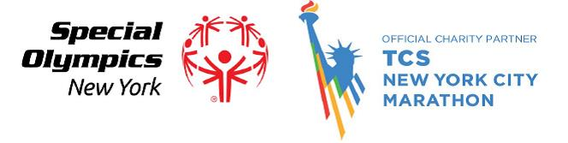
TCS New York City Marathon November 4, 2018
Application to join the Special Olympics New York Charity Team

Name: __________________________________________
Date of Birth: ______________
Address: ________________________________________
City: _________________ State: _________ Zip: _______
Phone Number: ____________________
Email: __________________________________________
Employer: _______________________________________

- Are you currently involved with Special Olympics New York? Yes No
If Yes, How? ______________________________________________________________

- If selected, are you aware you have to raise a minimum of $3,500 for Special Olympics New York? Yes No
How will you plan to raise funds? (Corporate Sponsorship, Friends, Family, Co-workers, etc.)
___________________________________________________________________________

- Have you ran a marathon before? Yes No
If Yes, Where & When: ________________________________________________________________________

- Why should you be selected to join Special Olympics New York’s 2018 Marathon Team?
_____________________________________________________________________________________________________________________________________________________________________________________________________________________________________________________________________________________________________________________________________________________________________________________________________________________________________________________________________________________________________________________________________________

**Application must be submitted no later than March 19, 2018 via mail or email.

Mail: Special Olympics New York, 560 Broadhollow Road, Suite 106, Melville, NY 11747
Email: Rstrickland@nyso.org

