Foundation of HOPE Diversion Program Report (January 1, 2019 – December 31, 2019)
Fifty three (98%) of the 54 youth referred to the program who were active, open, or closed this period, and received some type of service did not recommit any offenses. This translates to 2% recidivism rate. The safety rate of the program is 98%, which is the percentage of diversion participants who are not charged with a new offense while participating in diversion programs. The success rate is 31%, which is the percentage of diversion participants who successfully completed the diversion program during this report period. The post-program success rate is 100%, which is the percentage of participants who completed diversion program successfully and are not charged with a new offense within six months after program completion.
Chart 1: Number of Referrals by Month
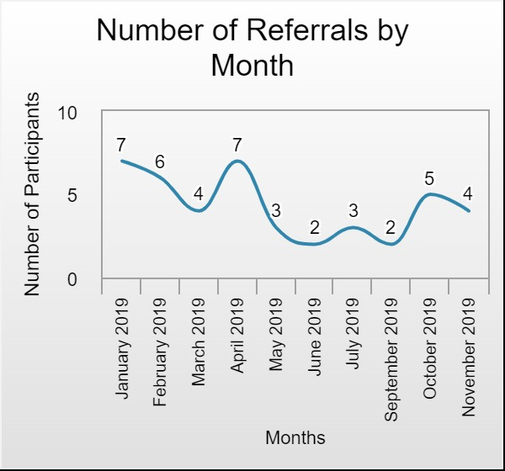
Chart 1 shows that there were only two months – January and April 2019 - that we reached the monthly target number of 7 for referrals.

Table 1: Number of Participants by Age Group
Age Group | # | % | Average Age
Age 9-12 | 6 | 11% | 11
Age 13-15 | 19 | 35% | 13
Age 16-19 | 26 | 48% | 16
Age 20-39 | 2 | 4% | 20
Age 40-59 | 1 | 2% | 45
Total | 54 | 100%
Average Age | 15

Chart 2: Number of Youth Active/Open/Closed/Referred but Refused Services
Chart 2 shows that about 61% (33) of the youth were either active or open and 32% (17) closed during this period. The chart also indicates that 7% (4) of the youth referred to the program during this period refused services.
Table 2: Number of Participants by Gender
Gender | # | %
Male | 30 | 56%
Female | 24 | 44%
Total | 54 | 100%

Chart 3: Race
Table 3: Number of Participants by Type of Offense Committed
Offense Committed | # | %
Other | 14 | 26%
Retail Theft - Juvenile | 4 | 7%
Drug Offense | 4 | 7%
Aggravated Assault - Juvenile | 3 | 6%
Trespassing | 3 | 6%
Simple Assault | 3 | 6%
Theft, Trespassing, Other | 2 | 4%
Theft | 2 | 4%
Loitering, Trespassing | 2 | 4%
Stolen Properties - Juvenile, Other | 2 | 4%
Unknown | 2 | 4%
Stolen Properties - Juvenile, Theft | 1 | 2%
Disorderly Conduct | 1 | 2%
Disorderly Conduct, Simple Assault | 1 | 2%
Disorderly Conduct, Theft, Other | 1 | 2%
Disorderly Conduct, Harassment, Simple Assault | 1 | 2%
Harassment, Simple Assault, Other | 1 | 2%
Disorderly Conduct, Other | 1 | 2%
Loitering, Theft | 1 | 2%
Obstructing Traffic, Other | 1 | 2%
Shoplifting | 1 | 2%
Theft, Other | 1 | 2%
Theft, Trespassing | 1 | 2%
Drug Offense, Stolen Properties - Juvenile | 1 | 2%
Grand Total | 54 | 100%

Tables 3 and 4 indicate that the most common and frequent offenses committed are: Other, Theft, Disorderly Conduct, and Trespassing.

Table 4: Most Frequent Offense Committed
Offense Committed | # | %
Other | 23 | 33%
Theft | 9 | 13%
Disorderly Conduct | 6 | 9%
Trespassing | 5 | 7%
Retail Theft – Juvenile | 5 | 7%
Simple Assault | 4 | 6%
Shoplifting | 4 | 6%
Aggravated Assault - Juvenile | 3 | 4%
Drug Offense | 3 | 4%
Loitering | 2 | 3%
Stolen Properties - Juvenile | 2 | 3%
Harassment | 1 | 1%
Obstructing Traffic | 1 | 1%
Unknown | 1 | 1%
Total | 69 | 100%

Table 5: Number of Participants by Source of Referral
Referral Source | # | %
Juvenile Probation | 33
City of Pittsburgh Bureau of Police – Zone 1 | 11
Propel Northside | 5
Housing Authority | 2
Other | 3
Total | 54 | 100%

Table 5 and Chart 4 shows that most of the referrals came from Juvenile Probation.
Chart 4: Number of Participants by Source of Referral
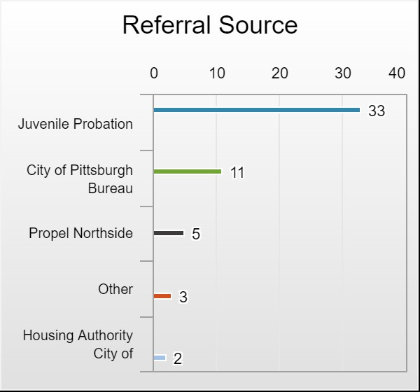
Table 6: Number of Participants by Neighborhood of Residence
Neighborhood | # | %
Brighton Heights | 6 | 11%
Marshall-Shadeland | 6 | 11%
Manchester | 5 | 9%
Perry North | 5 | 9%
Northview Heights | 4 | 7%
East Allegheny | 3 | 6%
Northside | 3 | 6%
Spring Hill-City View | 3 | 6%
Allegheny Center | 2 | 4%
California-Kirkbride | 2 | 4%
Perry North (Perry Hill Top) | 2 | 4%
Perry South | 2 | 4%
West End | 2 | 4%
Allegheny Center (Allegheny Commons) | 1 | 2%
Bellevue | 1 | 2%
Brookline | 1 | 2%
Marshall Shadeland | 1 | 2%
McKees Rocks | 1 | 2%
Oak Hill - Hill District | 1 | 2%
Other Municipalities/Townships | 1 | 2%
Spring Garden | 1 | 2%
Upper Hill | 1 | 2%
Total | 54 | 100%

Table 6 shows that most of the participants referred to the Diversion program came from Brighton Heights, Marshall-Shadeland, Manchester, and Northview Heights.

Table 7: Number of Participants by Neighborhood where Offense was Committed
Neighborhood | # | %
Brighton Heights | 9 | 17%
East Allegheny | 5 | 9%
Manchester | 4 | 7%
Northside | 4 | 7%
Other Municipalities/Townships | 4 | 7%
Allegheny Center | 3 | 6%
California-Kirkbride | 2 | 4%
Central Northside | 2 | 4%
East Liberty | 2 | 4%
Marshall-Shadeland | 2 | 4%
Perry Hill Top | 2 | 4%
Perry North | 2 | 4%
Bellevue | 1 | 2%
Carrick | 1 | 2%
Central Business District | 1 | 2%
Downtown Pittsburgh | 1 | 2%
Marshall Shadeland | 1 | 2%
North Hills | 1 | 2%
North Shore | 1 | 2%
Northview Heights | 1 | 2%
Perry High School | 1 | 2%
Spring Hill-City View | 1 | 2%
West End | 1 | 2%
West Mifflin area | 1 | 2%
Unknown | 1 | 2%
Total | 54 | 100%

According to Table 7 most of the offenses were committed in the following neighborhood Brighton Heights, East Allegheny, and Manchester.

Table 8: Number of Participants by Neighborhood of Residence and Neighborhood where Offense was Committed
Residence Neighborhood | Allegheny Center | Bellevue | Brighton Heights | California-Kirkbride | Carrick | Central Business District | Central Northside | Downtown Pittsburgh | East Allegheny | East Liberty | Manchester | Marshall Shadeland | Marshall-Shadeland | North Hills | North Shore | Northside | Northview Heights | Other Municipalities/Townships | Perry High School | Perry Hill Top | Perry North | Spring Hill-City View | West End | West Mifflin area | Unknown | Grand Total
Allegheny Center | 2 |  |  |  |  |  |  |  |  |  |  |  |  |  |  |  |  |  |  |  |  |  |  |  |  | 2
Allegheny Center (Allegheny Commons) |  |  |  |  |  |  |  |  |  |  |  |  |  |  |  |  |  | 1 |  |  |  |  |  |  |  | 1
Bellevue |  | 1 |  |  |  |  |  |  |  |  |  |  |  |  |  |  |  |  |  |  |  |  |  |  |  | 1
Brighton Heights |  |  | 5 | 1 |  |  |  |  |  |  |  |  |  |  |  |  |  |  |  |  |  |  |  |  |  | 6
Brookline |  |  |  |  |  |  |  |  |  |  |  |  |  |  | 1 |  |  |  |  |  |  |  |  |  |  | 1
California-Kirkbride |  |  |  | 1 |  |  |  |  |  |  |  |  |  |  |  |  |  |  |  | 1 |  |  |  |  |  | 2
East Allegheny |  |  |  |  |  |  |  |  | 3 |  |  |  |  |  |  |  |  |  |  |  |  |  |  |  |  | 3
Manchester |  |  |  |  |  |  |  |  | 1 |  | 3 |  |  |  |  |  |  |  | 1 |  |  |  |  |  |  | 5
Marshall-Shadeland |  |  |  |  |  |  |  |  | 1 |  |  | 1 | 2 |  |  | 1 |  | 1 |  |  |  |  |  | 1 |  | 7
McKees Rocks |  |  |  |  |  |  |  |  |  |  |  |  |  |  |  | 1 |  |  |  |  |  |  |  |  |  | 1
Northside |  |  |  |  |  |  |  |  |  |  |  |  |  |  |  | 2 |  |  |  | 1 |  |  |  |  |  | 3
Northview Heights |  |  |  |  |  | 1 |  |  |  |  |  |  |  |  |  |  | 1 | 1 |  |  |  |  | 1 |  |  | 4
Oak Hill - Hill District |  |  |  |  |  |  | 1 |  |  |  |  |  |  |  |  |  |  |  |  |  |  |  |  |  |  | 1
Other Municipalities/Townships |  |  | 1 |  |  |  |  |  |  |  |  |  |  |  |  |  |  |  |  |  |  |  |  |  |  | 1
Perry North (Perry Hill Top) |  |  | 2 |  | 1 |  |  |  |  | 1 | 1 |  |  |  |  |  |  |  |  |  | 1 |  |  |  | 1 | 7
Perry South |  |  |  |  |  |  | 1 |  |  |  |  |  |  |  |  |  |  |  |  |  | 1 |  |  |  |  | 2
Spring Garden |  |  |  |  |  |  |  | 1 |  |  |  |  |  |  |  |  |  |  |  |  |  |  |  |  |  | 1
Spring Hill-City View |  |  |  |  |  |  |  |  |  | 1 |  |  |  | 1 |  |  |  |  |  |  |  | 1 |  |  |  | 3
Upper Hill |  |  |  |  |  |  |  |  |  |  |  |  |  |  |  |  |  | 1 |  |  |  |  |  |  |  | 1
West End | 1 |  | 1 |  |  |  |  |  |  |  |  |  |  |  |  |  |  |  |  |  |  |  |  |  |  | 2
Grand Total | 3 | 1 | 9 | 2 | 1 | 1 | 2 | 1 | 5 | 2 | 4 | 1 | 2 | 1 | 1 | 4 | 1 | 4 | 1 | 2 | 2 | 1 | 1 | 1 | 1 | 54

Table 8: Comparison of Location Where Offense Was Committed by Neighborhood
Neighborhood of Residence | # of Offense Committed | Offense Committed Within Neighborhood of Residence |  | Offense Committed Out of Neighborhood of Residence
 | # | # | % | # | %
Allegheny Center | 2 | 2 | 100%
Allegheny Center (Allegheny Commons) | 1 |  |  | 1 | 100%
Bellevue | 1 | 1 | 100%
Brighton Heights | 6 | 5 | 83% | 1 | 17%
Brookline | 1 |  |  | 1 | 100%
California-Kirkbride | 2 |  |  | 2 | 100%
East Allegheny | 3 | 3 | 100%
Manchester | 5 | 3 | 60% | 2 | 40%
Marshall-Shadeland | 7 | 3 | 43% | 4 | 57%
McKees Rocks | 1 |  |  | 1 | 100%
Northside | 3 | 2 | 67% | 1 | 33%
Northview Heights | 4 |  |  | 4 | 100%
Oak Hill - Hill District | 1 |  |  | 1 | 100%
Other Municipalities/Townships | 1 |  |  | 1 | 100%
Perry North (Perry Hill Top) | 7 |  |  | 7 | 100%
Perry South | 2 |  |  | 2 | 100%
Spring Garden | 1 |  |  | 1 | 100%
Spring Hill-City View | 3 |  |  | 3 | 100%
Upper Hill | 1 |  |  | 1 | 100%
West End | 2 |  |  | 2 | 100%
Grand Total | 54 | 19 | 35% | 35 | 65%

Table 8 indicates that 35% of the participants committed offense within the neighborhood of residence and 65% out of the neighborhood of residence.

Table 8: Financial Assistance Received by Participants
Number of Participant by Type of Financial Assistance Received |  |  |  |  |  | Amount Received by Type of Financial Assistance
Type of Assistance | # Participants | % |  |  |  | Amount ($) | %
Transportation financial assistance | 10 | 24% |  |  |  | 1140 | 18%
Fine, court cost, and restitution | 4 | 10% |  |  |  | 1461 | 23%
Uniforms Fee | 1 | 2% |  |  |  | 285 | 4%
Miscellaneous fee | 1 | 2% |  |  |  | 105.5 | 2%
Other | 25 | 61% |  |  |  | 3,464.99 | 54%
Total | 41 | 100% |  |  |  | 6,456.49 | 100%

According to Table 8, most of the financial assistance received by participants is transportation financial assistance and other assistance. There were thirty (41) participants who received a total of $6,456.49 financial assistance during this report period.
Table 9: Types and Reasons for Contacts
Reason for Contact/Visit | Home Visits | Office Visit | Telephone Call | Other Contacts | Grand Total
Court Appearance |  |  |  | 14 | 14
Crisis Intervention | 2 |  | 6 | 2 | 10
Follow-up | 92 | 14 | 37 | 30 | 173
Other | 9 | 20 | 3 | 32 | 64
Schedule Appointment | 16 | 11 | 2 | 10 | 39
Service Plan | 1 |  | 1 | 3 | 5
Grand Total | 120 | 45 | 49 | 91 | 305

Table 9 shows that most of the contacts were by Home Visits (120) and the most frequent reason for contact was follow-up (173).

Table 10: Group Activities Attended
Activities | # Participants (Unique Count) | Total Length of Session (in hrs) | Total Activity Attendance
After school programming | 21 | 166 | 55
Behavioral health counseling | 9 | 37 | 22
Community engagement events | 25 | 558 | 95
Community Service | 3 | 90 | 18
Drug/alcohol counseling | 3 | 11 | 7
Job readiness | 13 | 67 | 43
Mental Health Counseling | 5 | 13 | 9
Restorative practice | 15 | 188 | 77
Sporting events | 18 | 157 | 49
Total | 39 | 1,287 | 375

Table 10 shows that 39 youth attended at least one of the activities and received a total of 1,287 hours of the 375 sessions attended.

