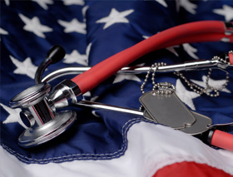

“Have you, a family member, or anyone in your household ever served in the military?” is the preferred screening question vs. “Are you a Veteran?" as it enables those who don’t feel comfortable with the term Veteran or don't identify as a Veteran to be recognized.
This also helps identify spouses (benefits) and non-family members who are providing care (caregiver benefits), allows others to identify Veterans, informs providers of conditions potentially associated with generational effects of military service, cues the potential to bill the VA for services, improves facility needs assessment efforts, gives a more accurate patient characteristic report to UDS, and providers can identify trends in Veteran health conditions, which could impact future legislation, such as the recent PACT Act.

It’s not just an intake form, it’s a life-altering journey!
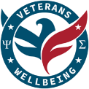

The PACT Act is a new law, and the most significant expansion and extension of Veteran benefits, eligibility, and care in 30+ years. Those previously denied for benefits should reapply. Contact your County VA Office and Veteran Service Officers. They provide accredited claims services (Health Care AND other benefits) for Veterans and their families, at no charge.

Find your County VA Office and Veteran Service Officers at michigan.gov/mvaa and select “Find a Veteran Service Officer”

Or dial 1-800-MICH-VET

mcrh.msu.edu/programs/Veterans-Care
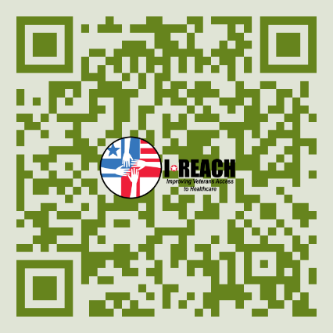

SCREEN FOR VETERAN STATUS DURING INTAKE
ASK, “HAVE YOU SERVED?”

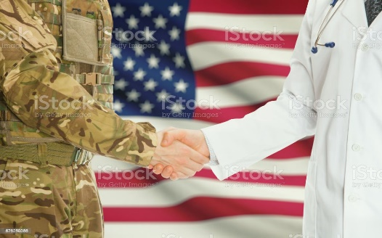
Less than 50% of Veterans are connected to all their military benefits. Connection to benefits saves lives and improves quality of life.
Help them get connected!
Over 1/3 of Veterans receive care in the community. Awareness of your clients’ military service and the potential implications can inform treatment planning and open doors to resources and benefits.
Community providers play a vital role in ensuring Veterans receive the care they’ve earned.
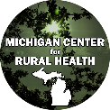

There are many success stories of providers connecting Veterans and their families with resources.
Greater enrollment leads to greater utilization.
Plus, it’s beneficial for the provider to know if the patient has served because of the unique culture, possible exposures, and common medical conditions of military service.

Veterans have unique health care needs, disease patterns, experiences, and cultural backgrounds.
More likely than non-veterans to have:
- Toxic exposures: Agent Orange, burn pits, contaminated water, asbestos, radiation, etc.
- Diabetes, ALS, chronic pain, moral injury, and adverse childhood experiences (increases risk for PTS and suicide), certain cancers, etc.
- Vaccines and/or exposure to hepatitis A & B, rabies, typhoid, cholera, yellow fever, anthrax, smallpox, malaria, botulinum toxoid, meningitis, PB, etc., etc.

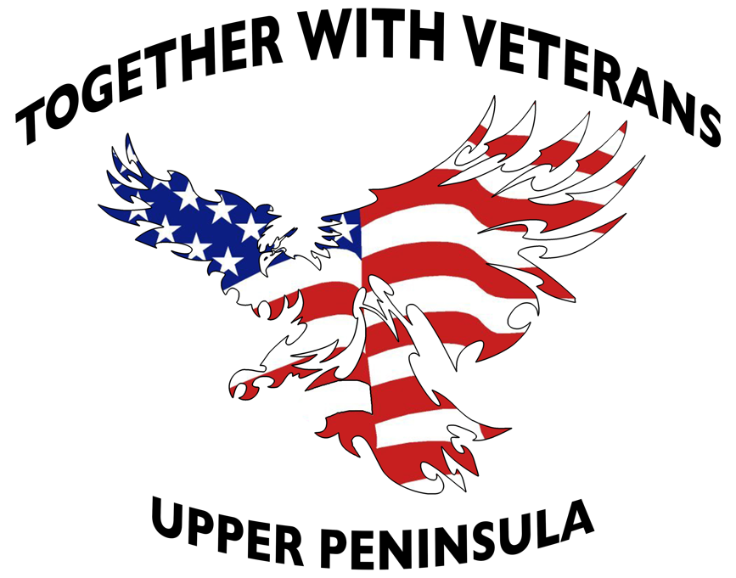
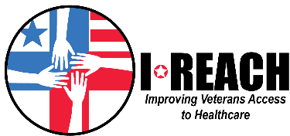

We’re asking care facilities to help us get Veterans connected. Care providers are in the best position to help with this, considering their existing screening process and professional skills. This concept is a national movement with national programs such as the Governors Challenge, “Have You Served?” and American Academy of Nursing’s, “Have You Ever Served?” screening programs.
Other supporters:
- American Medical Association
- Health Care Association of Michigan
- National Association of Community Health Centers
- Michigan HomeCare & Hospice Association
- Health Resources and Service Administration
- Substance Abuse and Mental Health Services Administration
- University of Michigan’s Center for Health and Research Transformation (CHRT)
- Michigan Health Endowment Fund
This topic has many peer reviewed articles.
Toolkits for when they answer “Yes”:
VA Community Provider Toolkit mentalhealth.va.gov/healthcare-providers

I-REACH Veteran Connector Toolkit
mcrh.msu.edu/programs/Veterans-Care

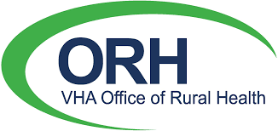

JOIN THE VA COMMUNITY CARE NETWORK
Community providers are critical to Veterans health!
More in-network providers are needed to improve Veterans access to health care. As of March 5, 2024, millions more Veterans are eligible for VA healthcare. Over 1/3 receive care via VA CCN. VA MISSION Act of 2018 created the Veterans Community Care Program (VCCP), allowing the VA to purchase community health care services. VA CCN addresses previous challenges, including claims processing and billing. VA CCN outperforms prior networks:
- Improved customer service
- More timely payments
- Prescriptions are easier
- Simplified appointment scheduling
- Provider-to-provider coordination promotes better care coordination
More types of providers can participate. Such as dialysis, residential care, comprehensive rehabilitation, home health, hospice, dental, long-term acute care, immunizations, complementary & integrated services in areas of biofeedback, hypnotherapy, massage therapy, relaxation methods and tai chi.
Advantages of being in the VA CCN: Increased utilization of services, including Urgent Care. VA billing including Medicare/ Medicaid & Medicare Supplemental services. Partnering with your local VA Medical Center can be mutually beneficial.
Community Care and Provider Overviews:
va.gov/communitycare/
va.gov/communitycare/providers/

